**cybersecurity portfolio**

By: Derek Liu

**Table of Contents**

Palo Alto Firewalls

* Factory Reset 3
* SOHO Configuration 8
* Version Updates 19
* URL Filtering 25
* Site to Site VPN Pre-Shared Key 30
* Site to Site VPN Certificate 57
* Remote Access VPN (Global Protect) 88
* Clientless VPN 113

PfSense Firewalls

* Setup & Remote Desktop 121

Cisco ASA

* Factory Reset 129
* Clientless VPN 136

**Factory Reset Palo Alto Firewall***Derek Liu*

Purpose

To become familiar with Palo Alto firewalls and basic skills required for configuring it.

Background Information

When accessing a new Palo Alto firewall or if you are unsure of the condition that the firewall is in, it is best practice to factory reset it before configuring it. In this lab, we got used to Palo Alto firewalls and the first step was to factory reset it so we could access it and configure it from scratch.

Configurations

Step 1.

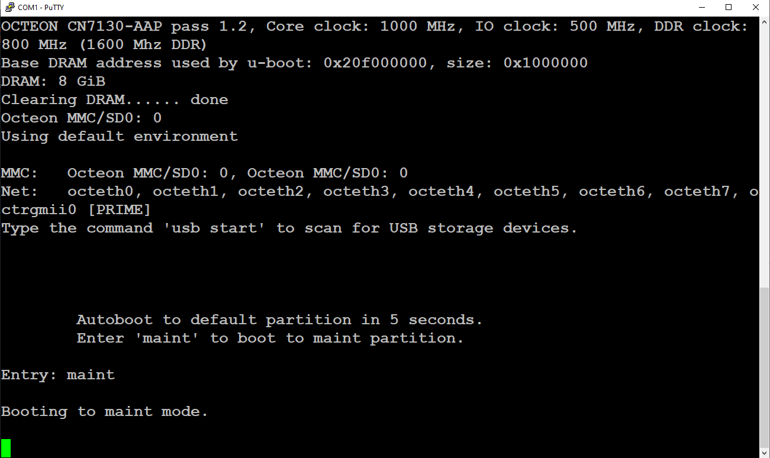

Console into the firewall using the console port. Wait for boot up text to finish. Type in “maint” to enter maint mode.

Step 2.

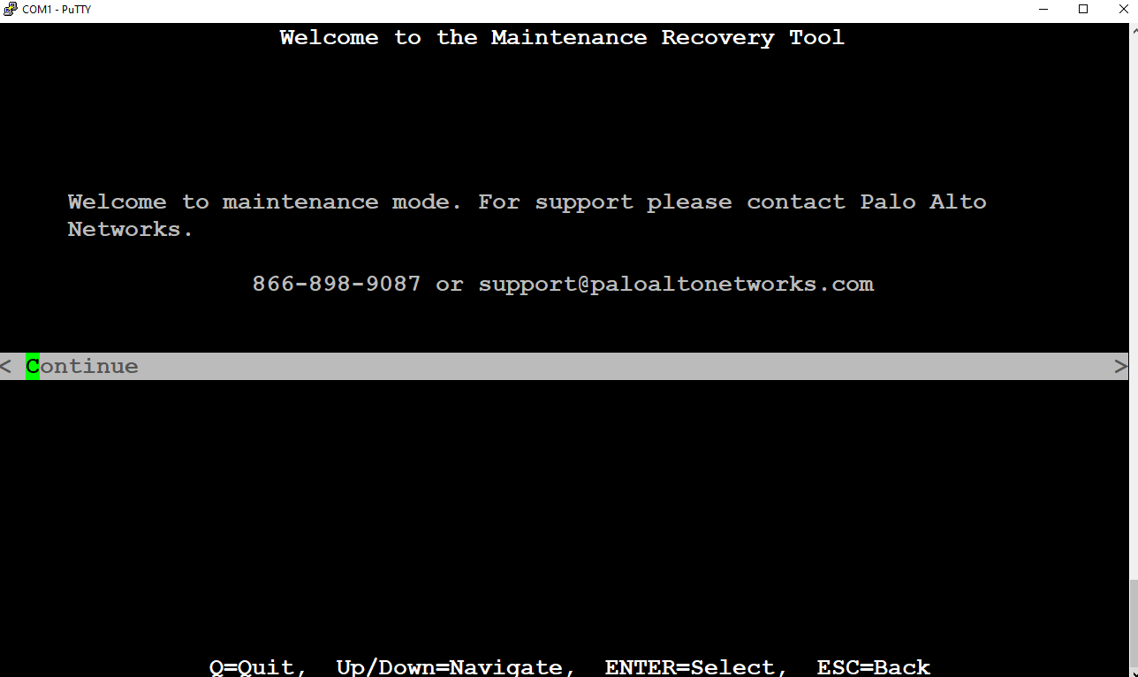

This is what the terminal should show after entering maint mode. Hit continue to continue.

Step 3.

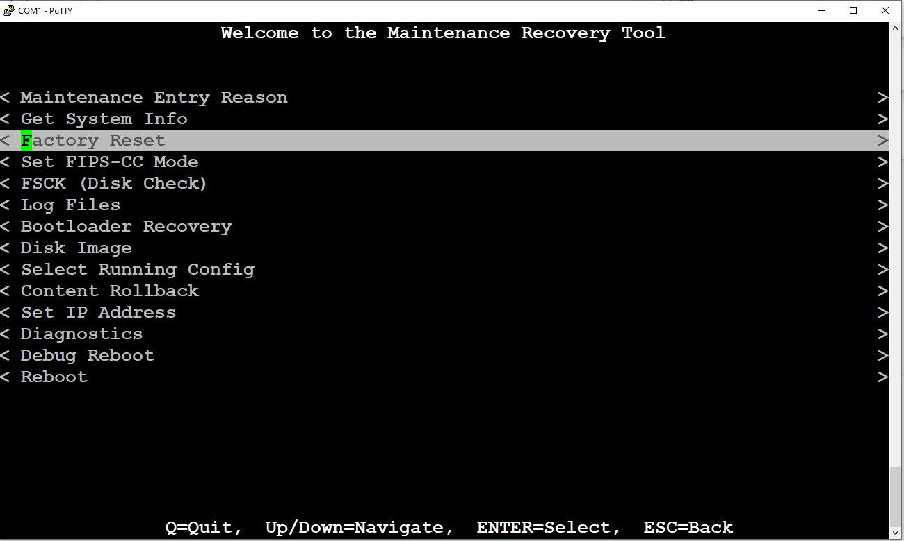

Scroll down to Factory Reset and press enter to select. This should be following screen:

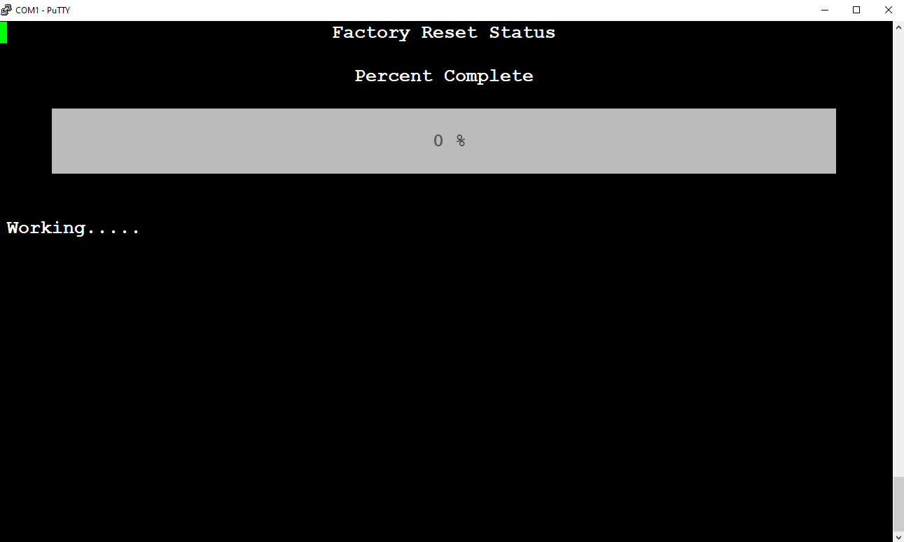

Step 3.

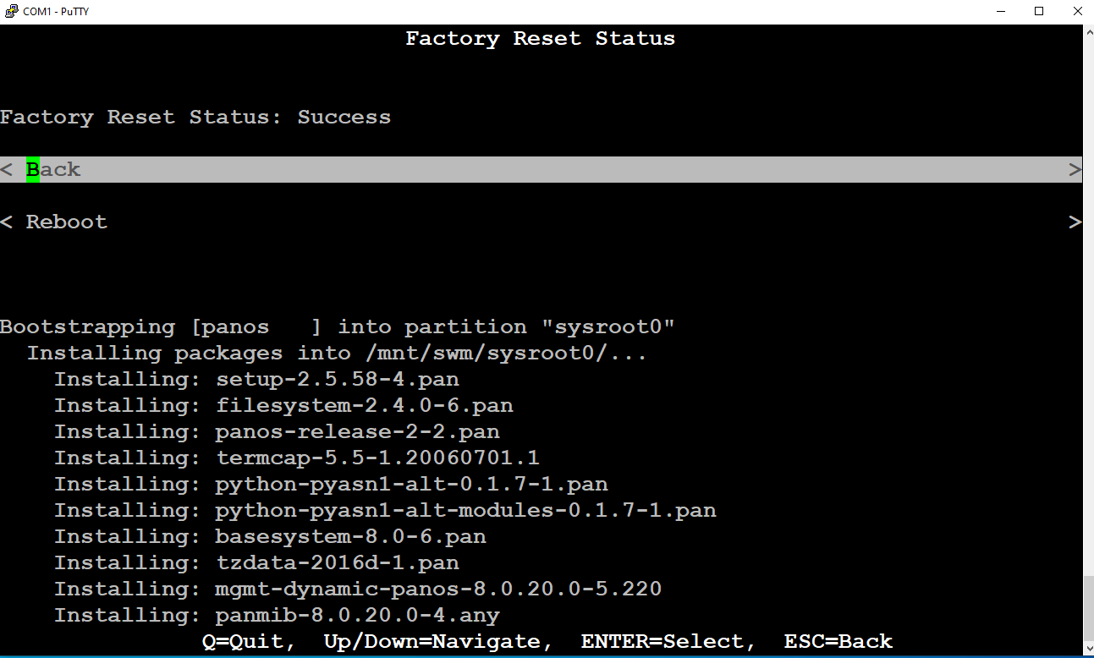

After it finishes factory resetting, select reboot and go through the startup text again.

Step 4.

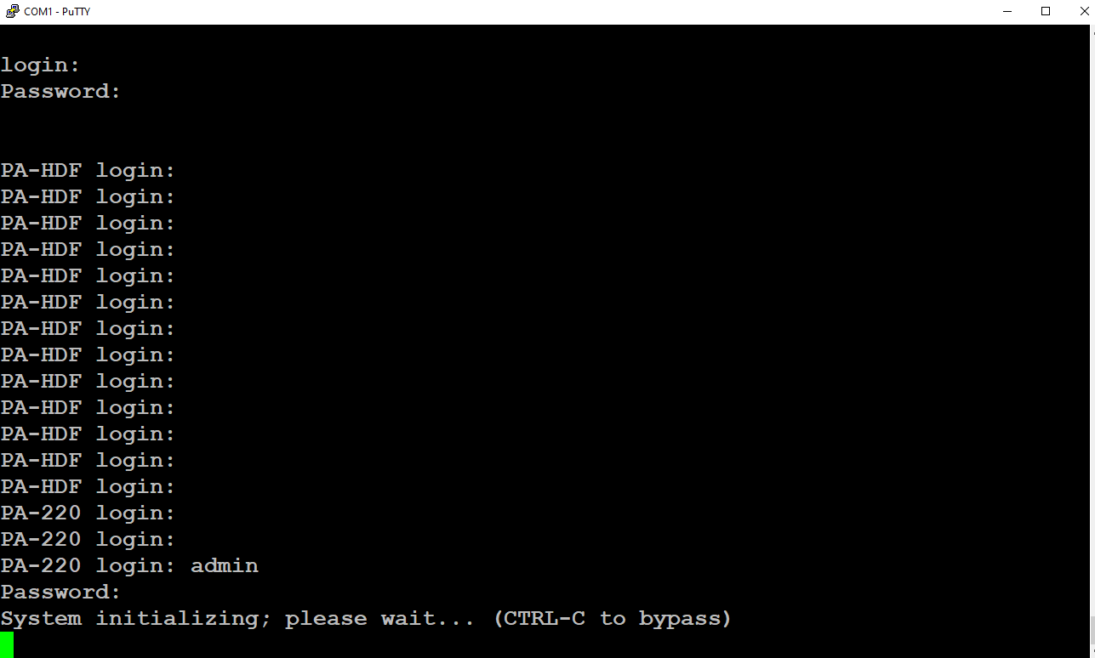

The default username and password are admin and admin respectively. But before being able to type in the username and password, the firewall needs to switch its prompt from “PA-HDF” to “PA-220”. Typing in admin and admin during PA-HDF will not let you in.

Problems

When figuring out when to type in “maint” at the beginning, we often were too late the first time. We learned that “maint” could be typed in during the startup text and still enter maint mode. After entering maint mode and clicking factory reset, we were unsure if the factory reset would go through so we rebooted it. The firewall should be factory reset after finishing the startup dialog. Initially after trying to enter the username and password of “admin” and “admin” we couldn’t get into the firewall since errors kept appearing. The solution was to wait until the prompt turned from “PA-HDF login:” to “PA-220 login:”.

Conclusion

In this lab, we obtained a used palo alto firewall 220. We used a pc with a console cord to console into the firewall to enter maint mode. From maint mode, we factory reset the firewall so that we can configure it in the future.

**Palo Alto SOHO Config***Derek Liu*

Purpose

The purpose of this lab was to use the web interface to configure the Palo Alto firewall for a SOHO setting and connect it to the internet. This was done through configuring DHCP and using NAT.

Background Information

After factory resetting a Palo Alto firewall, it will not be initially configured to be completely functional for a SOHO setting. In this lab we will make the necessary changes in the web interface for it to function. In this lab we configured ethernet 1/1 to be the interface to be connected to the ISP while interfaces 1/2 to 1/4 were configured to be trusted interfaces. We did not set any static routes and used DHCP to obtain IP addresses. VLANs and NAT were also configured in this lab.

After successful configuration of the Palo Alto for a SOHO network, you can access service through the Palo Alto. For example, if your network comes under attack, you can contact Unit 42 through the Palo Alto website for them to contain and remediate the breach. Unit 42 is made up of the industry’s elite incident response advisors.

Palo Alto firewalls are at the forefront of leaders in network firewalls and positioned highest in execution and furthest in vision by Gartner. A firewall comes with features for a zero trust enterprise, cloud native security, security operations, threat intel & consulting, ML-powered network security, and cloud delivered security.

Configurations

1. Connect to the management interface and change pc ipv4 address to 192.168.1.2 in order to access the web interface

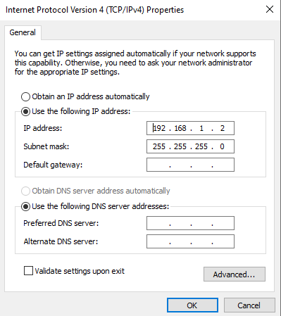

Go to <https://192.168.1.1> Default credentials should be username: admin, password: admin.

1. Go to network -> zones and then click “add” on the bottom left.

Create three different zones:

* Untrust, Type Layer 3.
* Trust-L3, Type Layer 3.
* Trust-L2, Type Layer 2

1. Connect ethernet 1/1 to the ISP.
2. Go to Network -> interfaces and select “ethernet 1/1”

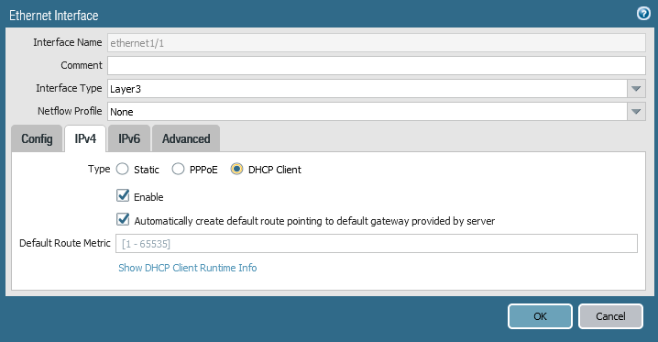  
Change interface type to layer 2, set virtual router to default, and set as DHCP client

1. Go to Virtual Wire and delete everything on the page
2. Go to Network -> VLANs and click “add”

Set the name as “Vlan Object” and VLAN interface as “vlan”.

1. Go to Network -> interfaces and configure the following interfaces:

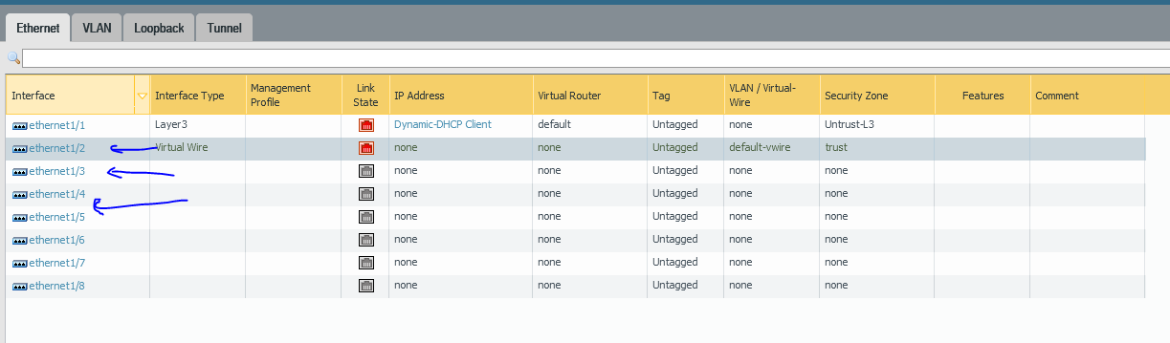

For all of them (1/2, 1/3, 1/4) Select the following:

* Interface type: Layer2
* VLAN: Vlan Object
* Security Zone: Trust-L2

1. Go to Network -> interfaces -> VLAN and edit the following:

* VLAN: Vlan Object
* Virtual Router: Default
* Security Zone: Trust-L3

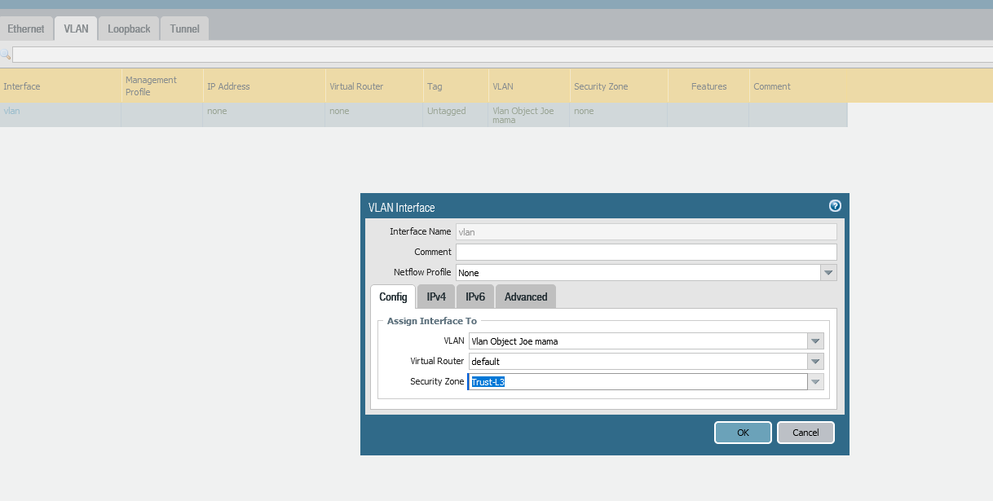

1. Go to the IPV4 tab and select DHCP Client (or set a static IP address if step 10 doesn’t work)
2. Go to Network -> DHCP -> DHCP Server and click “add”

And put in the following configuration:

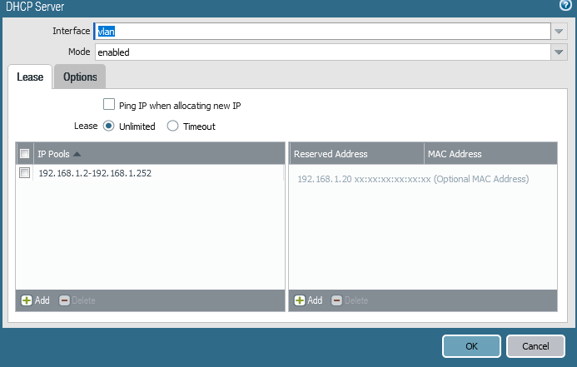

Go to options and configure the following:

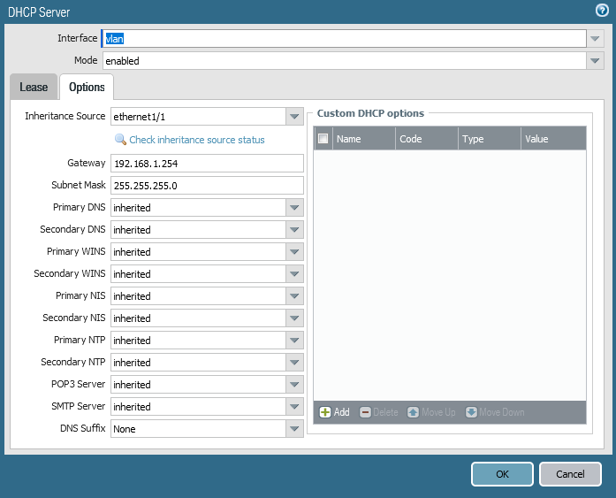

1. Objects -> Security Profile Groups and click “add”
2. Name: “Internet”; Antivirus profile: “default”; Anti-spyware profile: “strict”; Vulnerability protection profile: “strict”; URL filtering profile: “default”.
3. Policies -> security and click “add”

Configure the following:

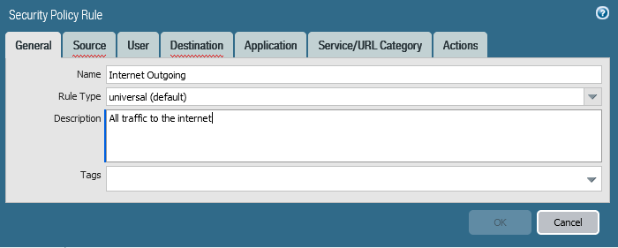

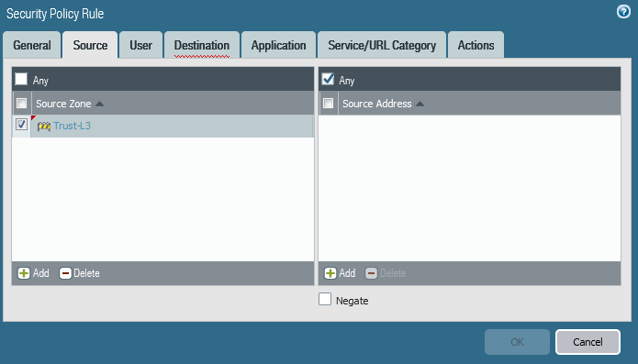

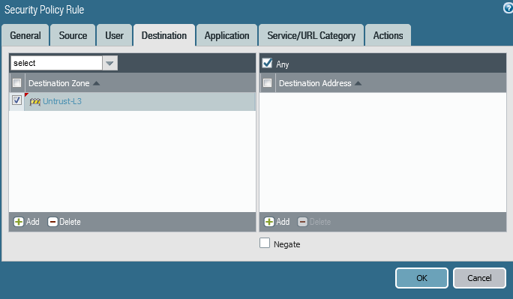

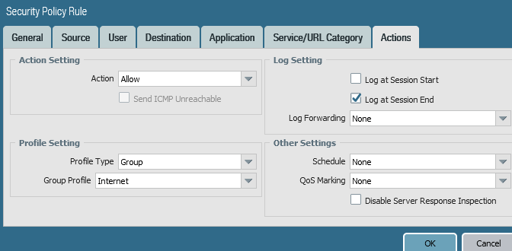

1. Go to Policies -> NAT, and click “add”

Configure the following:

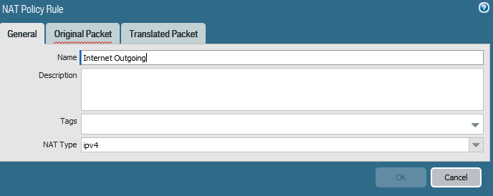

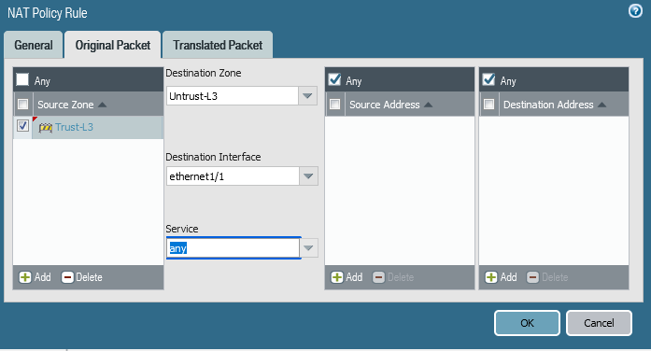

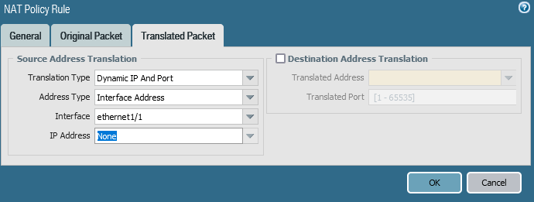

1. Go to Device -> Setup -> Interfaces

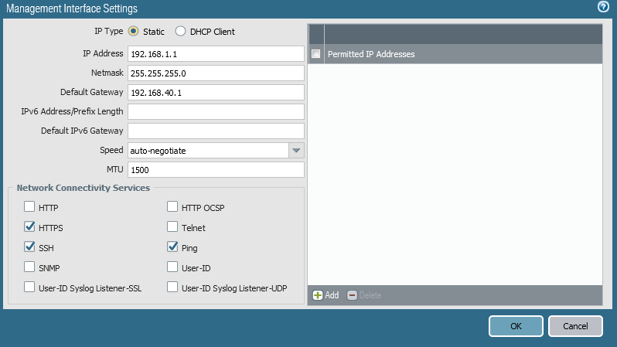

1. Go to Device -> Setup -> Services

Configure the following:

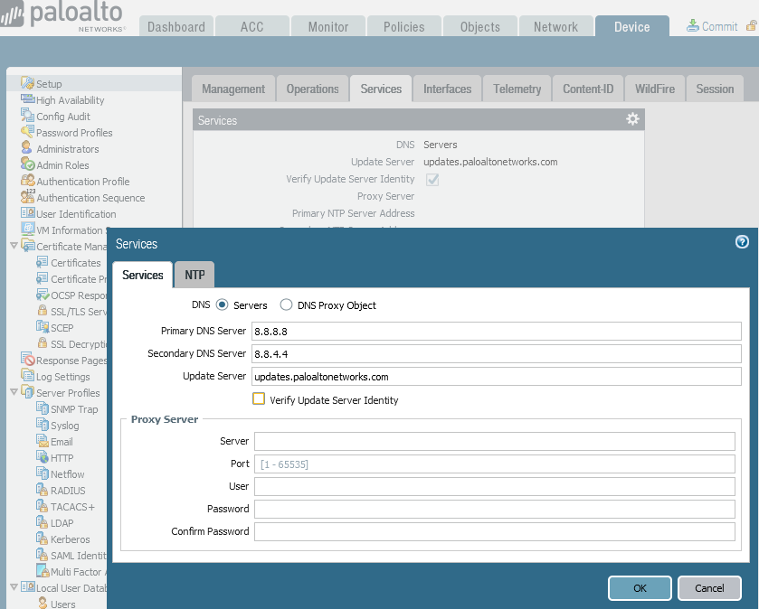

1. Click the commit button at the top right of the web interface to save configurations.
2. Change ipv4 configuration of PC to DHCP

Problems

The lab had a lot of steps that weren’t very specific so the first time we tried to configure the firewall it didn’t go smoothly. We originally configured static routes which didn’t work very well so we switched to DHCP and there was a lot of confusion following which steps were meant for static routes and which ones were meant for DHCP. Another problem that we had was that we were getting warnings while committing with the virtual wire. We fixed it by deleting the virtual wire. Another problem that we had was finding a suitable DHCP pool. We originally chose a DHCP pool in the range of 192.168.40.1 to 192.168.40.252 but that ended up cutting off the connection to the web interface. The fix was using the DHCP pool of 192.168.1.1-192.168.1.252. Another problem that we ran into was that we often forgot to change the ipv4 address of the pc to DHCP which caused the connection to time out while we were trying to connect to the web interface.

**Version Updates on Palo Alto Firewall***Derek Liu*

Purpose

To update an outdated firewall software version to the latest version to better protect networks and defend against cyber threats.

Background Information

After successful configuration of a Palo Alto firewall and connecting it to the internet, it is possible to download and install version updates for the firewall. When accessing a new Palo Alto firewall, the software may not necessarily be the latest version. We have a firewall configured for a SOHO network, but its software version is 8.0.20 and the most recent version as of September of 2022 is 10.2.2-h2. In this lab, we will update the Palo Alto firewall from version 8.0.22 to version 10.2.2-h2. This is necessary to ensure the firewall can defend against the ever-changing advances in technology and threats.

With each version update, new features usually come with it that can increase security and support a zero-trust policy. In the case of version 10.2, it comes with cloud identity engine, PAN-OS OpenConfig Support, administrator level push, and advanced routing engine.

Through the cloud identity engine, Palo Alto firewalls can provide a cloud-based solution to reallocate resources for authentication from the firewall to the cloud. OpenConfig support means that the firewall will allow OpenConfig data models and protocols to automate configuration. Administrator-level push allows for configurations to be pushed onto certain managed firewalls. Advanced routing engine assists in creating routing maps while reducing the learning curve. In this lab, we will be updating the firewall to a version that can support these features.

Palo Alto firewalls have a unique update sequence.

Configurations

1. The first step would be to log into the firewall through the management interface. We connected the management port to a configured trusted port on the firewall using a copper straight-through cable.
2. After logging into the firewall, go to device -> licenses and then Retrieve license keys from license server.

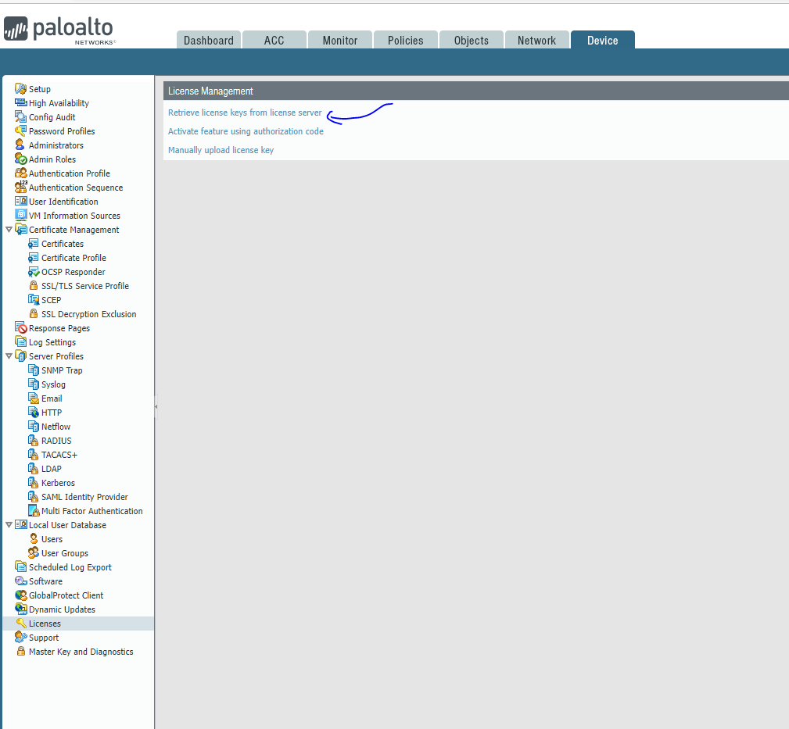

1. The result should look something similar to this:

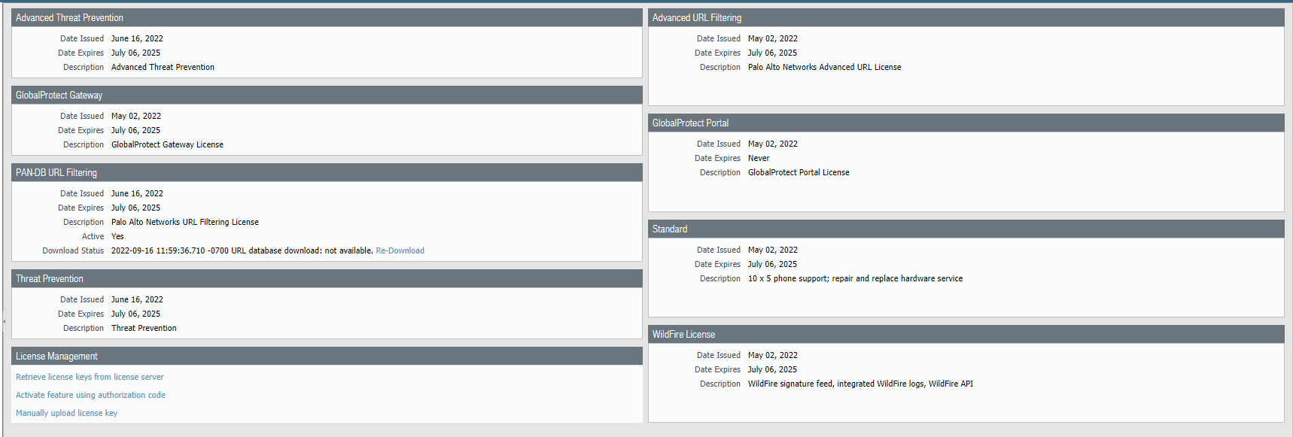

1. Go to Devices -> Software, and click Check Now

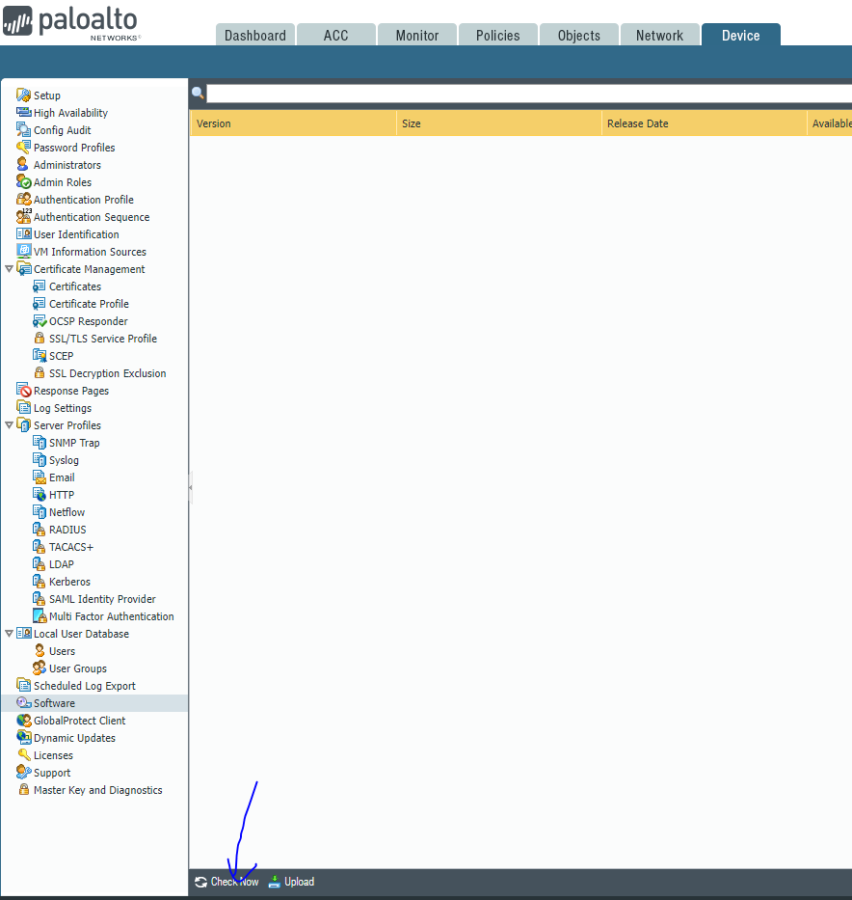

1. At this point, you should be able to see the available versions and the version that your firewall is currently on.
2. Go to Device -> Dynamic updates, and download everything applicable (VPN, Wildfire, Global protect)

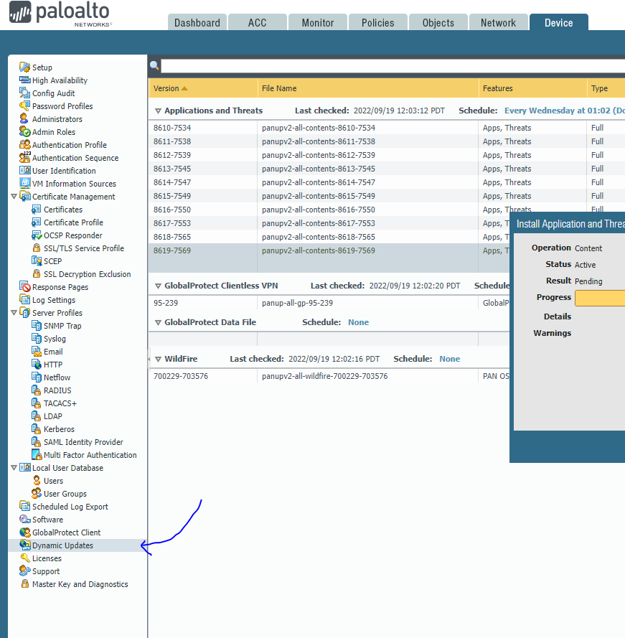

1. Upgrade the firewall in this order.
   1. Download and install the latest software in the third digit of the version (e.g if the current version is PAN-OS 8.0.x then install 8.0.20.
   2. After installing the highest version in the third digit, download and install the version that’s one greater on the second digit (e.g. version 8.0.20 to 8.1.0).
   3. After reaching the highest number available for the second digit, upgrade to the version with one greater on the first digit while the second and third digits are 0.

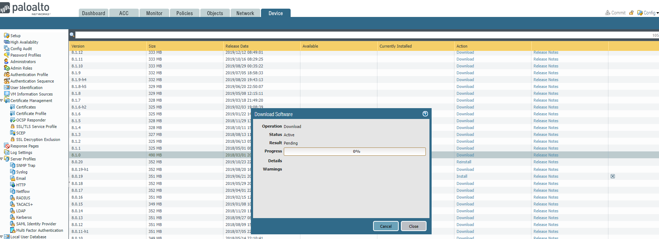

This should be what the update screens look like.

1. Finished

Problems

Due to the complexity of the update process, we ran into a lot of problems. Originally, we tried to update directly to the latest version but ran into the error of having to update to the next version. We also originally didn’t do dynamic updates which prevented us from doing updates. Another problem that we faced was timing out while getting the configuration lock. The problem was fixed after we rebooted the firewall.

Conclusion

In this lab, we updated a palo alto firewall 220 with out-of-date software. After connecting the firewall to the internet, we were able to obtain the license and begin to update the software and install dynamic updates. After successful installation of the newest version, we can start implementing new features on the firewall.

**URL Filtering and Override on a Palo Alto Firewall***Derek Liu*

Purpose

The purpose of this lab was to filter URLs in groups and configure an option to override the filter for specific types of URLs if the user has a pre-shared password.

Background Information

When configuring a firewall for a SOHO network or even a company, it is good practice to filter out harmful or potentially harmful websites on the internet. Using the Palo Alto firewall, there is an option to filter out groups of URLs ranging everything from “malware” to “home-and-garden”. In this lab we will be blocking all websites that belong in the category of “online games” to prevent off-task behavior during work. We will also configure an option to override the filtering of the website if a pre-shared password is provided.

The lab will be done without using certificates. A URL group will be selected to be blocked and then applied to an interface management profile and security policy rule. After typing in the pre-shared password, the override will be done in transparent mode which means that the user will be take directly to the site that was originally blocked.

Configurations

1. The first step would be to choose a website that you would want to filter on the firewall and then find what category it belongs to using the following website: <https://urlfiltering.paloaltonetworks.com/>
2. Go to Objects -> URL Filtering -> and click “add”

Configure the following:

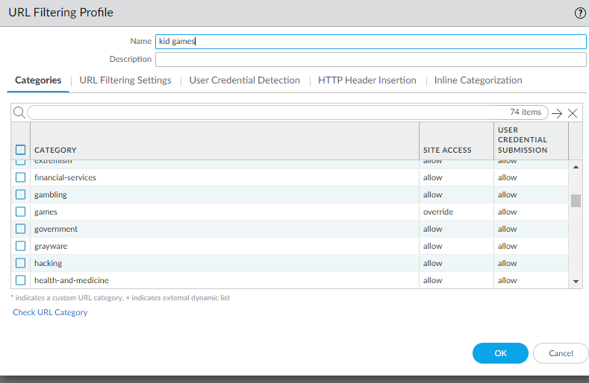

1. Go to Network -> interface management and click “add”

Configure the following:

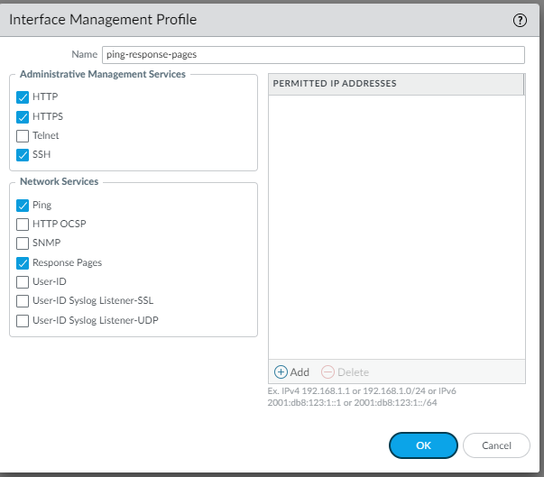

1. Go to Network -> Interfaces -> “ethernet 1/1” -> Advanced and configure the following

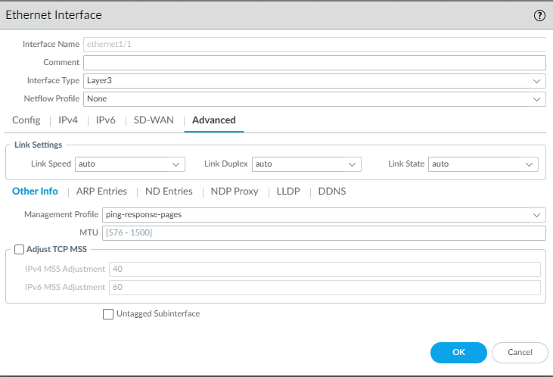

1. Go to Policies -> Security -> “Internet Outgoing” and go to “actions”

Configure the following:

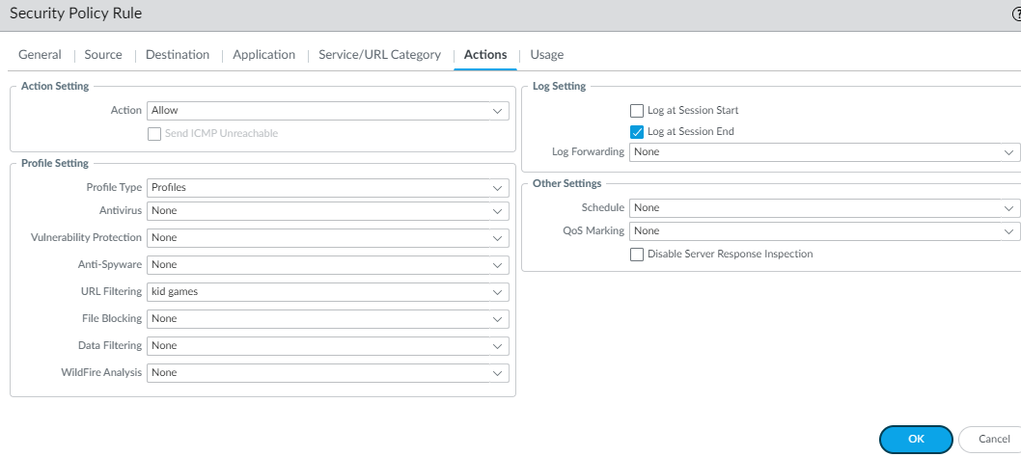

1. Go to Device -> Setup -> Content-ID and change the URL filtering to what is desired. We configured the following to have the block screen appear every 1 minute:

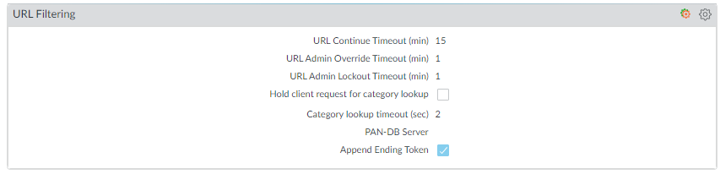

1. Go to Device -> Setup -> Content-ID and under URL Admin Override click “add”. Configure a password and configure the following:

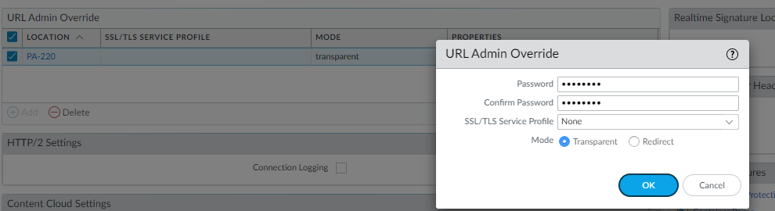

1. Commit Changes.

Problems

Originally, we tried to configure the URL filtering to “override” and “block”. This didn’t let the override screen appear and when an online game website was opened it took us directly to a page that said, “site can’t be reached”. This was fixed by changing the configuration to “override” and “allow”. We also originally configured a certificate that allowed the filtering to work some of the time for http website but wouldn’t function for https websites. This was fixed by removing the filter and having the firewall filter without a certificate.

Conclusion

URL filtering and the URL override feature were implemented on a PA-220 firewall in this lab to block online games. This was necessary to both show the capabilities of the firewall and prevent users from potentially dangerous websites. However, if the user were to intentionally want to access a website given that it was filtered, they would be given the option to enter a pre-shared password to gain access to the website.

**Implementing Site-to-Site VPN**

*Derek Liu*

Purpose

The purpose of this lab is to create a site-to-site VPN with a pre-shared key and verify the existence of the VPN using a packet sniffer and capture VPN packets being sent across the network.

Background Information

A site-to-site VPN is a type of connection that encrypts traffic to create secure communications between two different networks. Site-to-site VPNs are useful when connecting networks from different locations over the internet while preventing unauthorized access or interception of data traffic through encryption.

An important protocol suite that provides security for IP communications over untrusted networks is IPsec or internet protocol security. IPsec is used to encrypt, decrypt, and authenticate IP packets in a VPN. Two services in IPsec are the authentication header (AH) and the encapsulation security payload (ESP). The authentication header provides authentication for the packet while the encapsulation security payload encrypts the data so if the packet is intercepted, it cannot be read. In this lab, we will intercept ESP packets but will not attempt to decrypt them.

In terms of encryption and hashing in this lab, we used AES256 and SHA512. AES256 is a symmetric encryption algorithm that uses a 256-bit encryption key. This encryption method is widely used and considered one of the strongest encryption methods available today (2023). We used SHA512 as the cryptographic hash function that produces an output of 512 bits. It is a more secure version of SHA256 and is also widely used in security protocols.

Site-to-site VPNs work by establishing an IPsec tunnel between two separate networks usually using the internet as a medium of transporting data traffic. Traffic is encrypted in the first gateway and decrypted at the second. The gateways in this lab were the Palo Alto firewalls. The gateways authenticate by using a pre-shared key.

However, it is also important to keep in mind that regardless of strength all encryptions are still vulnerable to attacks given that the attacker has enough time and resources to crack the encryption. Additionally, advancements in technology and research in cryptography can render current encryption methods obsolete or vulnerable in the future.

VPNs can be used for more than just securing data traffic. Some notable examples include masking you public IP address and your location, access restricted content or services that are blocked in certain countries, reducing the cost of communication without the cost of dedicated infrastructure, and allowing for workers to securely access corporate network resources while being at home or travelling.

Lab Summary

This lab was completed using static routes on the interfaces. The lab was relatively straightforward with minimal problems. Connection across the network was verified with pings and the IPSec tunnel was verified as function by capturing ESP packets that were being transmitted between the two firewalls.

Network Diagrams with IP

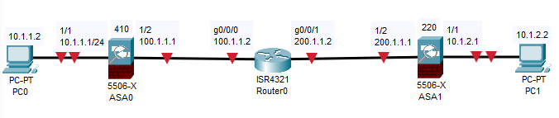

Configurations

Step 1: Reset firewalls. Set up a topology like what is shown in Network Diagrams with IP. We used Palo Alto firewalls in this lab rather than Cisco ASAs. We also included a layer 2 device between the Palo Alto 410 and the Router.

Step 2: Connect to the management interface of the 410 and manually set IP address of the end device to 192.168.1.2 255.255.255.0 and access <https://192.168.1.1>

Step 3: log in with user: admin and password: admin. Create a more secure password and disable ZTP.

Step 4: Configure the following.

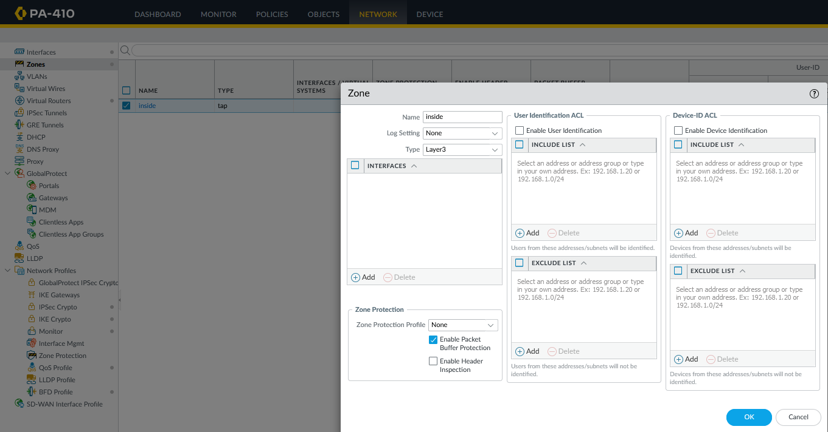

Step 5: Create another zone

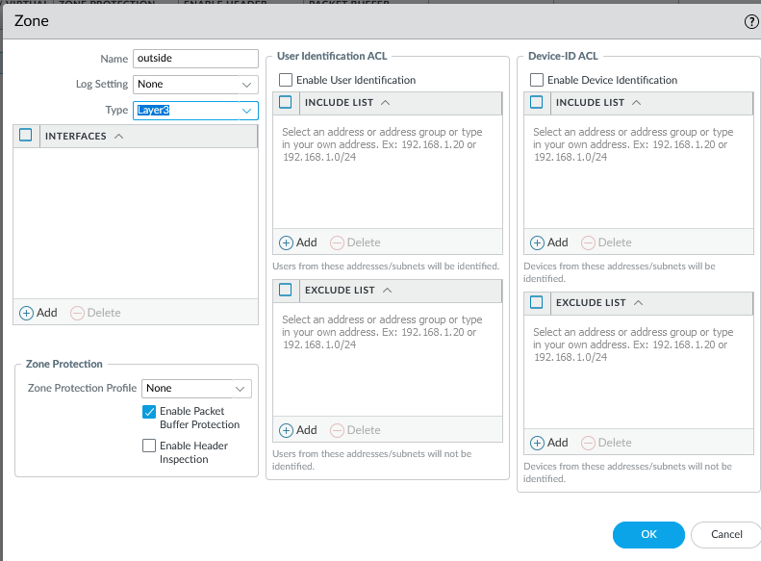

Step 6: Create another zone.

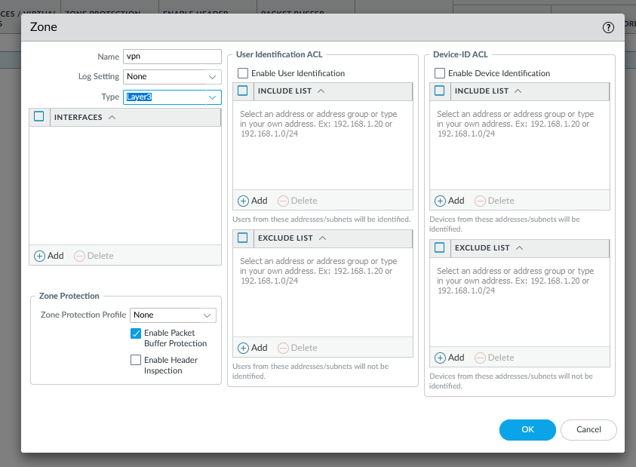

Step 7: Delete the virtual wires. Go to Policies and delete any preconfigured ZTP rules

Step 8: Configure the following

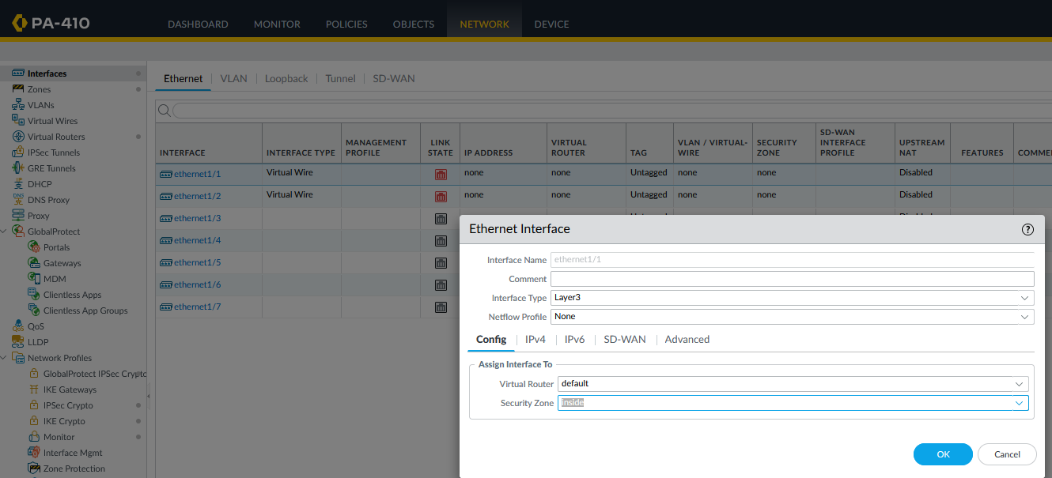

Step 9: Configure the following in the IPv4 tab

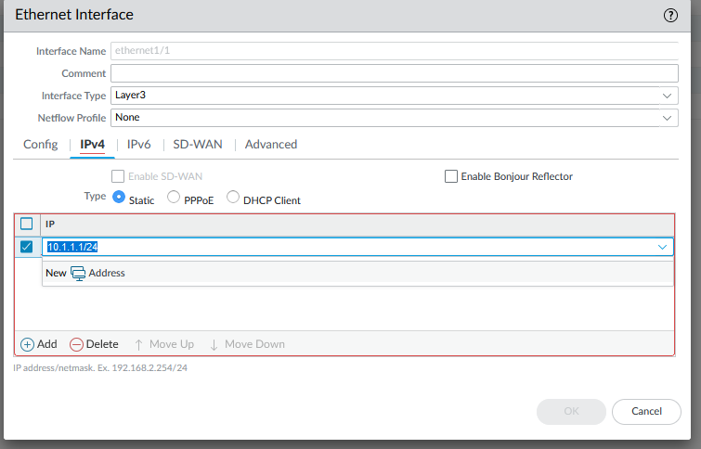

Step 10: configure the other interface

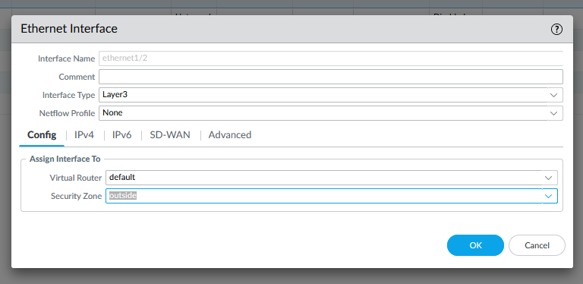

Step 11: Configure the following in the IPv4 tab

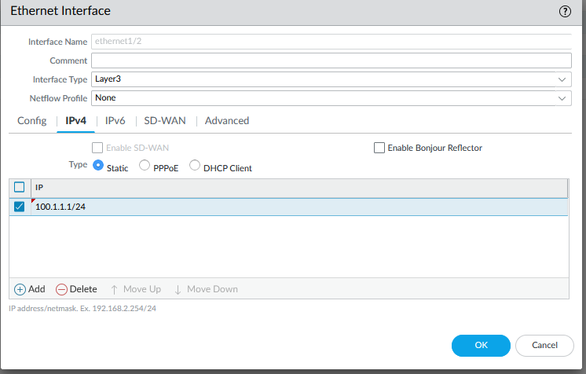

Step 12: create a new tunnel

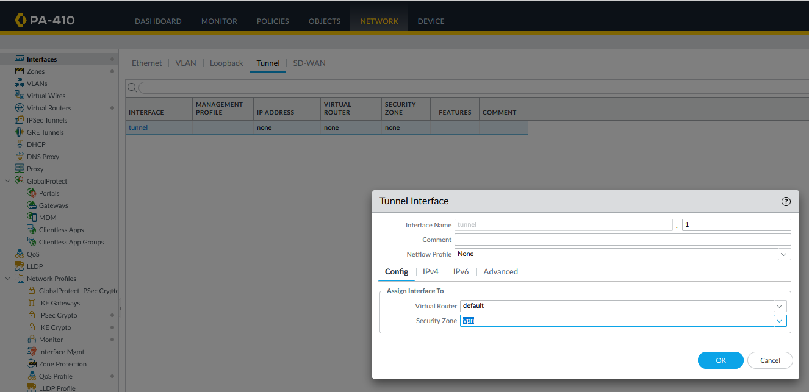

Step 13: set an IPv4 address on the tunnel (not required for site-to-site).

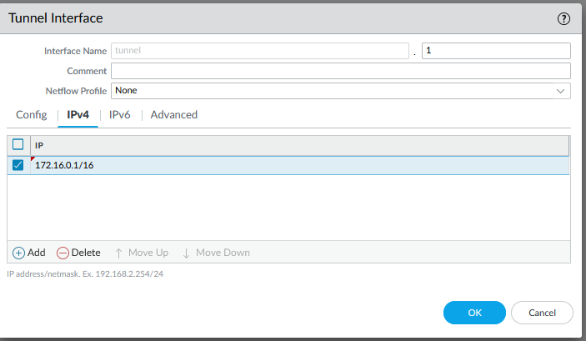

Step 14: create a default route

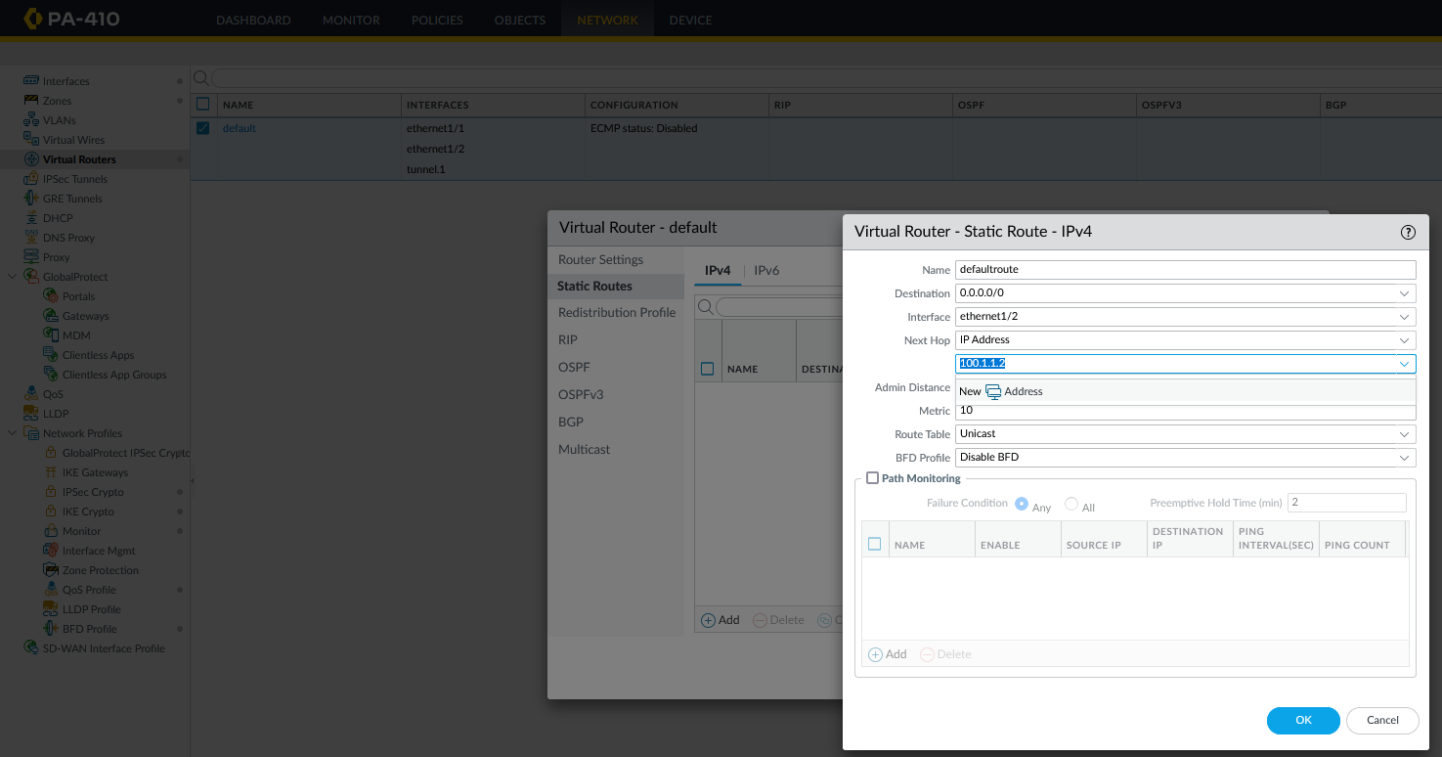

Step 15: create a route to the network on the other side of the tunnel

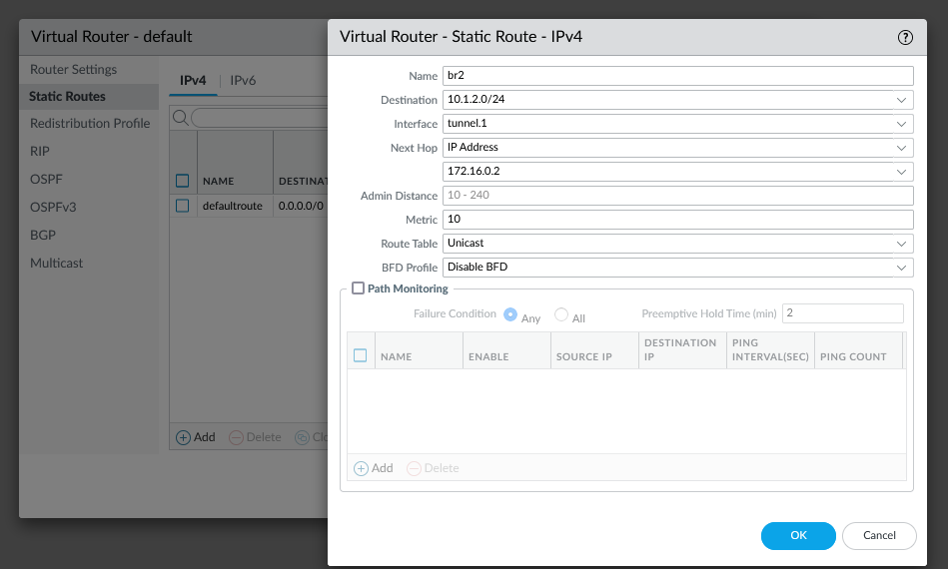

Step 16: Commit changes. While it is committing changes, console into the PA210

Step 17: create a new zone

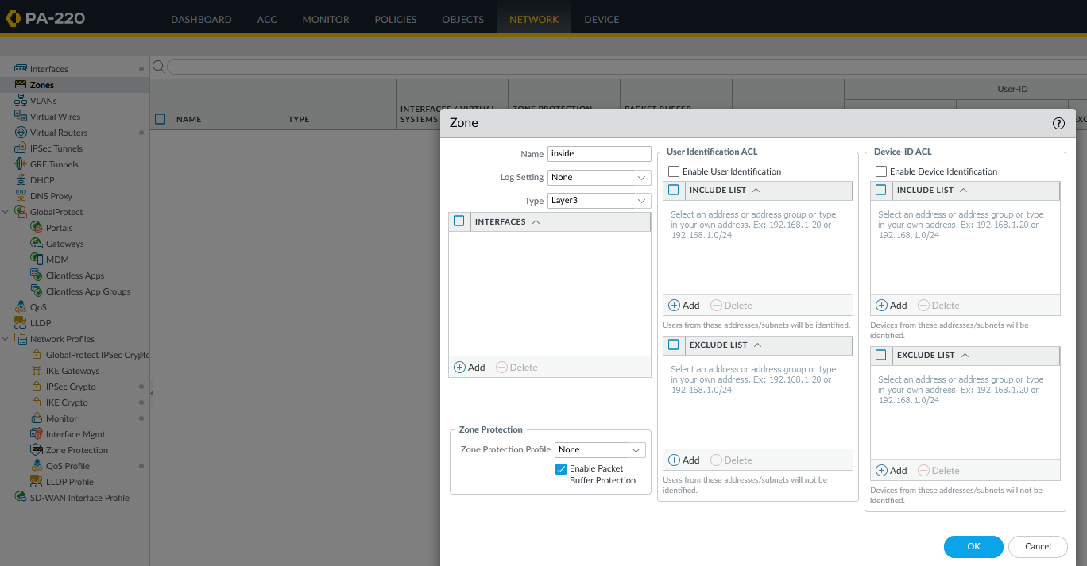

Step 18: create another new zone

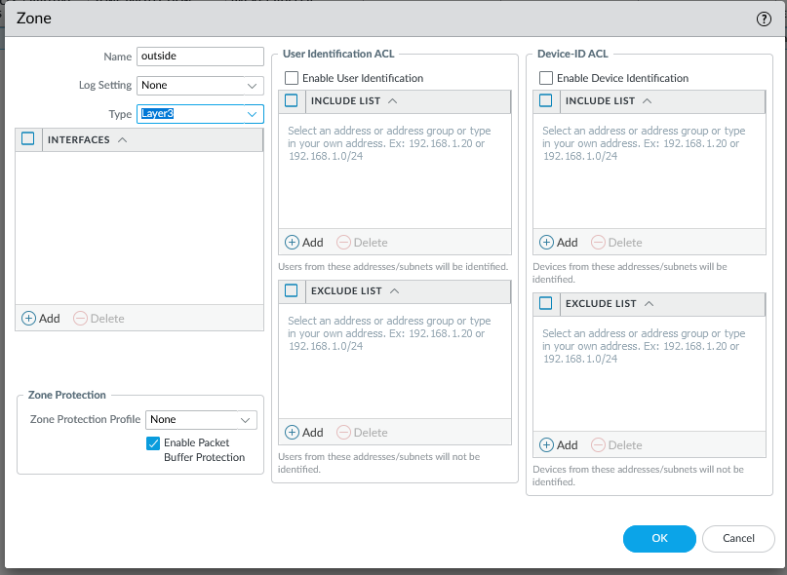

Step 19: create another new zone

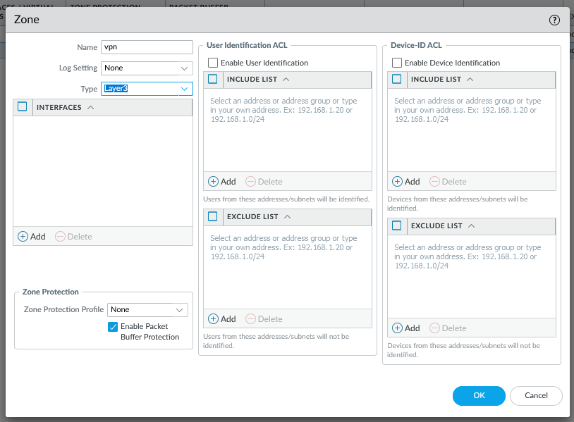

Step 20: configure the interface

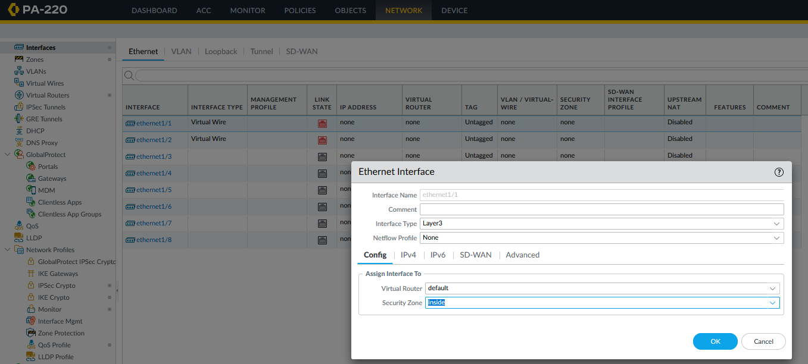

Step 21: give the interface an IP address

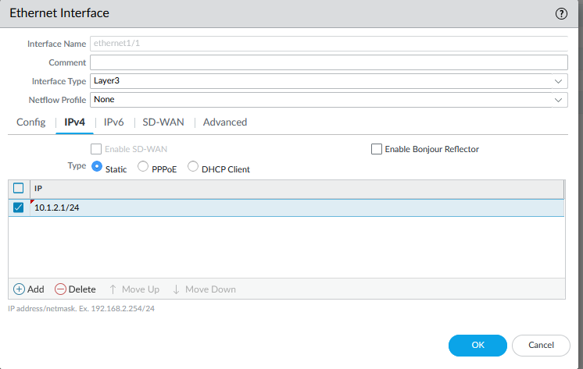

Step 22: configure the other interface

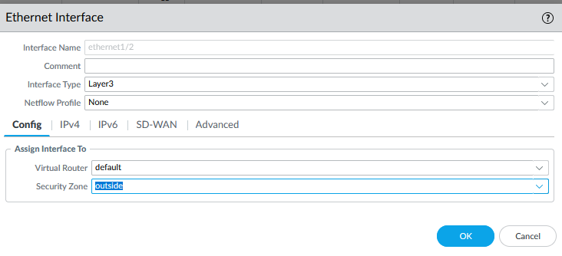

Step 23: give the interface an IP address

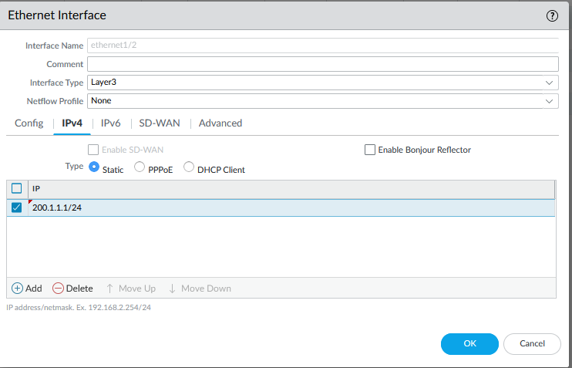

Step 24: create a new tunnel

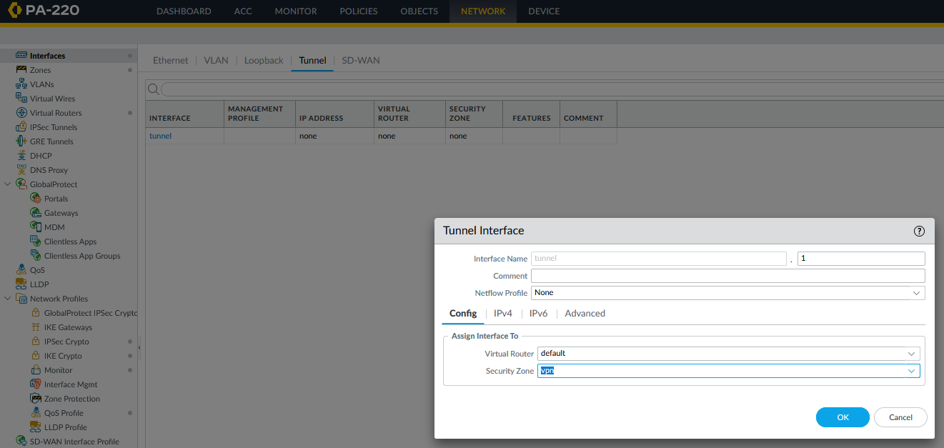

Step 25: give the tunnel an IP address (once again, note required for site-to-site)

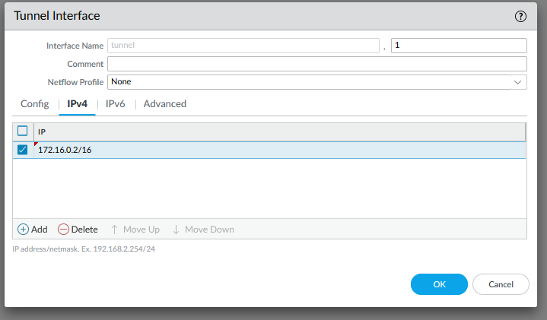

Step 26: create a default route

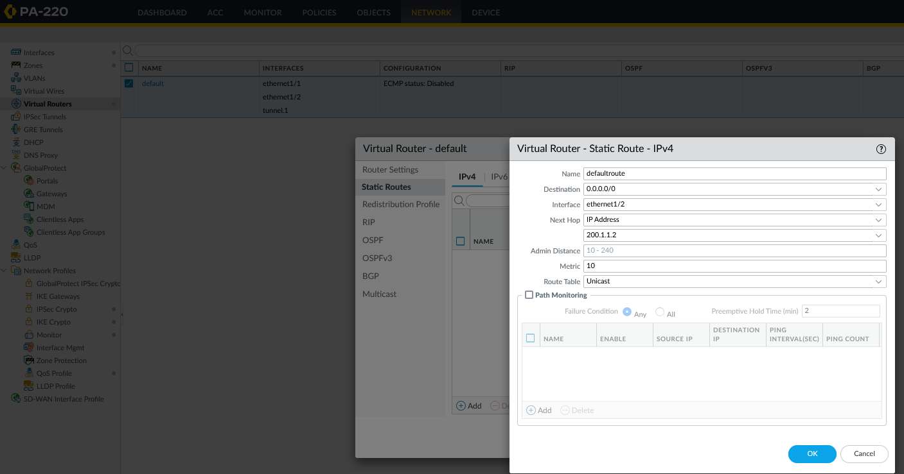

Step 27: create a route to the network on the other side of the VPN 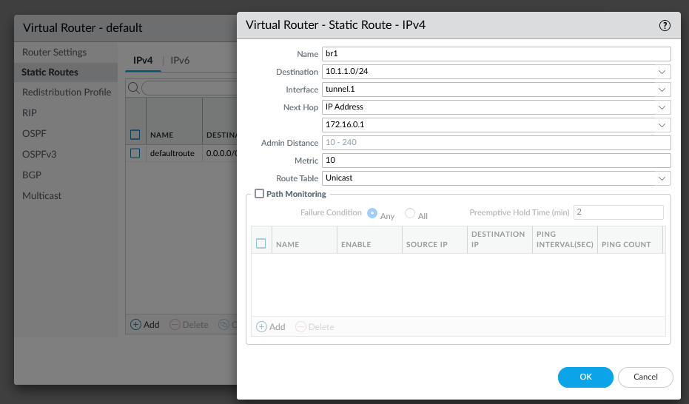

Step 28: commit changes. While committing, console back into 410. Ensure that the previous configurations successfully committed.

Step 29: create a security policy rule

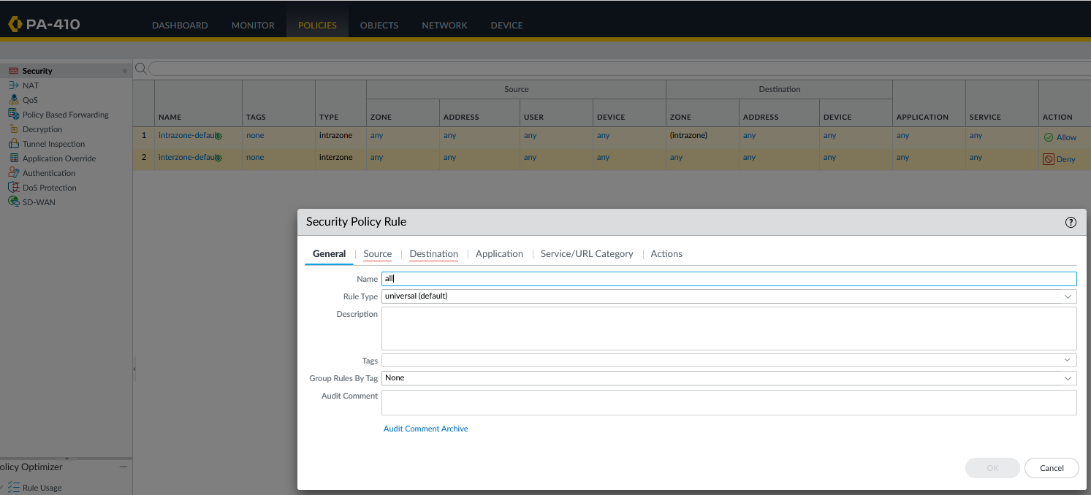

Step 30: set source zones

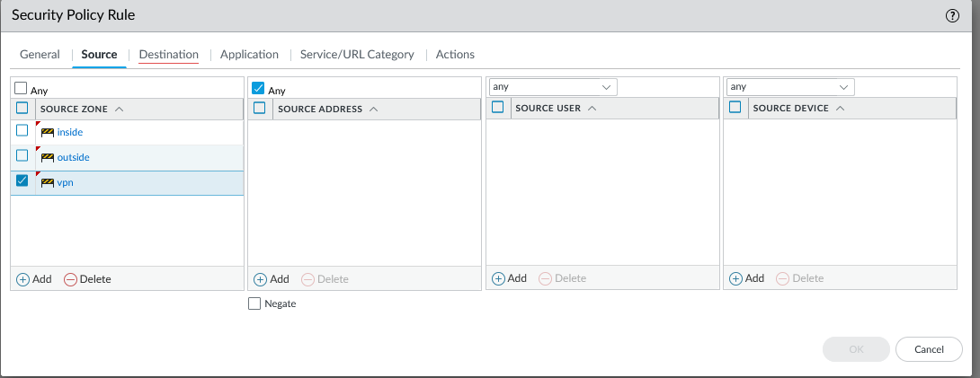

Step 31: set destination zones

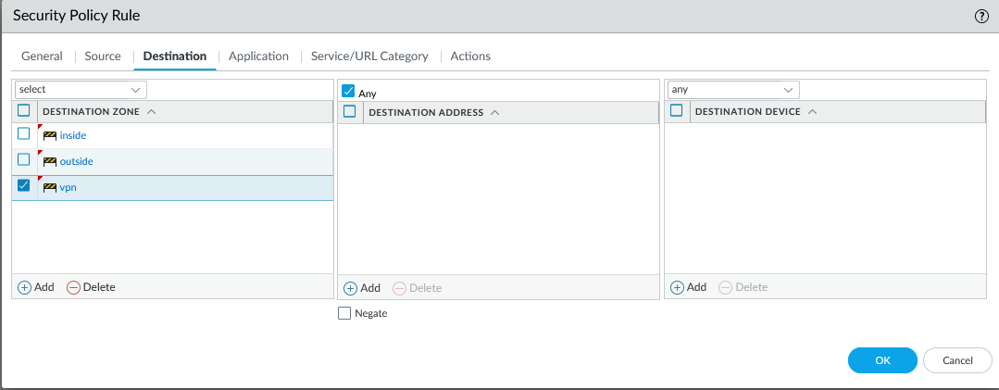

Step 32: Commit changes and console back into the 220 and ensure that changes have successfully committed.

Step 33: create new security policy rule

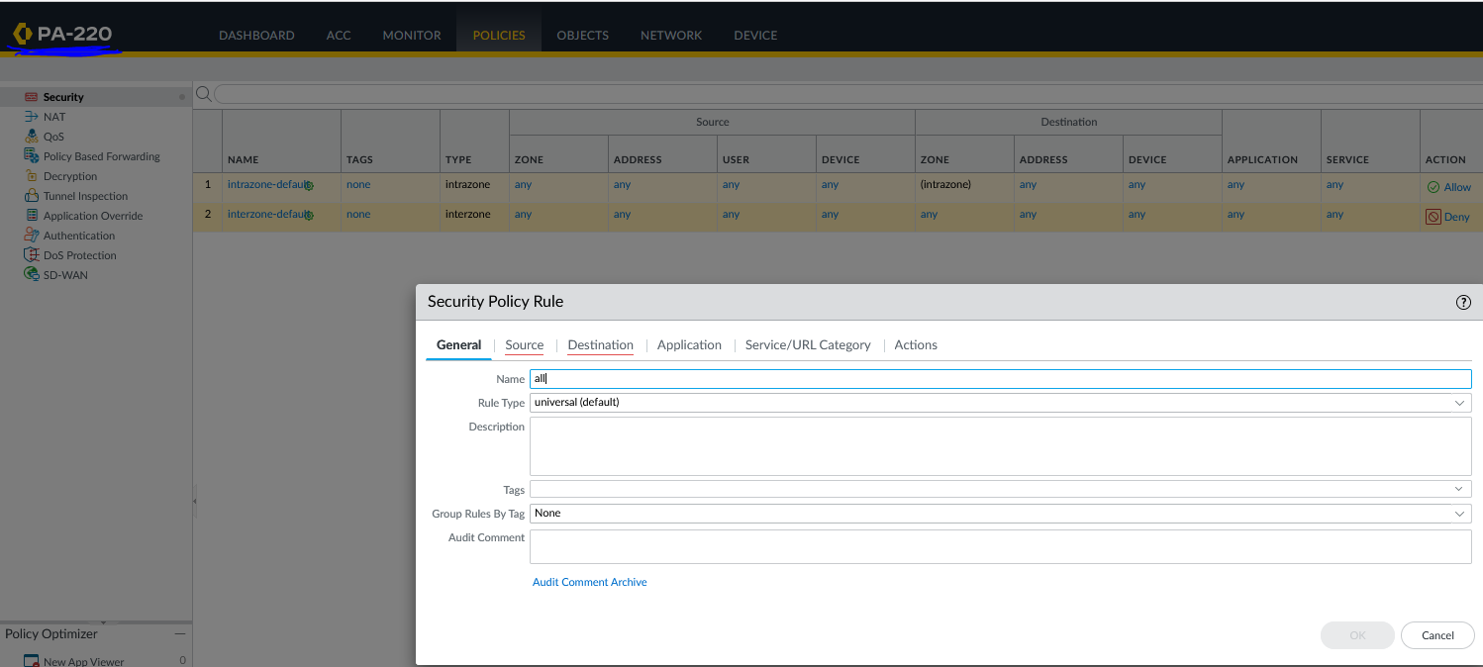

Step 34: set source zones

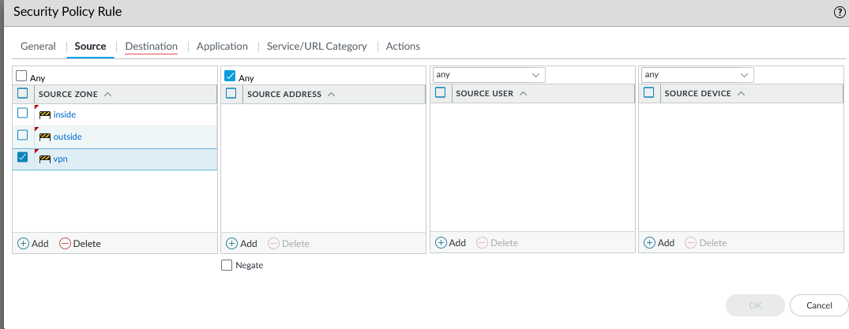

Step 35: set destination zones

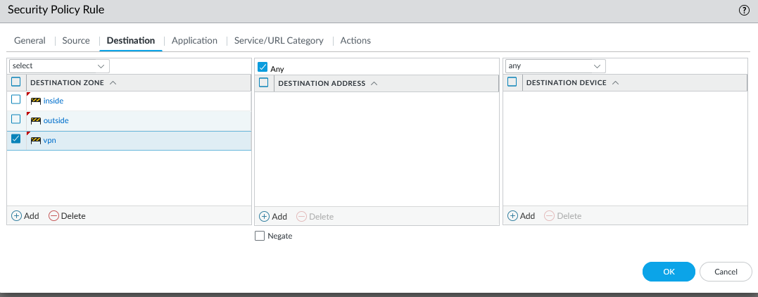

Step 36: commit changes and console back into the 410. Ensure that the commit was completed successfully.

Step 37: Create an IKE crypto profile. Make sure an adequate encryption and authentication are used. 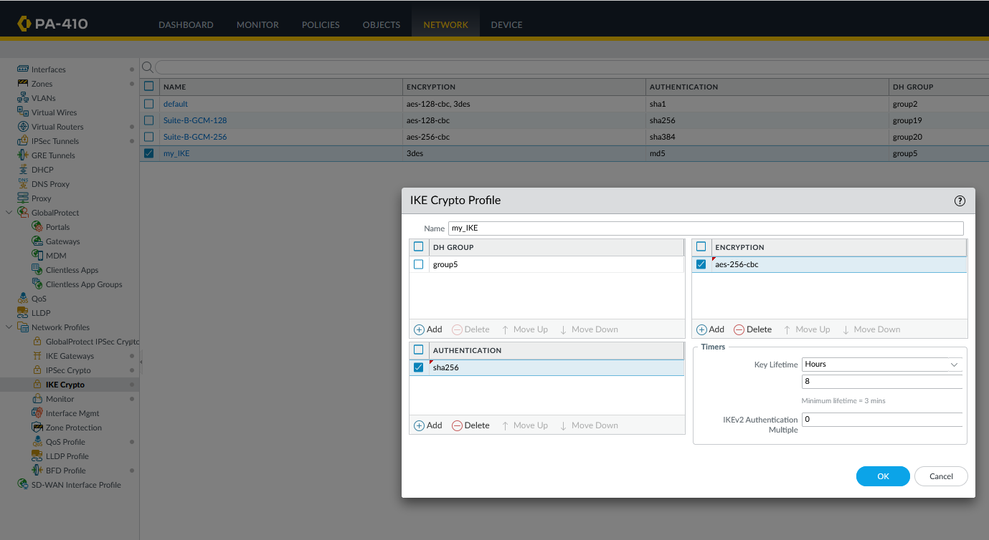

Step 38: Create and IPSec crypto profile. Make sure adequate encryption and authentication are used.

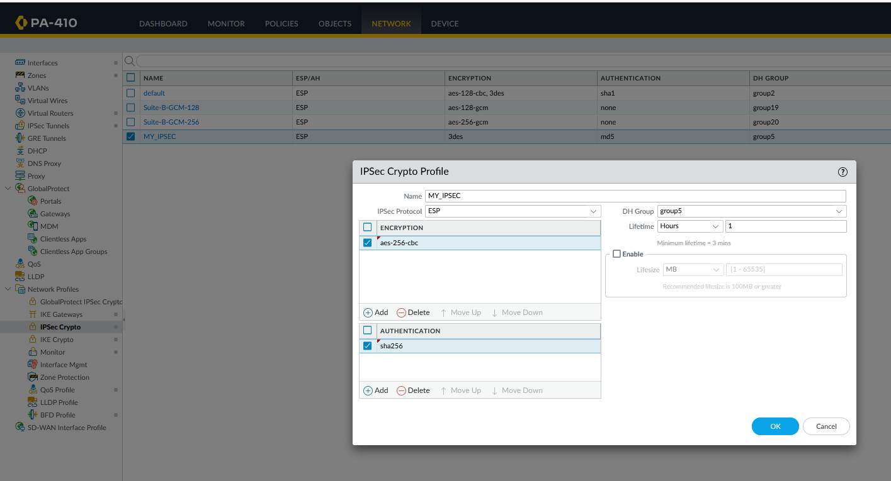

Step 39: Create an IKE gateway and set your pre-shared key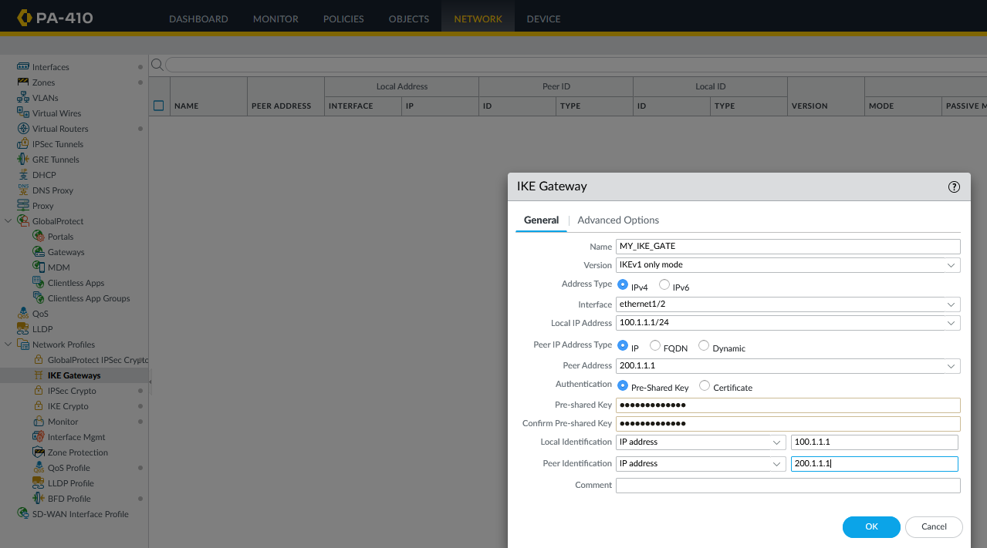

Step 40: configure the following

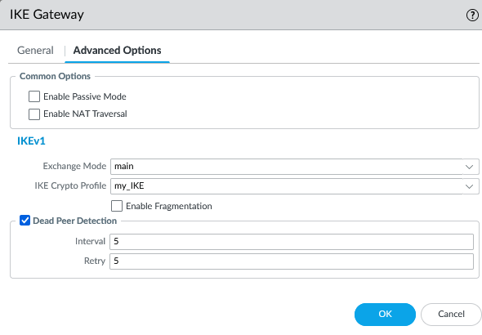

Step 41: Create the IPsec tunnel

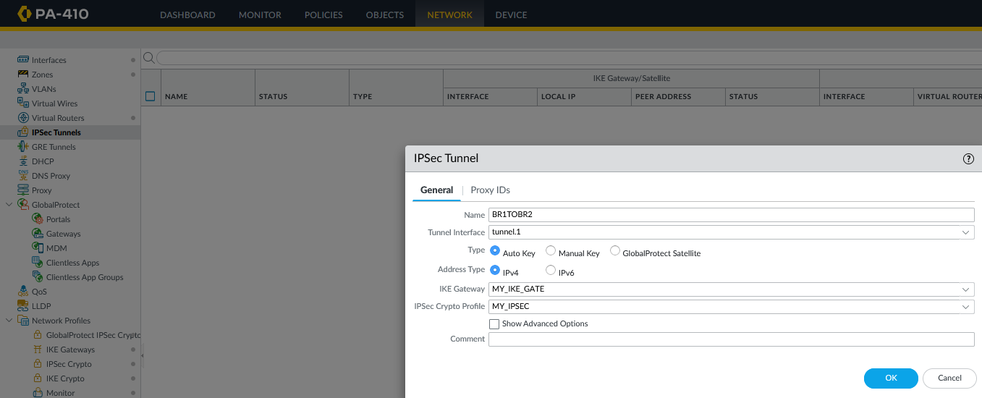

Step 42: commit changes and console into 220 and ensure the previous commit was successful

Step 43: Create an IKE crypto profile. Ensure that adequate authentication and encryption methods are used.

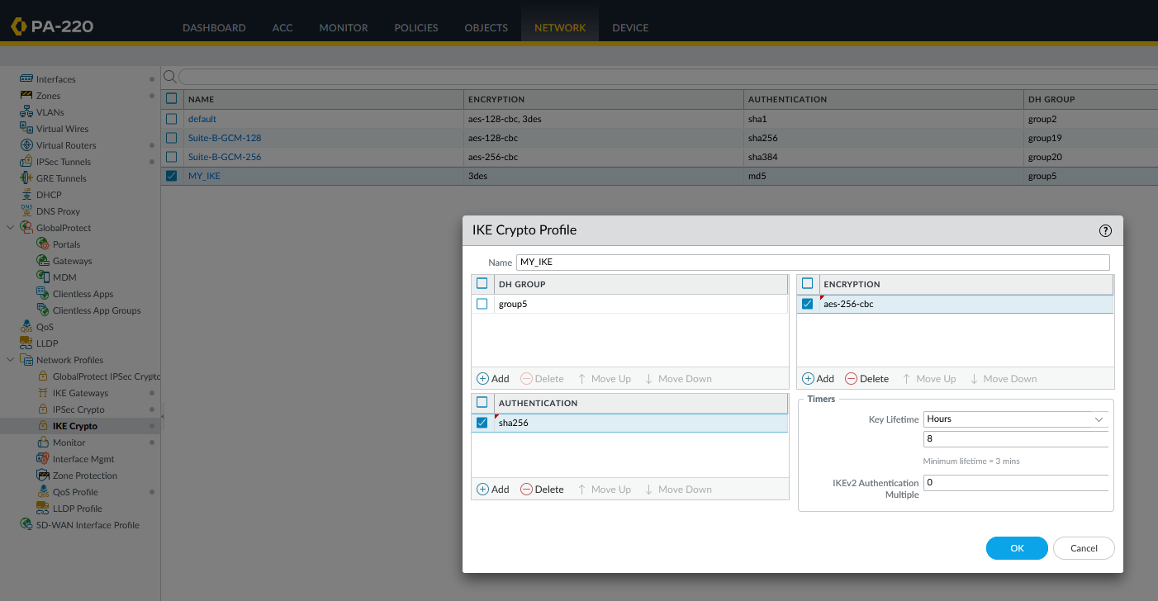

Step 44: Create an IPSec crypto profile. Ensure that adequate encryption and authentication methods are used.

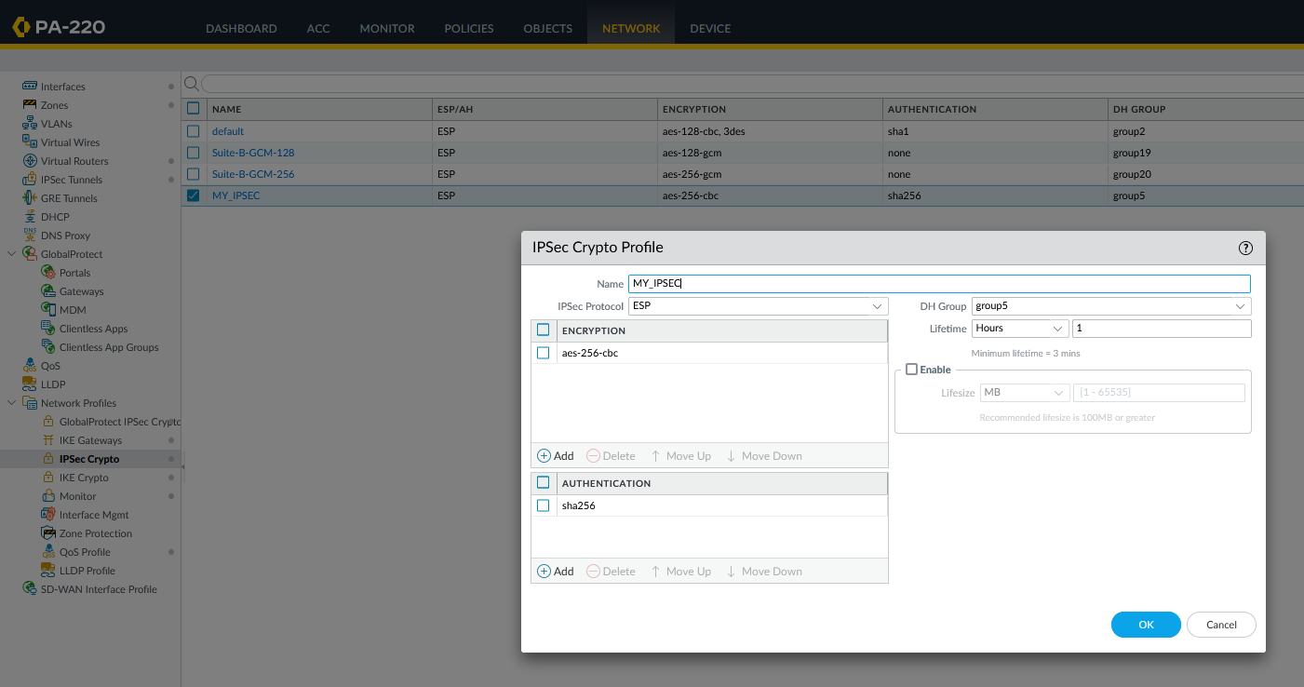

Step 45: Create an IKE gateway. Set pre-shared key.

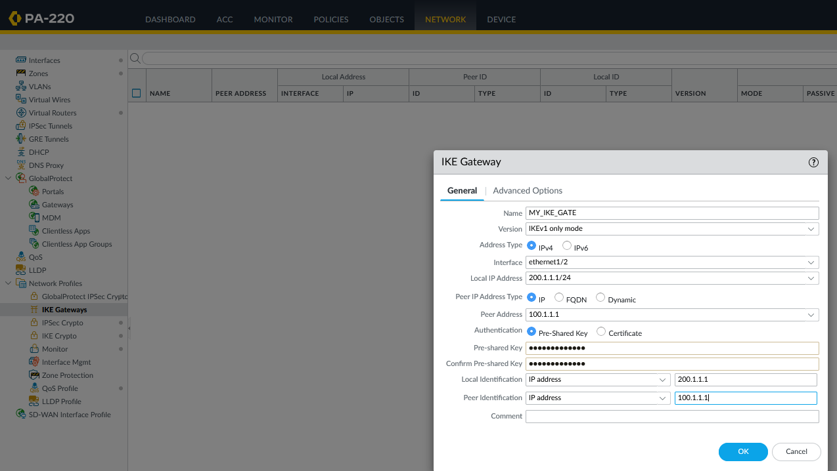

Step 46: Configure the following

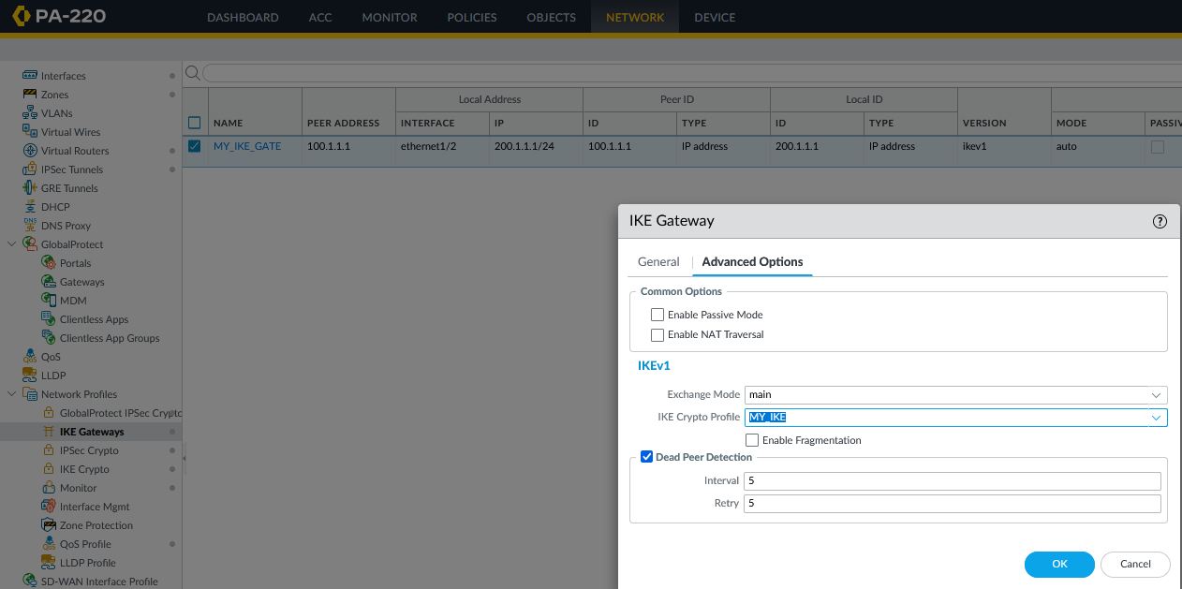

Step 47: Create the IPSec tunnel

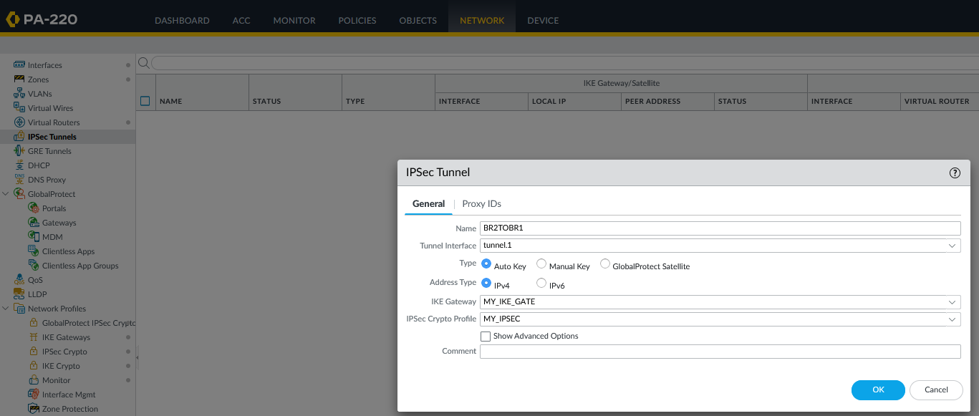

Step 48: Console into the router and configure the following (set IP address on interfaces and activate them).

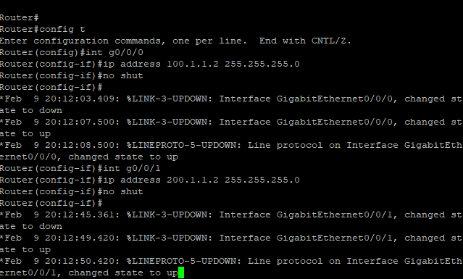

Step 49: Console into the switch. Connect f1/0/1 to the firewall and f1/0/2 to the router. Connect f1/0/3 to a pack sniffer (PC running Wireshark).

Step 50: Configure the following



Access the management interface of either firewall or ensure that IPSec tunnel status is green. Sometimes some tunnels take a moment to activate. If it remains inactive, try using the “enable” button on the bottom left. If that doesn’t work, console the firewall and issue these commands and ensure that these are the outputs:

admin@PA-410> test vpn ike-sa

Start time: Feb.09 13:08:23

Initiate 1 IKE SA.

admin@PA-410> test vpn ipsec-sa

Start time: Feb.09 13:08:30

Initiate 1 IPSec SA.

These should appear the monitor after the two previous commands are issued:

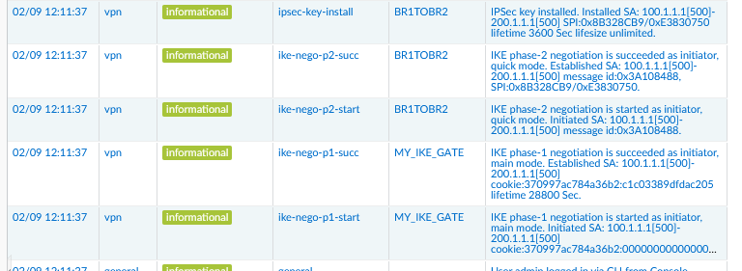

To ensure functionality of the site-to-site VPN, disable the windows defender firewall on both end devices and create a rule to allow for pings. Ping from one end device to another. These should be the outputs:

C:\Users\user>ping 10.1.2.2

Pinging 10.1.2.2 with 32 bytes of data:

Reply from 10.1.2.2: bytes=32 time=2ms TTL=126

Reply from 10.1.2.2: bytes=32 time=2ms TTL=126

Reply from 10.1.2.2: bytes=32 time=2ms TTL=126

Reply from 10.1.2.2: bytes=32 time=2ms TTL=126

Ping statistics for 10.1.2.2:

Packets: Sent = 4, Received = 4, Lost = 0 (0% loss),

Approximate round trip times in milli-seconds:

Minimum = 2ms, Maximum = 2ms, Average = 2ms

C:\Users\user>ping 10.1.1.2

Pinging 10.1.1.2 with 32 bytes of data:

Reply from 10.1.1.2: bytes=32 time=2ms TTL=126

Reply from 10.1.1.2: bytes=32 time=2ms TTL=126

Reply from 10.1.1.2: bytes=32 time=2ms TTL=126

Reply from 10.1.1.2: bytes=32 time=2ms TTL=126

Ping statistics for 10.1.1.2:

Packets: Sent = 4, Received = 4, Lost = 0 (0% loss),

Approximate round trip times in milli-seconds:

Minimum = 2ms, Maximum = 2ms, Average = 2ms

The packet sniffer capturing traffic on the layer 2 device should also capture traffic. If using Wireshark and filter for ESP traffic.

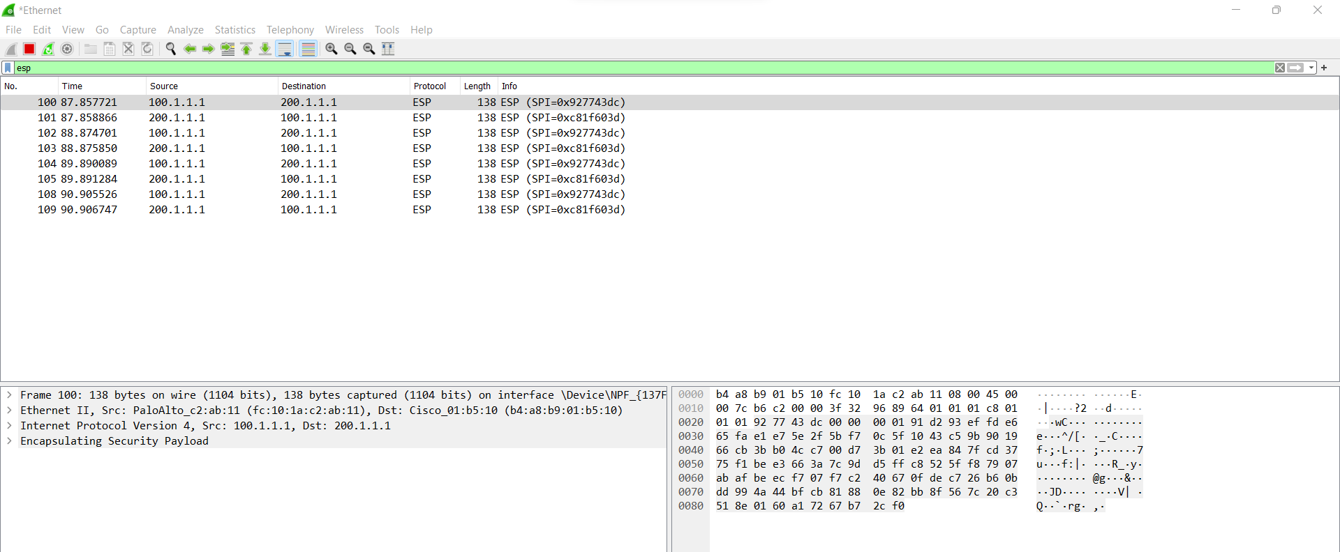

Problems

While time consuming, there were relatively few problems with this lab. The main challenge was figuring out what topology should be used and what IP address should be used as the next hop. The tunnel initially refused to activate but after some time, it activated by itself. Capturing ESP packets required more than just connecting the device to the switch but also “monitor session” command.

Conclusion

The site-to-site VPN is widely used and especially useful when used to protect data traffic from attackers. In this lab, we set up a site-to-site VPN on a private network with very few problems. Most of our time was spent reimaging our PFSense firewall into a windows OS so we could capture ESP packets being transmitted across the network. In the future, we plan on exploring site-to-site VPNs with certificate verifications and remote access VPNs.

**Implementing Site-to-Site VPN**

*Derek Liu*

Purpose

The purpose of this lab is to create a site-to-site VPN with a self-signed certificate and verify the existence of the VPN using a packet sniffer and capture VPN packets being sent across the network.

Background Information

The main difference between this lab and the previous lab is the fact that we used a self-signed certificate instead of a pre-shared key. Originally, we set up the topology by connecting the two firewalls to a router and attaching end devices to the firewalls. In this lab, that was kept the topology constant. In the PA410 we had to disable ZTP and delete the virtual wire for the thing to work.

Pre shared keys are two different ways of authenticating a connection. A Pre-shared key is a symmetric encryption key that is shared. In this case, the key was shared in both firewalls meaning that we made sure the key was the same in both cases. In order for the two parties to communicate, they must be configured with the same keys.

This key can be manually created or generated using a key exchange protocol such as Diffie-Hellman. Drawbacks of having a pre-shared key include being susceptible to attacks such as dictionary or brute force attacks.

Self-signed certificates I signed with a private key. These certificates should be used for the purpose of testing an internal network or when a trusted third-party certificate is not available. Self-signed certificates are vulnerable to man-in-the middle attacks since the authenticity of the certificate cannot be verified by a third party. The most secure way of establishing a secure connection with IPsec is to use a certificate that is not self-signed and can be authenticated by a trusted third party. However, self-signed certificates can be more convenient and easier to create.

Examples of trusted third parties in real life include escrows, agents, notaries, and banks. For example, an escrow agent may be used to hold funds until the transaction is complete. Similarly, the trusted third party in establishing a secure IPsec connection will authenticate the connection and provide a secure environment for both sides since they are neutral.

Lab Summary

This lab was completed using static routes on the interfaces. The lab was relatively straightforward with minimal problems. Connection across the network was verified with pings and the IPSec tunnel was verified as function by capturing ESP packets that were being transmitted between the two firewalls.

Network Diagrams with IP



Configurations

Step 1: Reset firewalls. Set up a topology like what is shown in Network Diagrams with IP. We used Palo Alto firewalls in this lab rather than Cisco ASAs. We also included a layer 2 device between the Palo Alto 410 and the Router.

Step 2: Connect to the management interface of the 410 and manually set IP address of the end device to 192.168.1.2 255.255.255.0 and access <https://192.168.1.1>

Step 3: log in with user: admin and password: admin. Create a more secure password and disable ZTP.

Step 4: Configure the following



Step 5: Create another zone



Step 6: Create another zone



Step 7: Delete the virtual wires. Go to Policies and delete any preconfigured ZTP rules

Step 8: Configure the following



Step 9: Configure the following in the IPv4 tab



Step 10: configure the other interface



Step 11: Configure the following in the IPv4 tab



Step 12: create a new tunnel



Step 13: set an IPv4 address on the tunnel (not required for site-to-site).



Step 14: create a default route



Step 15: create a route to the network on the other side of the tunnel



Step 16: Commit changes. While it is committing changes, console into the PA210

Step 17: create a new zone



Step 18: create another new zone



Step 19: create another new zone



Step 20: configure the interface



Step 21: give the interface an IP address



Step 22: configure the other interface



Step 23: give the interface an IP address



Step 24: create a new tunnel



Step 25: give the tunnel an IP address (once again, note required for site-to-site)



Step 26: create a default route



Step 27: create a route to the network on the other side of the VPN 

Step 28: commit changes. While committing, console back into 410. Ensure that the previous configurations successfully committed.

Step 29: create a security policy rule



Step 30: set source zones



Step 31: set destination zones



Step 32: Commit changes and console back into the 220 and ensure that changes have successfully committed.

Step 33: create new security policy rule



Step 34: set source zones



Step 35: set destination zones



Step 36: commit changes and console back into the 410. Ensure that the commit was completed successfully.

Step 37: Create an IKE crypto profile. Make sure an adequate encryption and authentication are used. 

Step 38: Create and IPSec crypto profile. Make sure an adequate encryption and authentication are used.



Step 39: Generate a root certificate

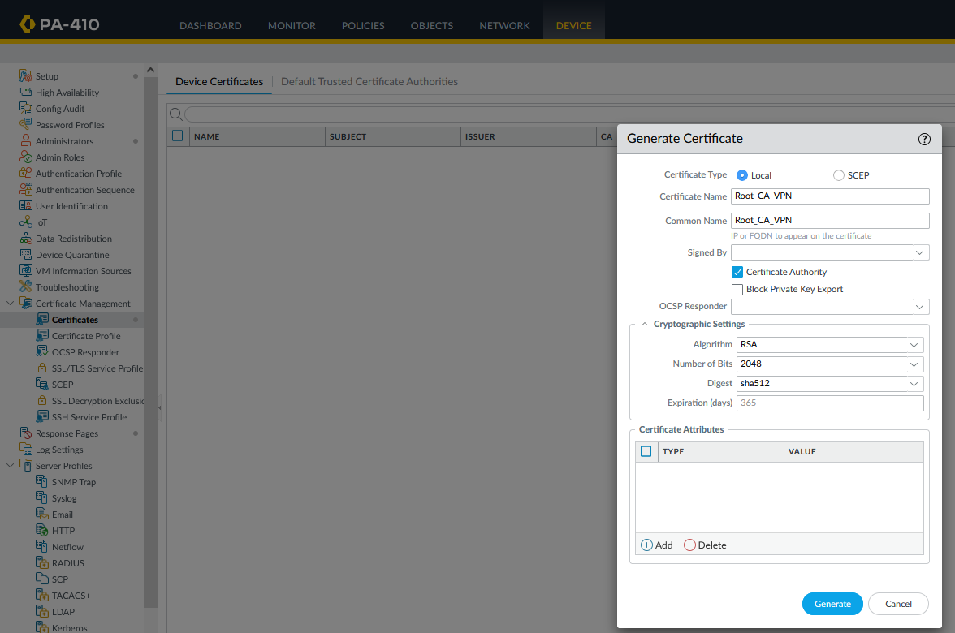

Step 40: Export certificate

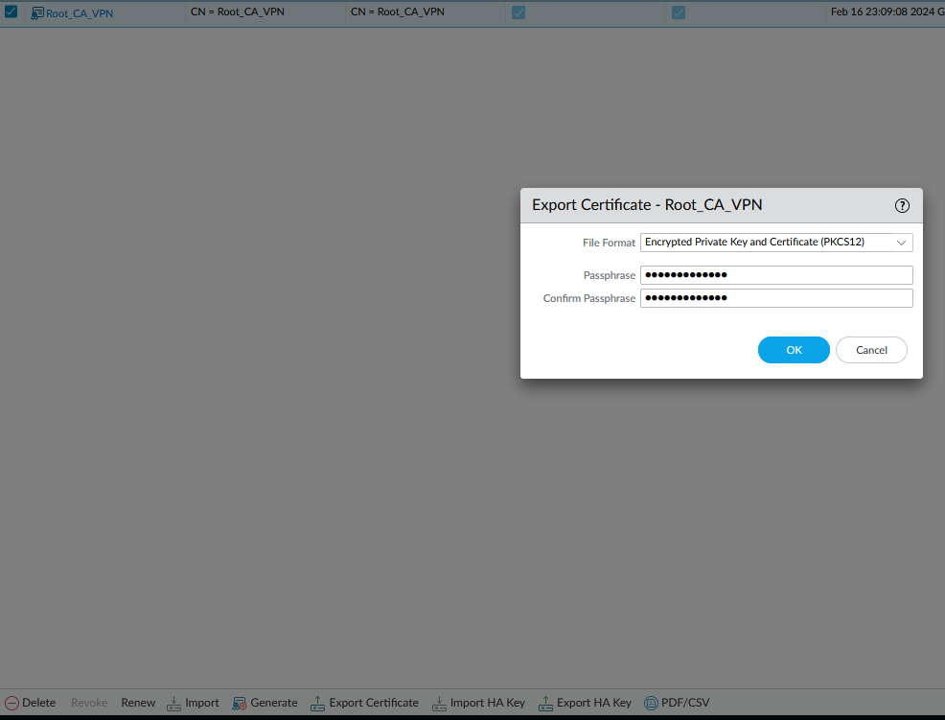

Step 41: Import root certificate

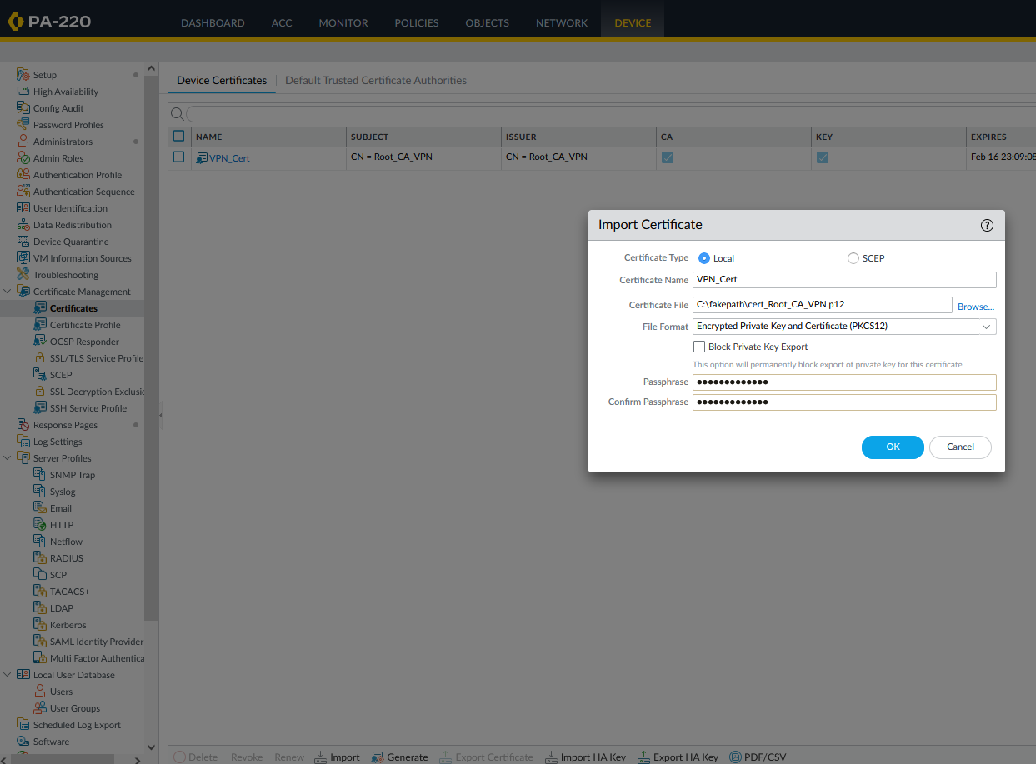

Step 42: generate certificate

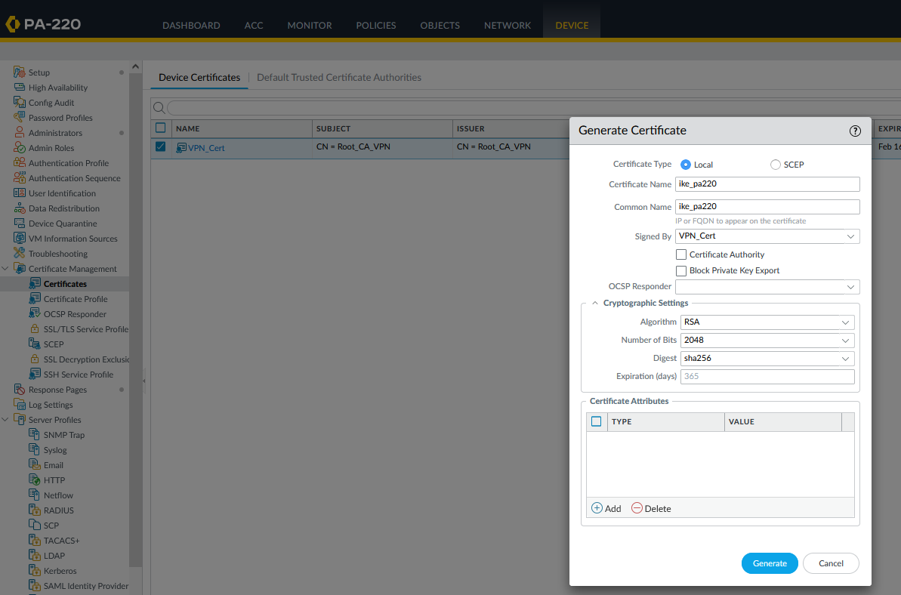

Step 43: generate certificate on other firewall

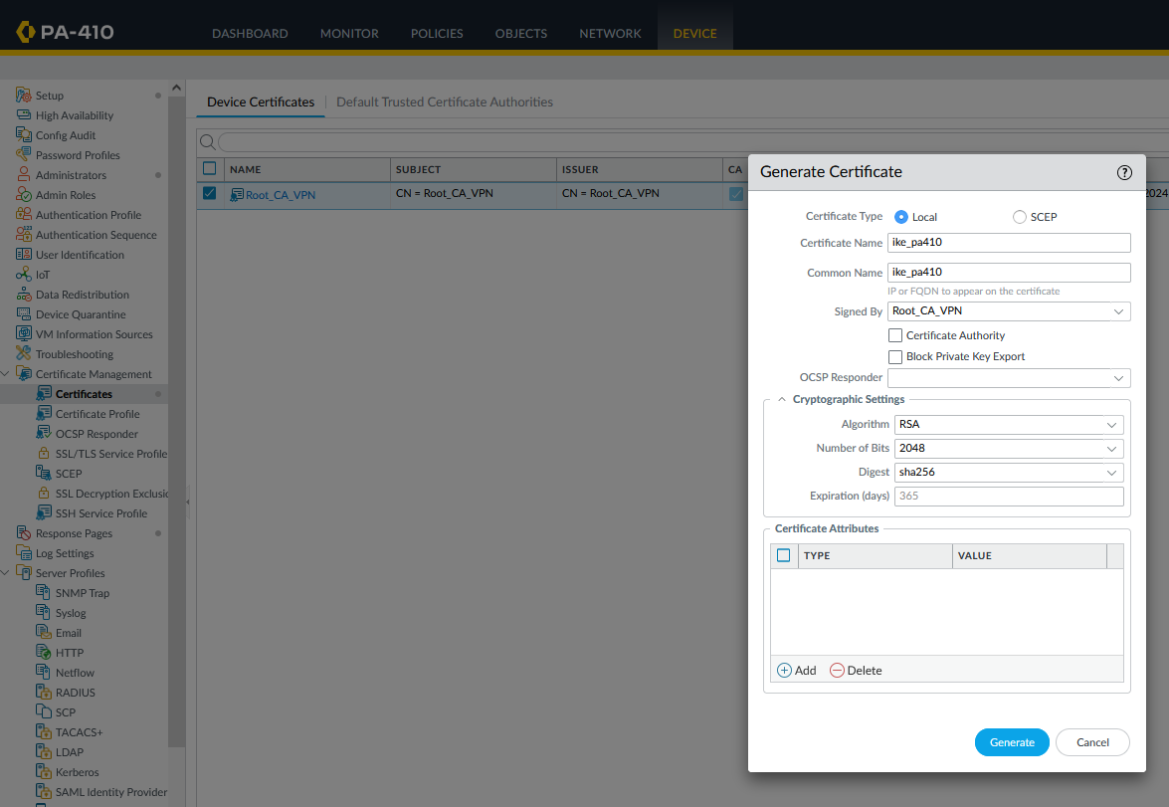

Step 44: create certificate profile

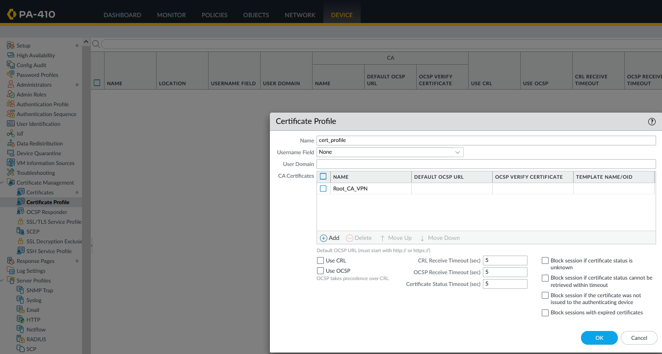

Step 45: create certificate profile on the other firewall

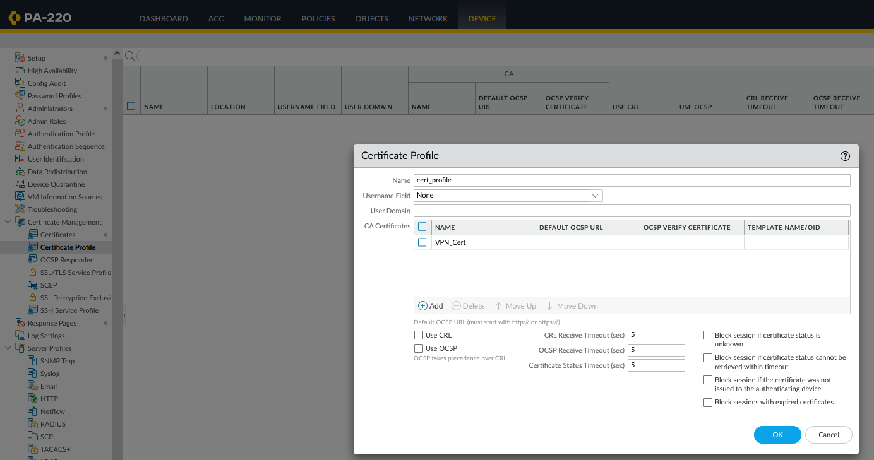

Step 47: Create an IKE gateway using the certificate that was generated

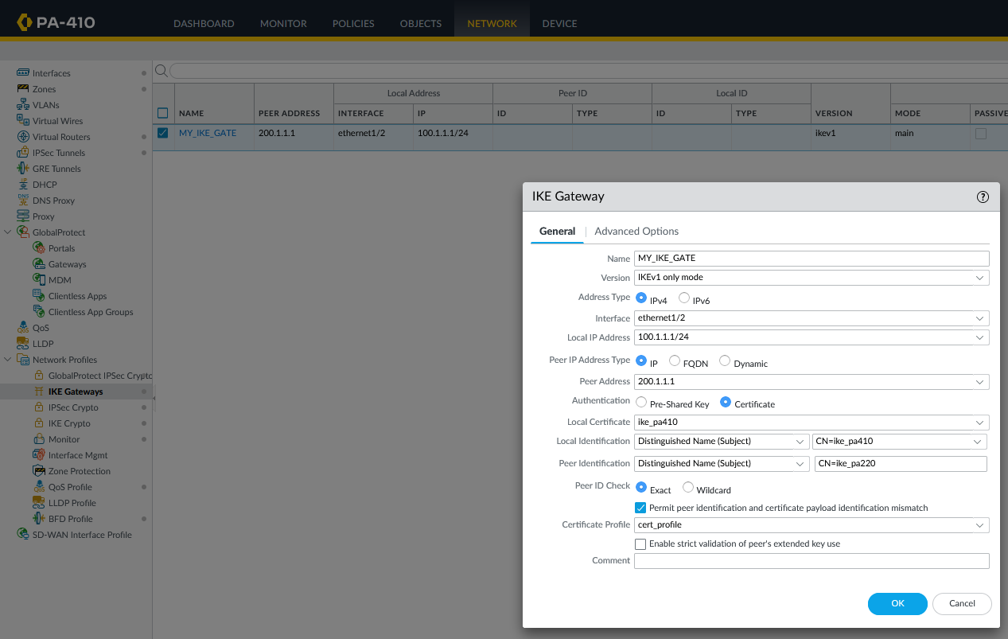

Step 48: configure the following



Step 49: Create the IPsec tunnel



Step 50: commit changes and console into 220 and ensure the previous commit was successful

Step 51: Create an IKE crypto profile. Ensure that adequate authentication and encryption methods are used.



Step 52: Create an IPSec crypto profile. Ensure that adequate encryption and authentication methods are used.



Step 53: Create an IKE gateway. Use previously created certificate as authenticate method.

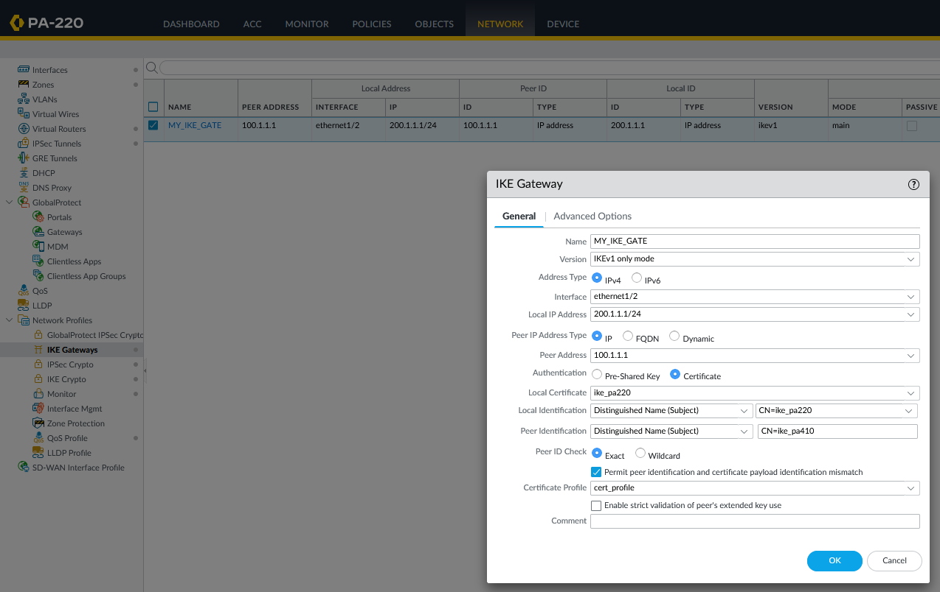

Step 54: Configure the following



Step 55: Create the IPSec tunnel



Step 56: Console into the router and configure the following (set IP address on interfaces and activate them).



Step 57: Console into the switch. Connect f1/0/1 to the firewall and f1/0/2 to the router. Connect f1/0/3 to a pack sniffer (PC running Wireshark).

Step 58: Configure the following



Access the management interface of either firewall and ensure that IPSec tunnel status is green. Sometimes some tunnel takes a moment to activate. If it remains inactive, try using the “enable” button on the bottom left. If that doesn’t work, console the firewall and issue these commands and ensure that these are the outputs:

admin@PA-410> test vpn ike-sa

Start time: Feb.09 13:08:23

Initiate 1 IKE SA.

admin@PA-410> test vpn ipsec-sa

Start time: Feb.09 13:08:30

Initiate 1 IPSec SA.

These should appear the monitor after the two previous commands are issued:



To ensure functionality of the site-to-site VPN, disable the windows defender firewall on both end devices or create a rule to allow for pings. Ping from one end device to another. These should be the outputs:

C:\Users\user>ping 10.1.2.2

Pinging 10.1.2.2 with 32 bytes of data:

Reply from 10.1.2.2: bytes=32 time=2ms TTL=126

Reply from 10.1.2.2: bytes=32 time=2ms TTL=126

Reply from 10.1.2.2: bytes=32 time=2ms TTL=126

Reply from 10.1.2.2: bytes=32 time=2ms TTL=126

Ping statistics for 10.1.2.2:

Packets: Sent = 4, Received = 4, Lost = 0 (0% loss),

Approximate round trip times in milli-seconds:

Minimum = 2ms, Maximum = 2ms, Average = 2ms

C:\Users\user>ping 10.1.1.2

Pinging 10.1.1.2 with 32 bytes of data:

Reply from 10.1.1.2: bytes=32 time=2ms TTL=126

Reply from 10.1.1.2: bytes=32 time=2ms TTL=126

Reply from 10.1.1.2: bytes=32 time=2ms TTL=126

Reply from 10.1.1.2: bytes=32 time=2ms TTL=126

Ping statistics for 10.1.1.2:

Packets: Sent = 4, Received = 4, Lost = 0 (0% loss),

Approximate round trip times in milli-seconds:

Minimum = 2ms, Maximum = 2ms, Average = 2ms

The packet sniffer capturing traffic on the layer 2 device should also capture traffic. If using Wireshark and filter for ESP traffic.



Problems

No problems. Lab took me 10 minutes.

Conclusion

The site-to-site VPN is widely used and especially useful when used to protect data traffic from attackers. In this lab, we set up a site-to-site VPN on a private network with very few problems. In the future, we plan on exploring remote access VPNs.

**Setting Up a Remote Access VPN***Derek Liu*

Purpose

The purpose of this lab is to set up a remote access VPN with a Palo Alto firewall. This lab was done by using self-signed certificates as a method of authentication.

Background Information

A remote access VPN is a type of network that allows a user to securely connect to a network, such as a corporate network from a remote location using the internet as a medium of transport.

A VPN or virtual private network creates a secure and encrypted tunnel between the user’s device and the network which prevents unwanted interception of data. Remote access VPNs are commonly used by businesses and organizations to enable employees or students to access resources and applications from remote locations. This allows for work to be done while people are working from home or travelling.

The VPN maintains a high level of security, so no sensitive information is leaked.

In a previous lab, we configured a site-to-site VPN. The main difference between site-to-site VPNs and remote access VPNs is the usage of the VPNs. Remote access VPNs are used by individuals to connect to a network while site-to-site VPNs are used to connect two or more private networks together.

Palo Alto firewalls provide a feature called GlobalProtect that is used for establishing a secure connection when setting up a remote access VPN. GlobalProtect is client-based and can be used for a variety of platforms including Windows, macOS, iOS, and Android.

This lab was configured using a self-signed certificate to establish a secure connection. A certificate is a digital document that is used to authenticate a device. The certificate usually contains information such as the owner’s name, public key, and other identifying information. Certificates are usually issued by a trusted third party but in this lab, we created our own certificate. Other options exist such as a pre-shared key (legacy option) or SSL. SSL or Secure Sockets Layer is a security protocol that uses a combination of asymmetric and symmetric encryption to secure a connection.

Lab Summary

In this lab, we created a topology like the one shown below. We connected the firewall to the internet (steps can be found in a SOHO configuration lab) and connected the management interface to the internet. Global Protect Client software was downloaded. We generated a self-signed certificate, created an SSL/TLS profile, created a tunnel, and then configured a Global Protect Portal and Gateway. Global Protect software was then distributed to a user device and connection was verified on both ends.

Network Diagrams with IP

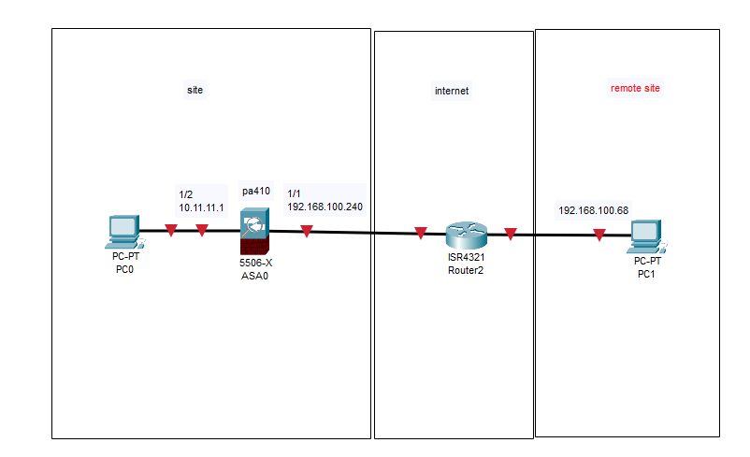

Configurations

Step 1: Delete the Virtual Wire.

Step 2: Connect the management interface to the internet (we did this by configuring a WAN port that allowed the firewall to connect to the internet. Then an interface was configured to allow a layer 2 connection to the management interface).

Step 3: Got to Device, interfaces, ethernet1/1, and change the virtual router to default. 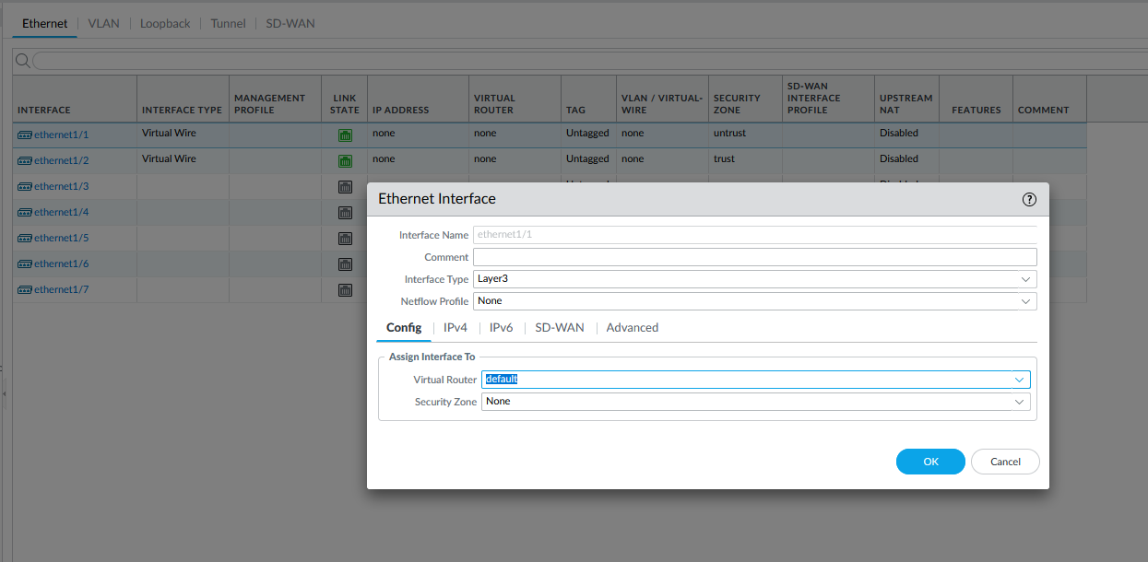

Step 4: for security zone, click create new and name it “INTERNET”

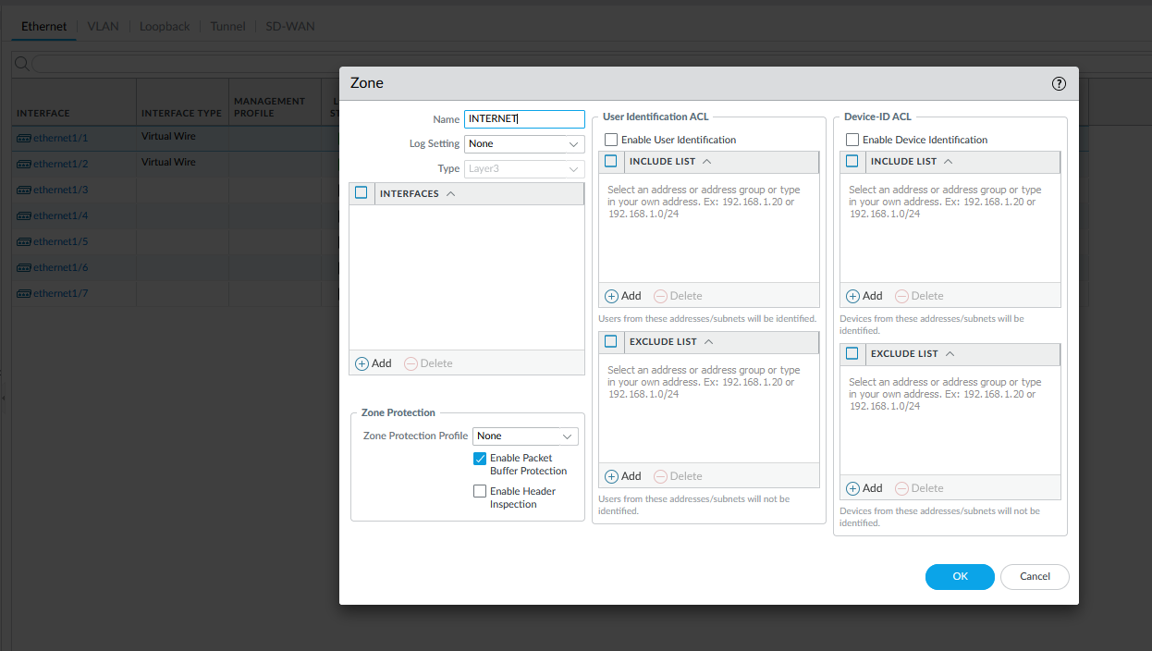

Step 5: go to Ipv4 tab and set a static IP address of 192.168.100.240/24

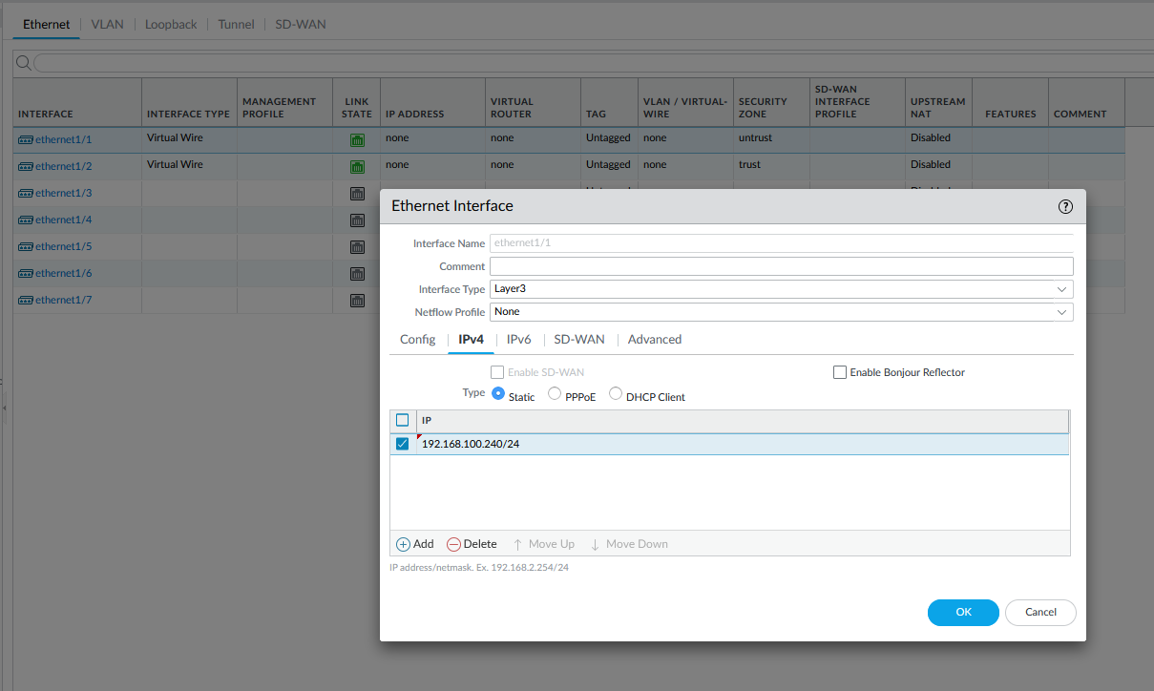

Step 6: open ethernet 1/2. Set the interface type to layer 3 and virtual router to default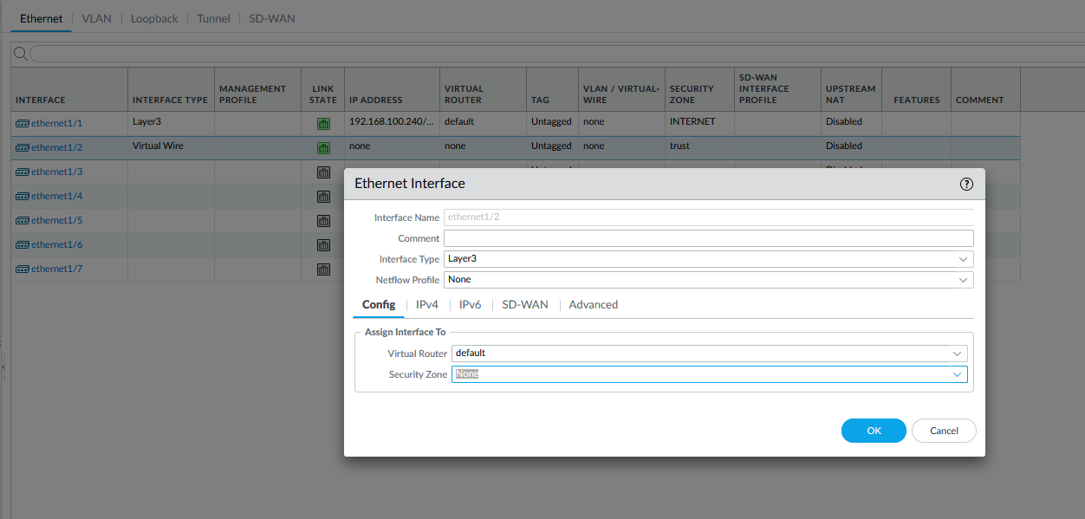

Step 7: create a new security zone and name it “INSIDE”

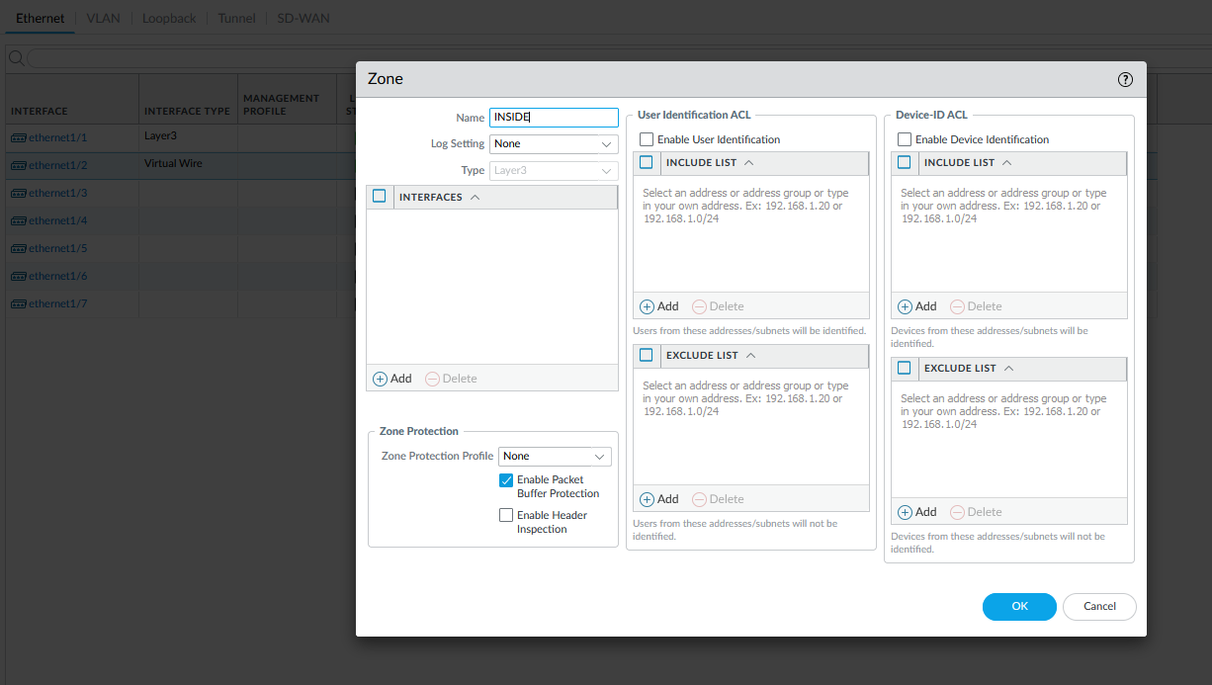

Step 8: go to IPv4 and set a static IP address

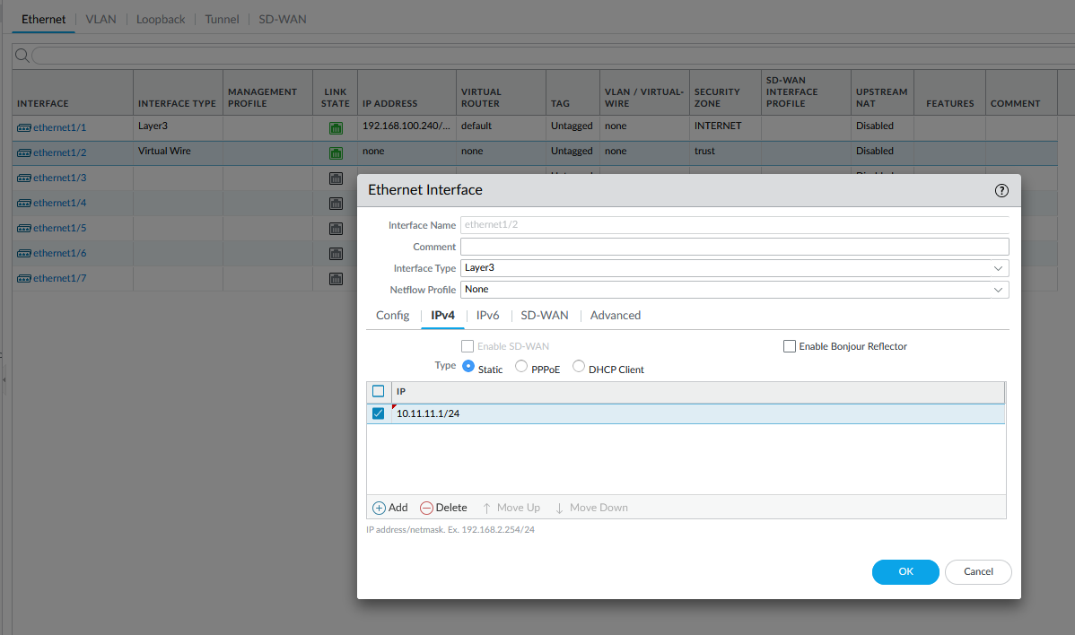

Step 9: Go to Virtual Router, Static routes, and configure the following 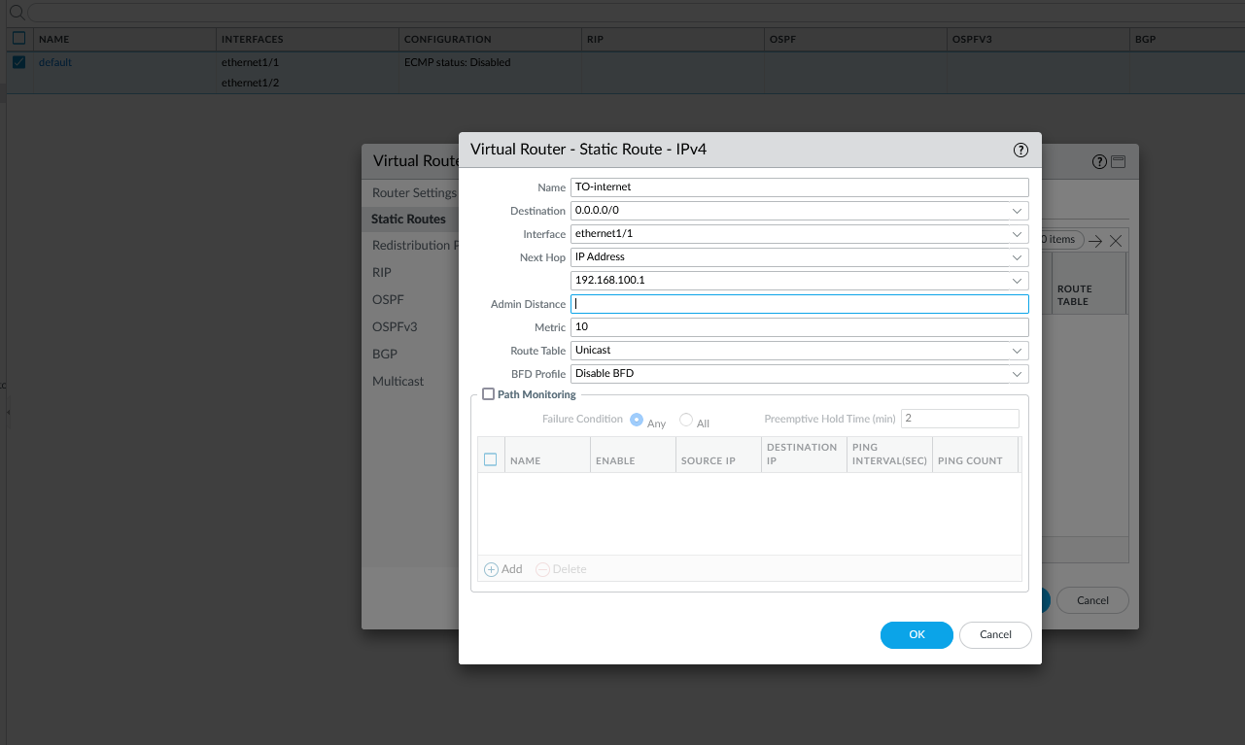

Step 10: Go to Security Policies, edit the pre-existing rule.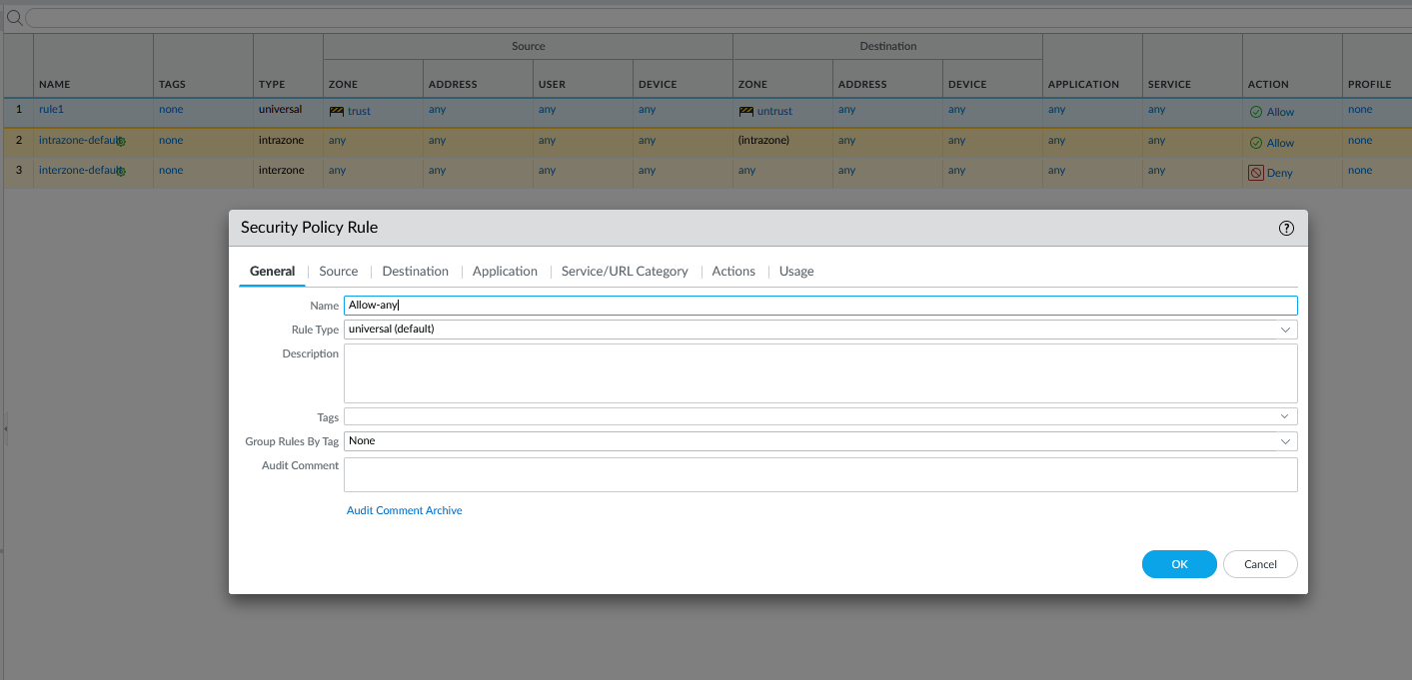

Step 11: configure the following in Source

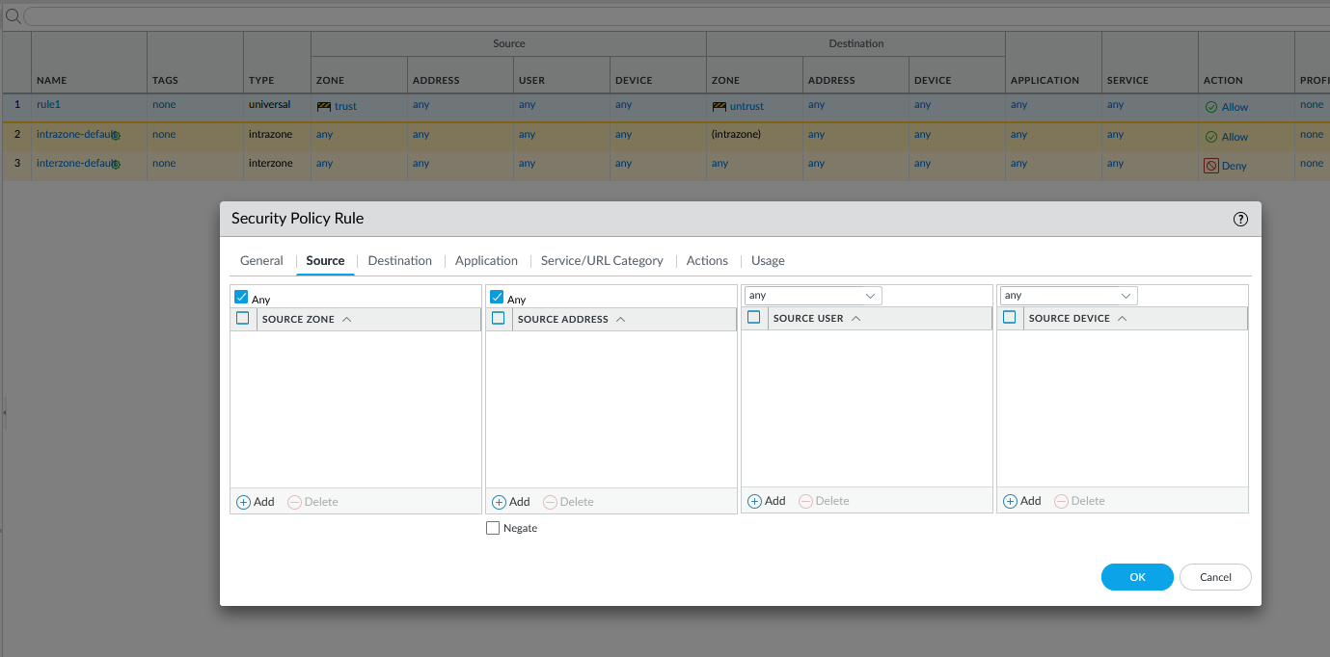

Step 12: Configure the following in Destination

And tconnect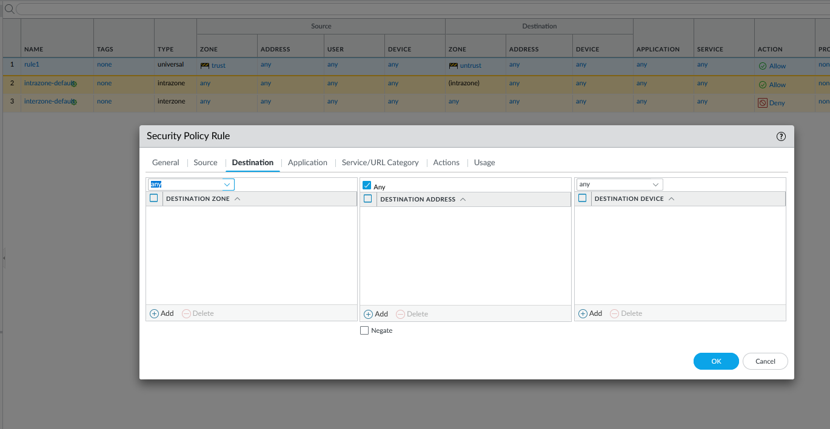

Step 13: Configure the following in Service/URL Category

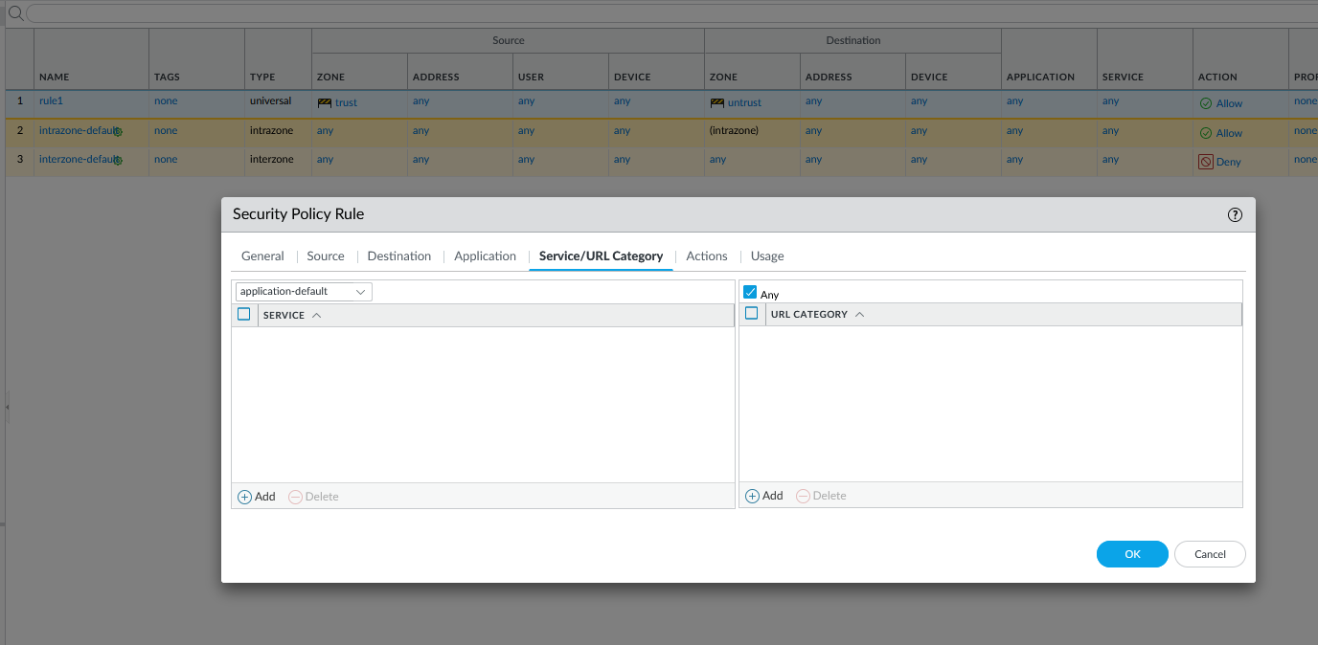

Step 14: Go to certificates and generate a new certificate. Configure the following

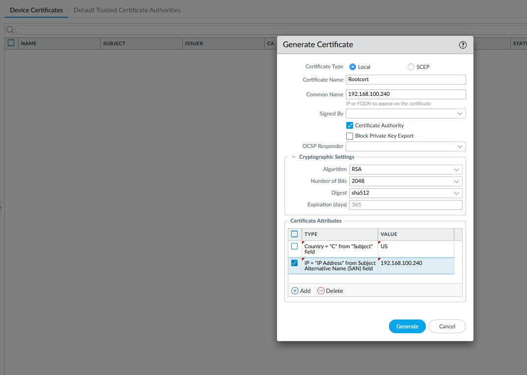

Step 15: Go to SSL/TLS Service Profile. Click add and configure the following

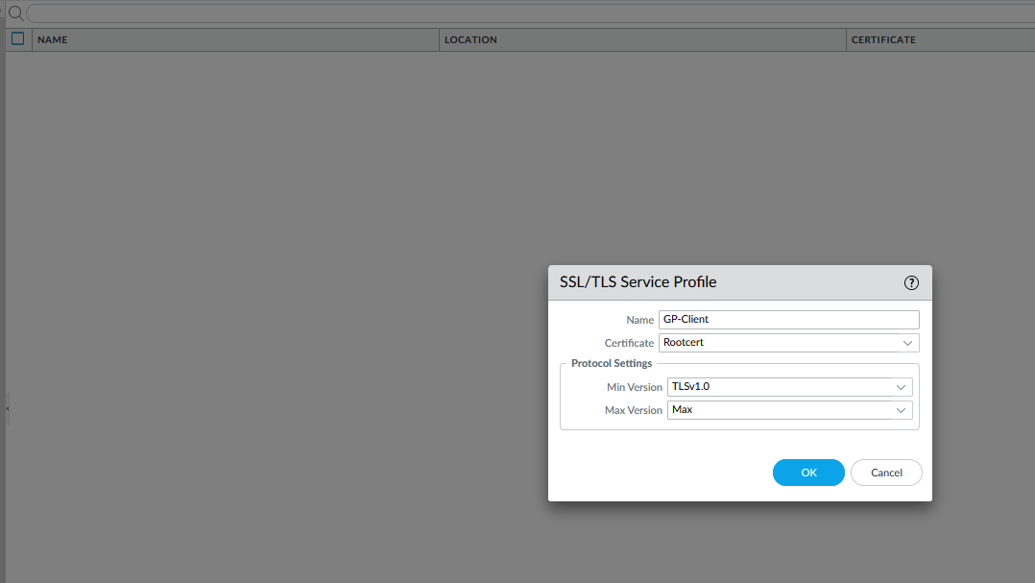

Step 16: go to Users, click add, and configure the following

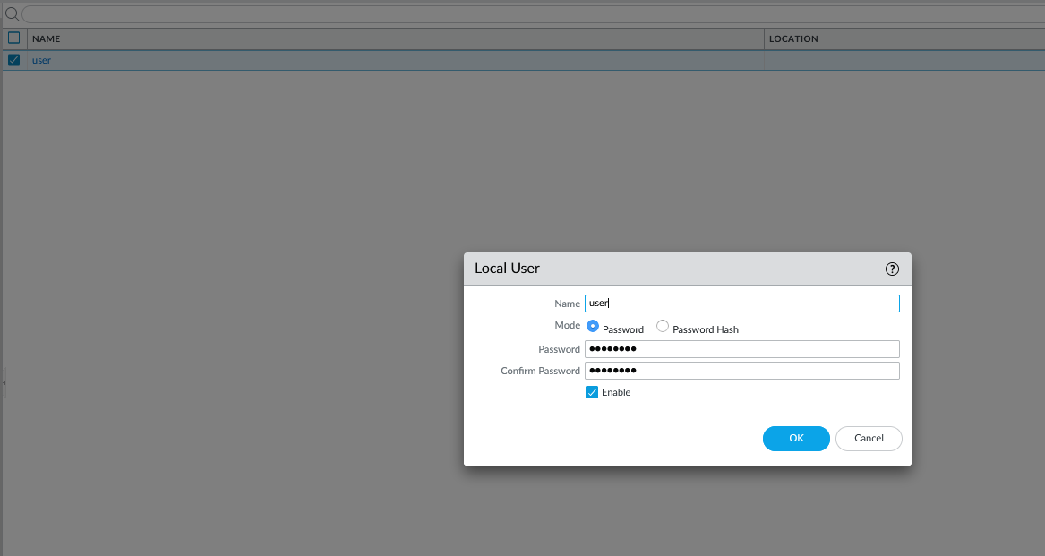

Step 17: Go to Authentication Profiles, click add, and configure the following

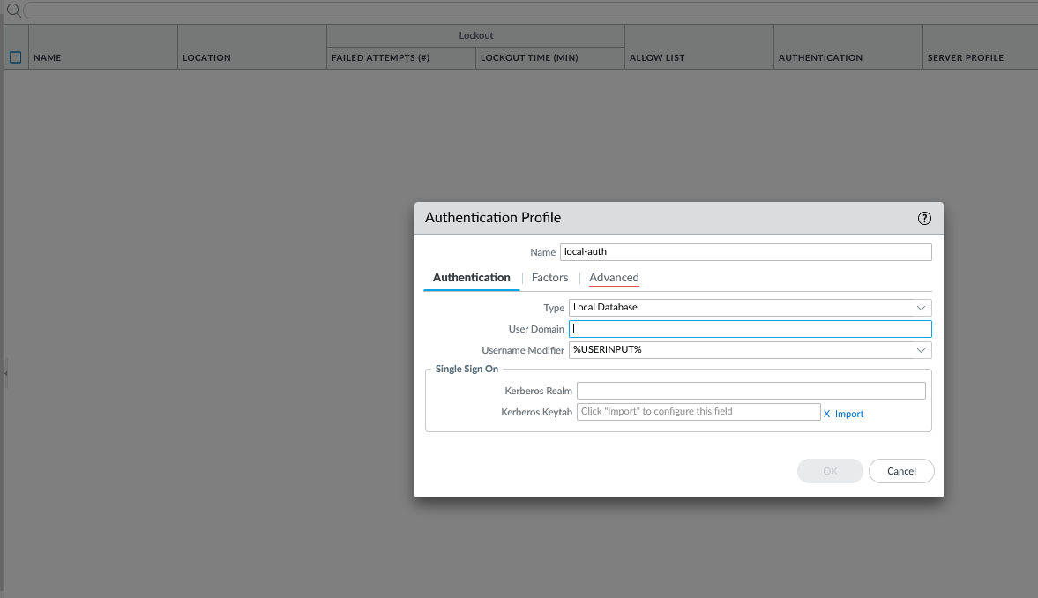

Step 18: Go to Advanced and configure the following

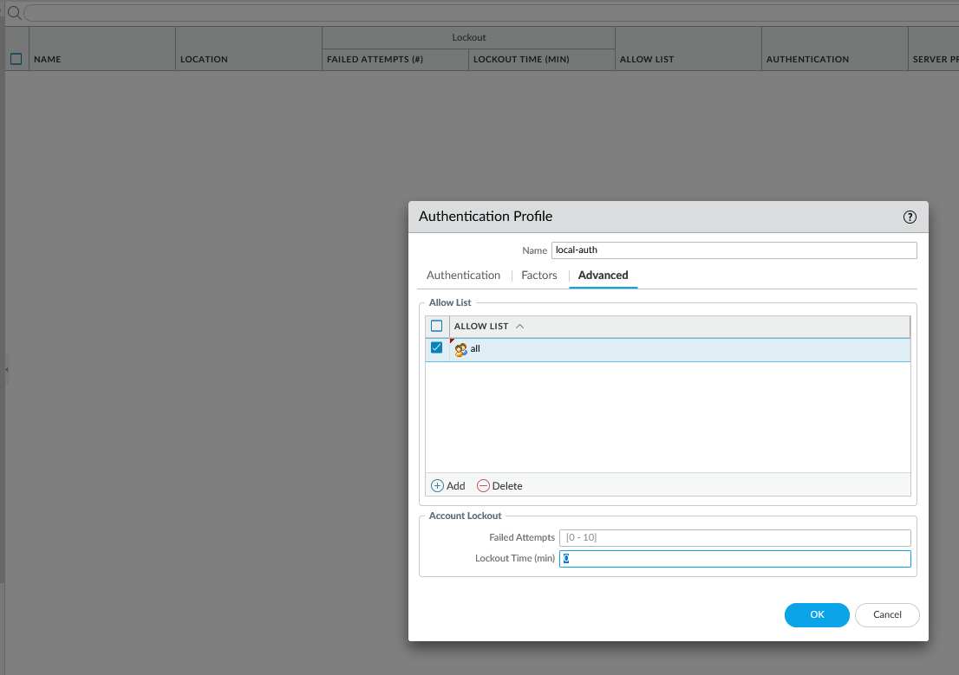

Step 19: Go to Device, interfaces, tunnels, and click add. Configure the following

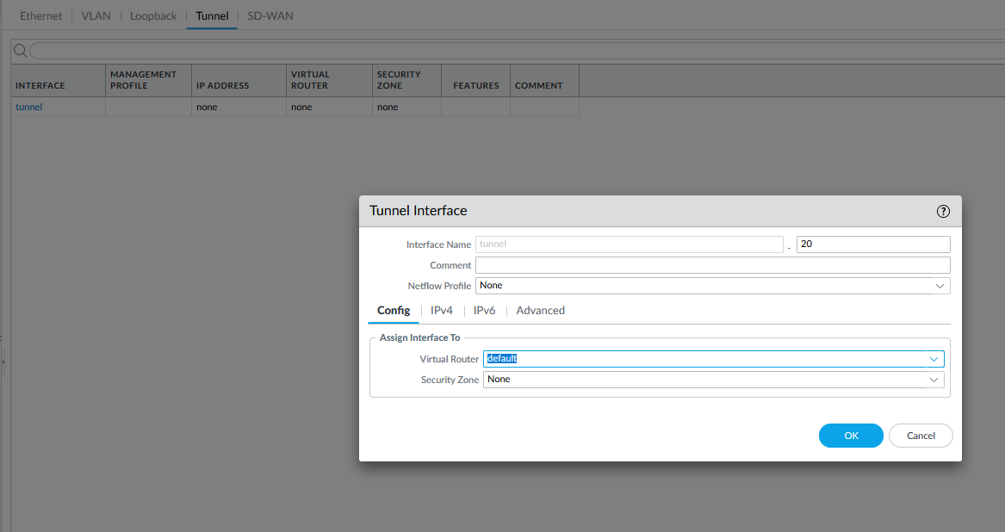

Step 20: create a new security zone and name it “VPN”. Enable User Identification

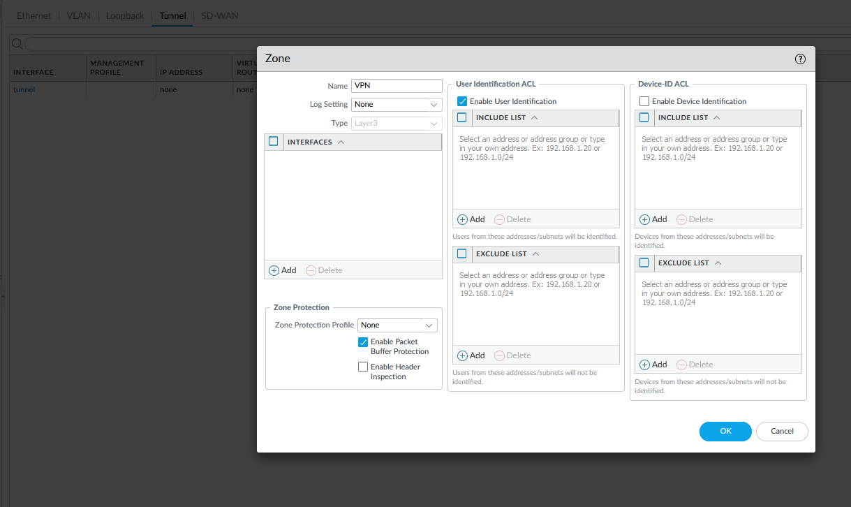

Step 21: Go to Global Protect Portal. Click add and configure the following

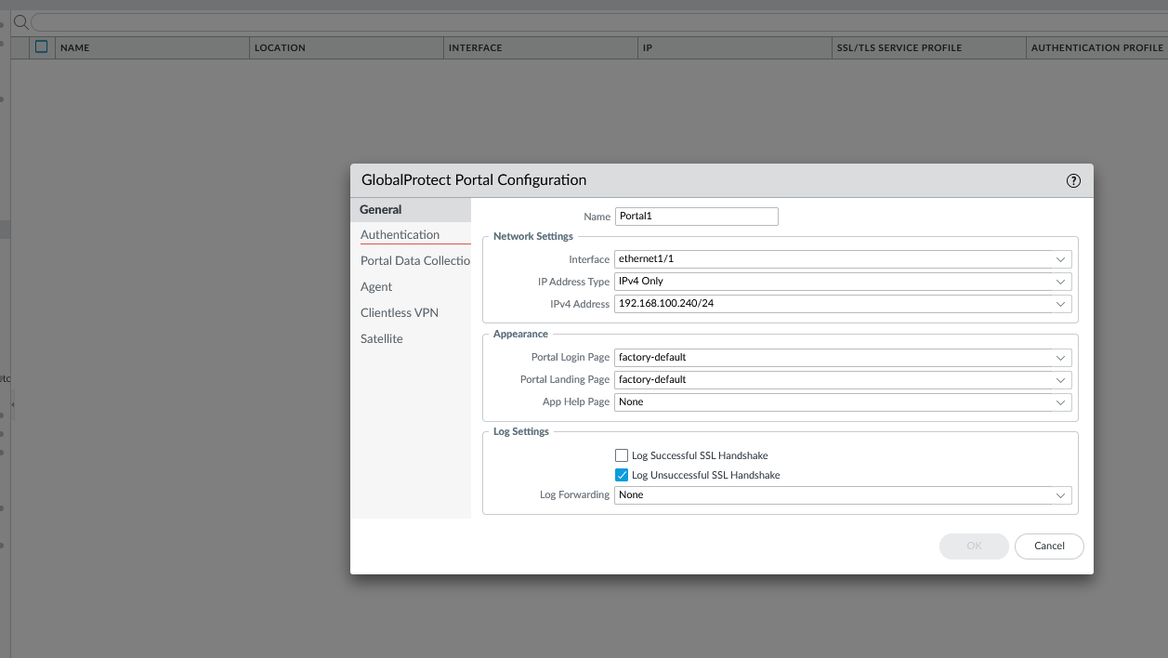

Step 22: Go to Authentication and configure the following

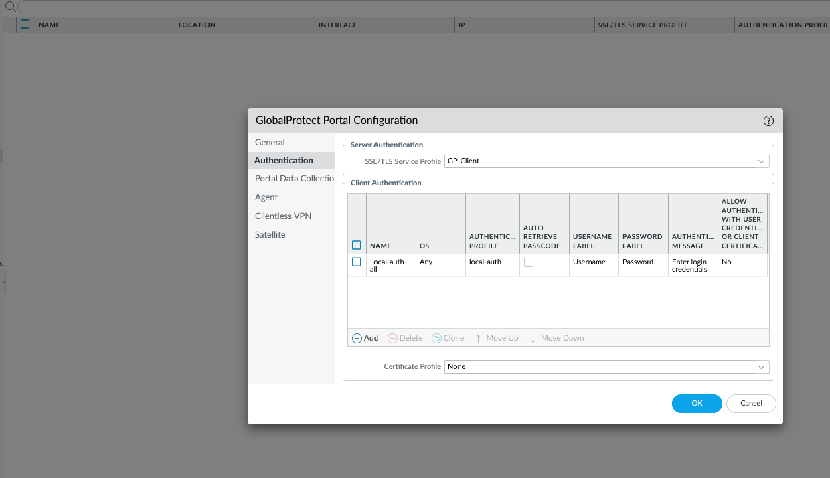

Step 23: Click Add and configure the following

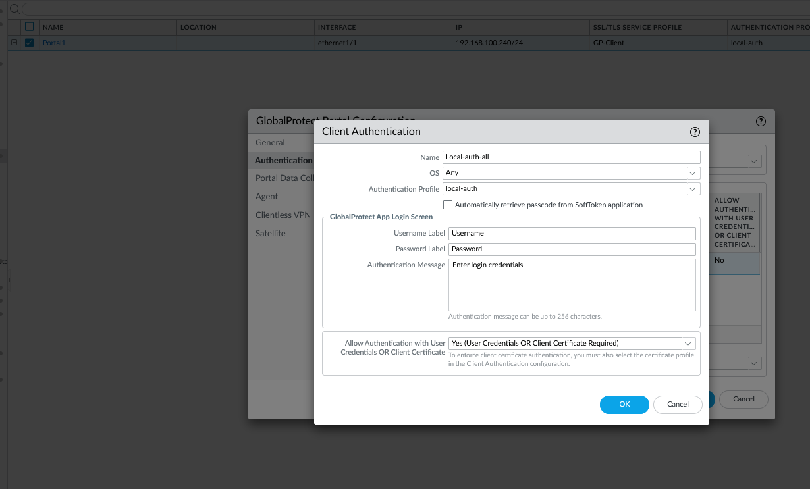

Step 24: Go to Agents and configure the following

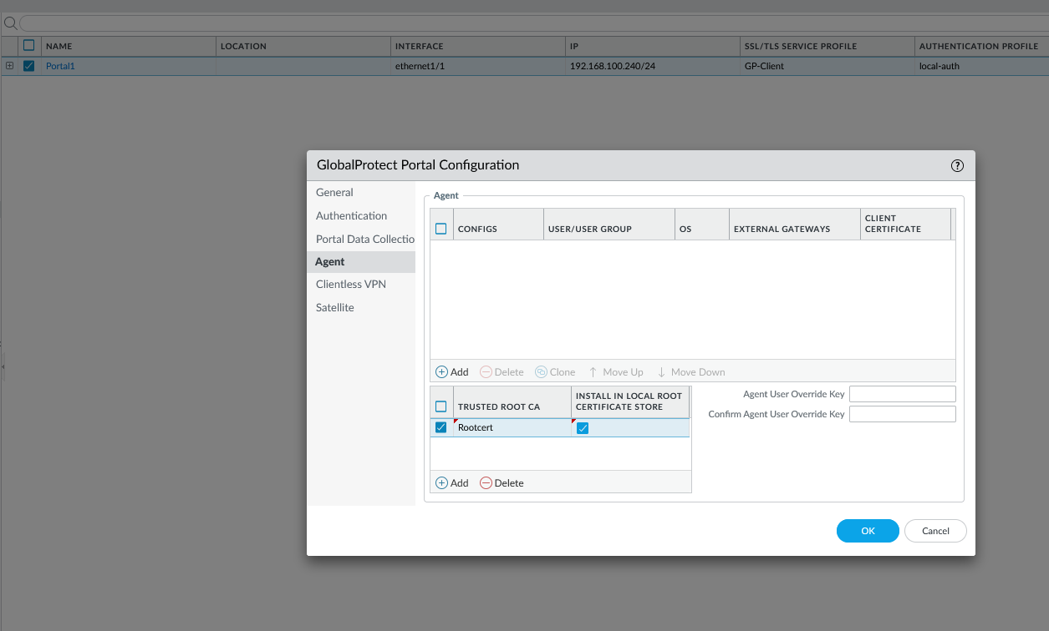

Step 25: click add and configure the following

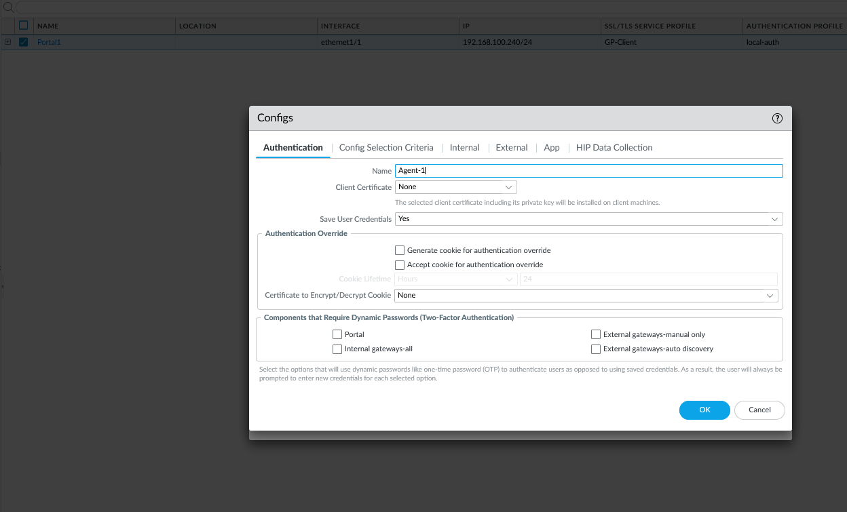

Step 26: Go to External, click add, and configure the following

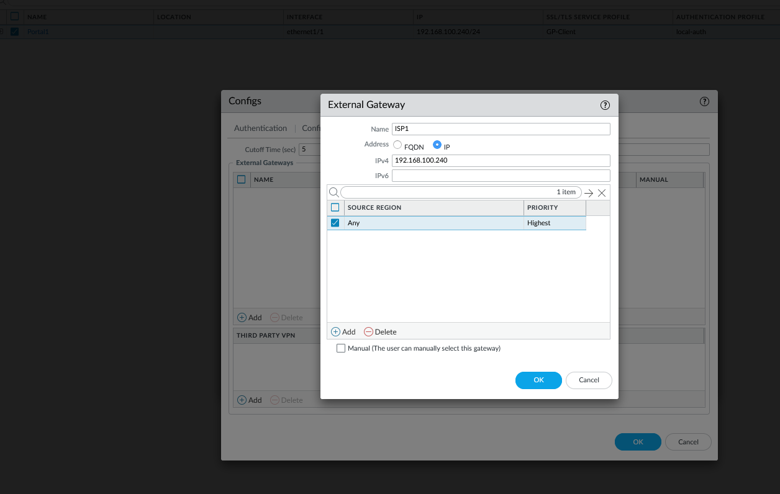

Step 27: Go to Global Protect Gateway, click add, and configure the following

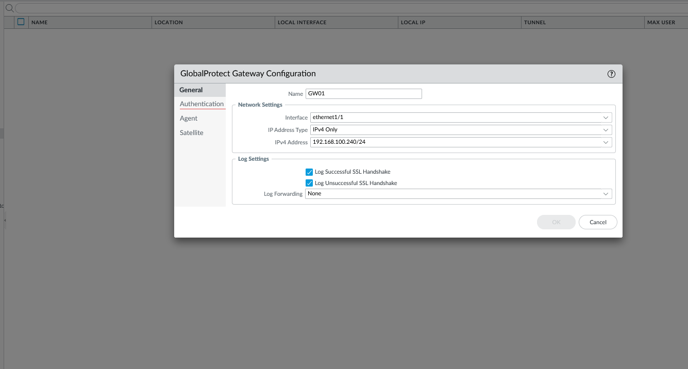

Step 28: Go to Authentication and configure the following

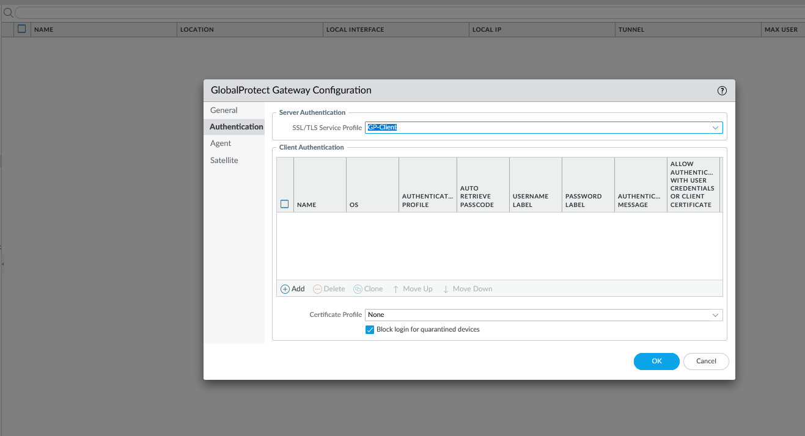

Step 29: Click add and configure the following

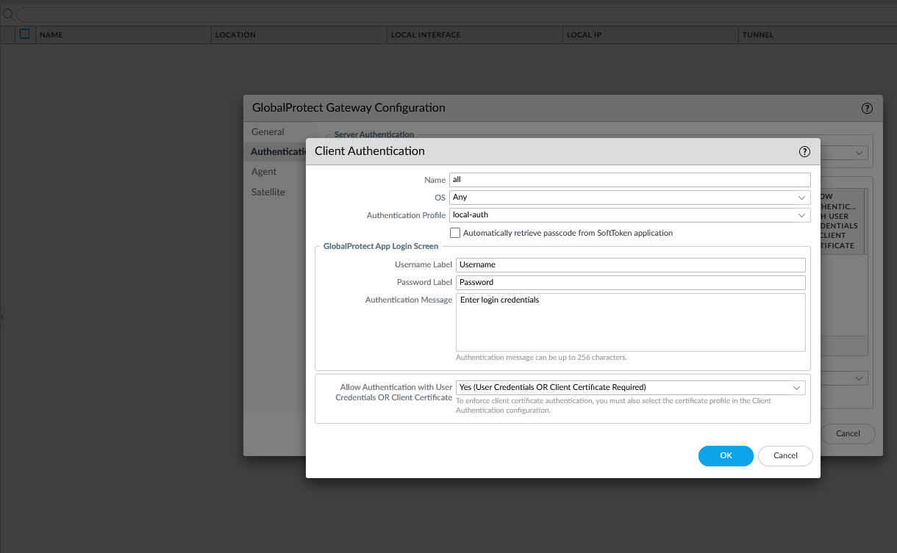

Step 30: Go to Agent and configure the following

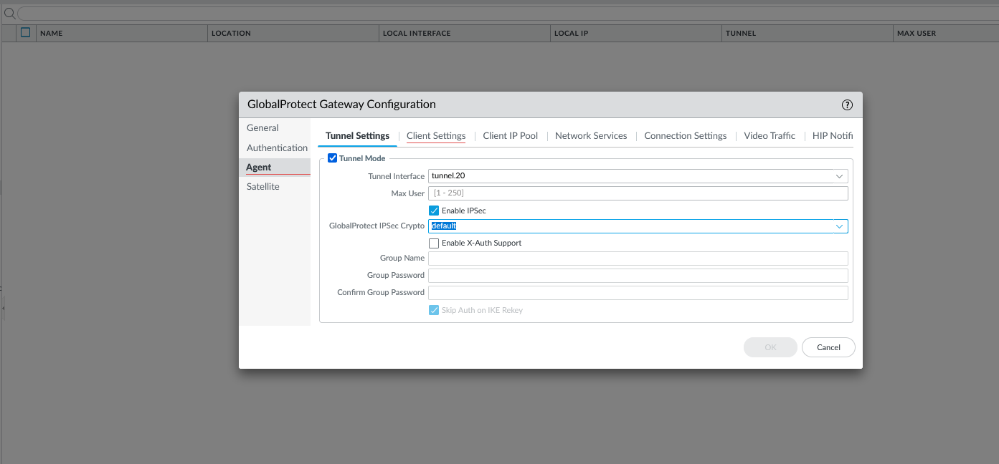

Step 31: Go to Client settings, click add, and configure the following

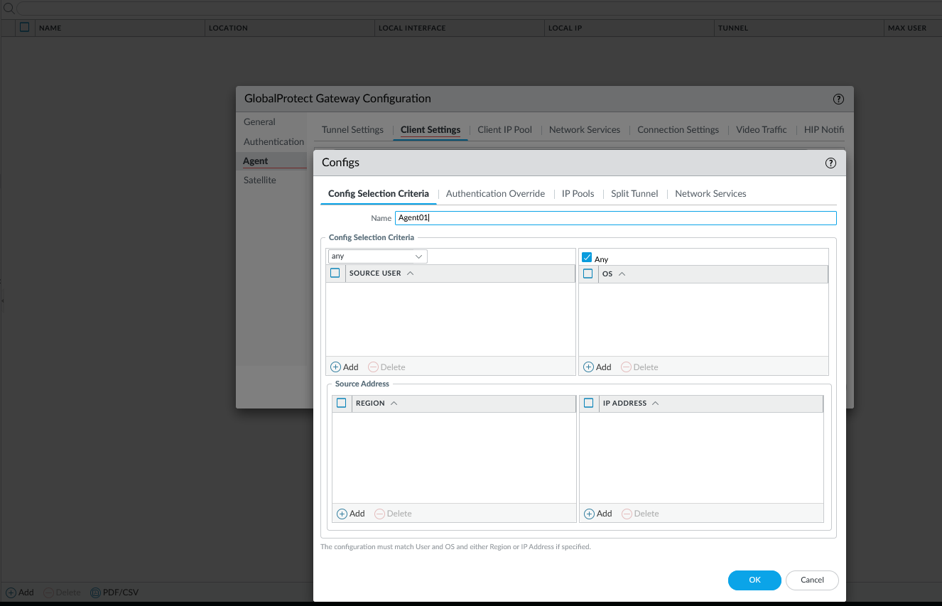

Step 32: Go to IP pools and configure the following

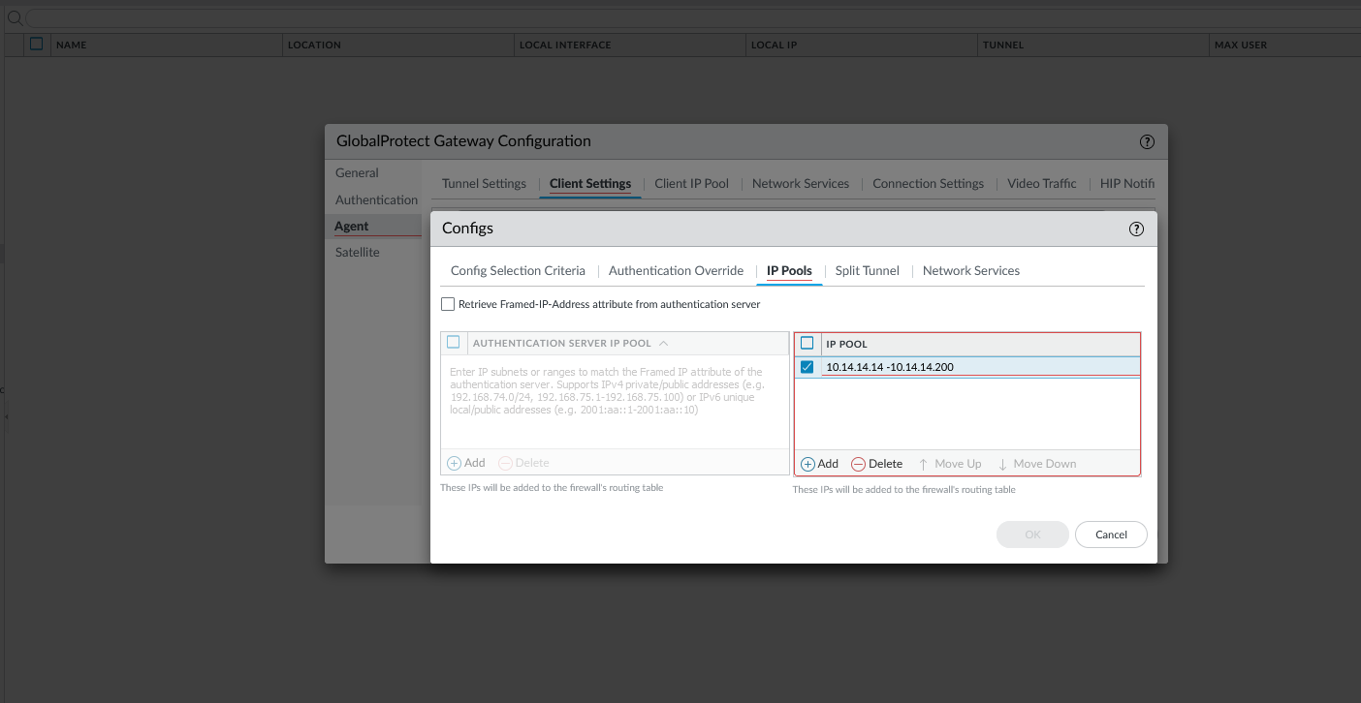

Step 33: Commit Changes

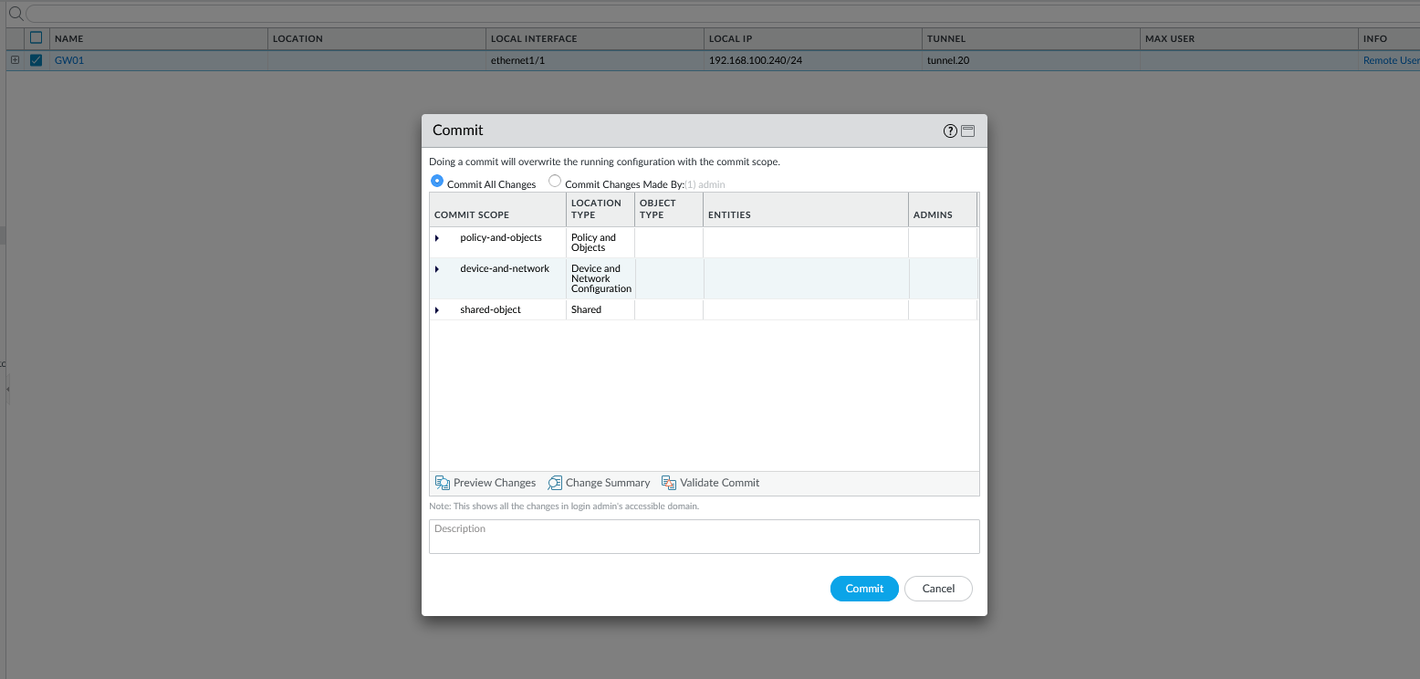

Step 34: Go to License and retrieve licenses. Go to GlobalProtect Client and download the latest version

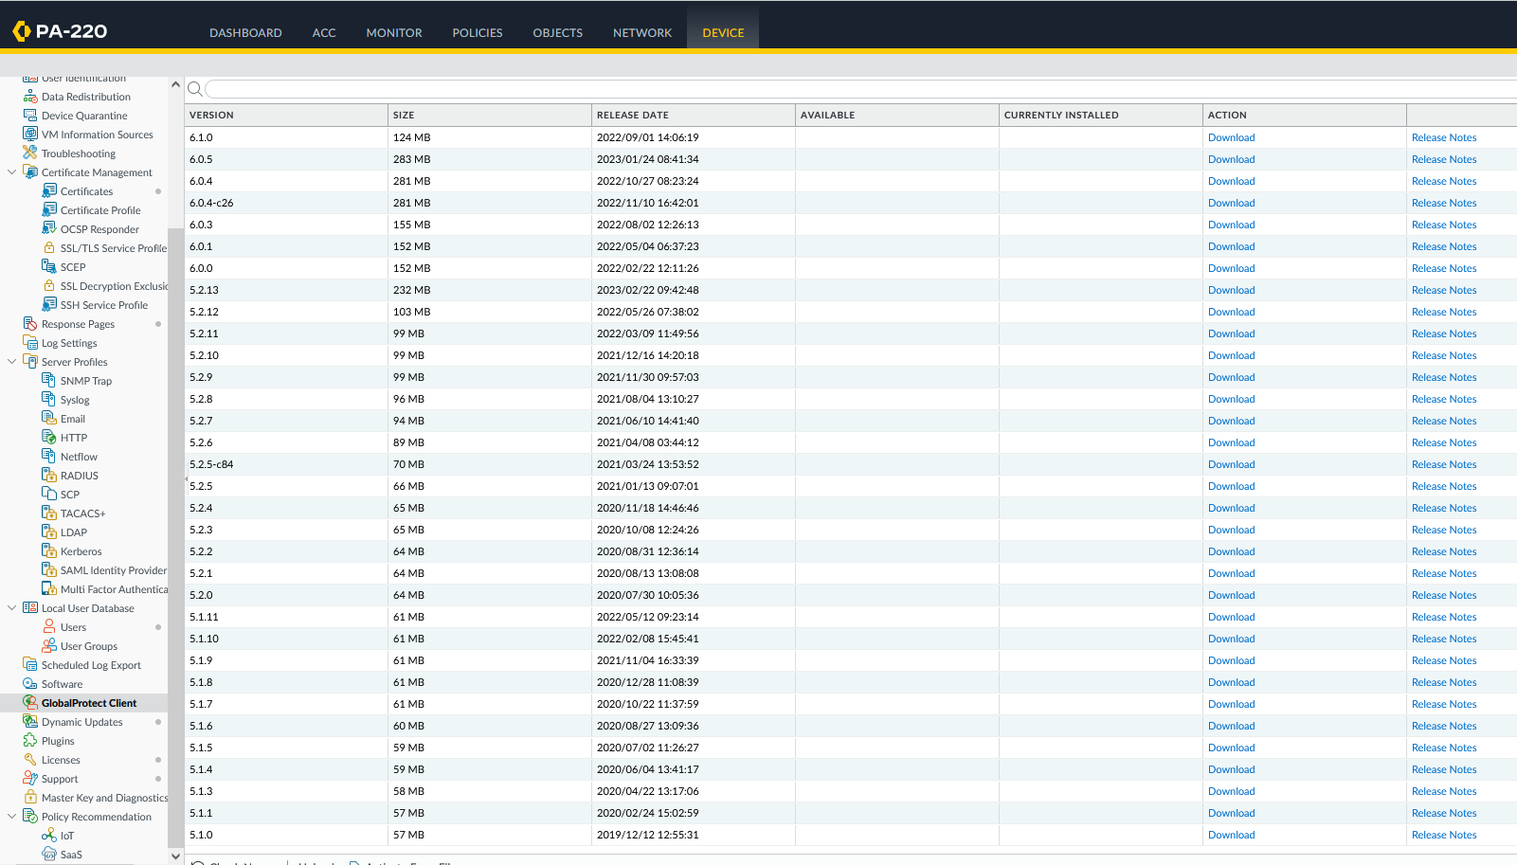

Step 35: open the remote user and go to the <https://192.168.100.240>. Log in.

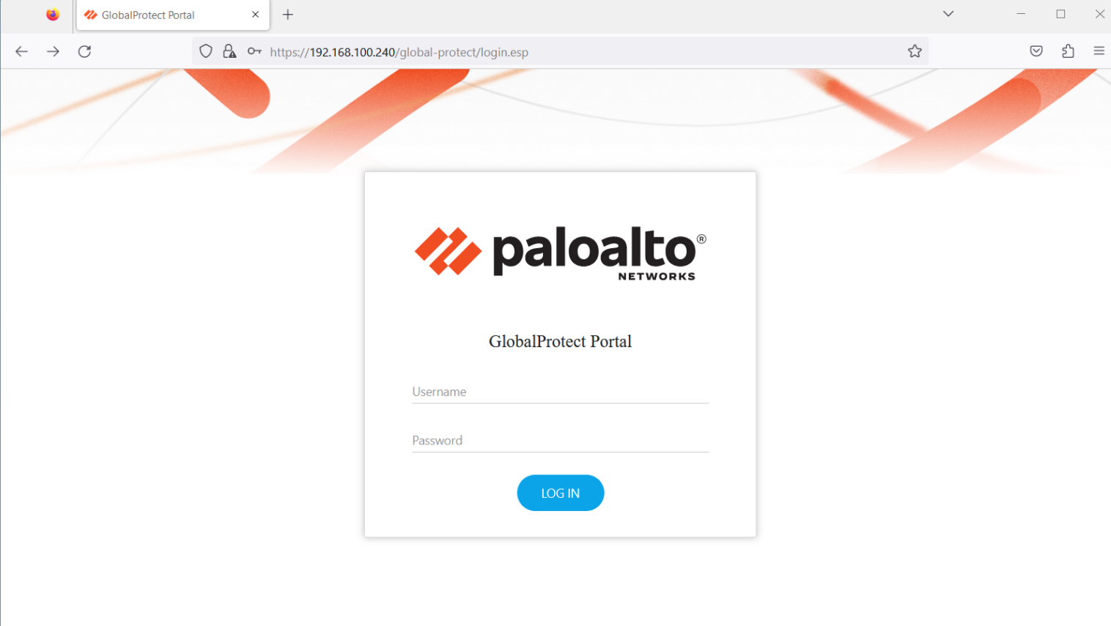

Step 36: Download Global Protect Client

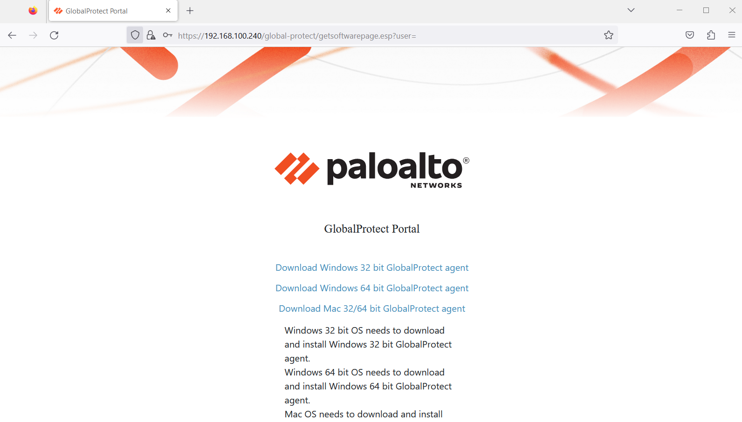

Step 37: Run the installer 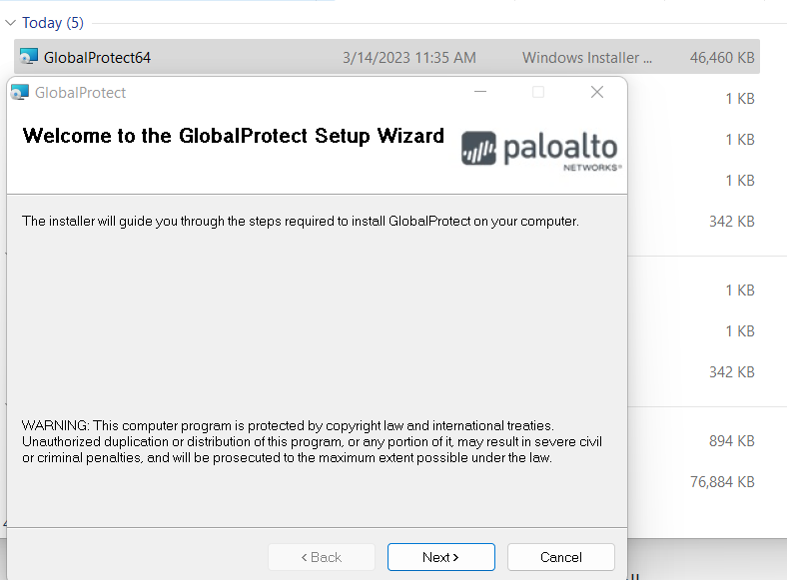

Step 38: Once it finishes installing, open the Global Protect Client

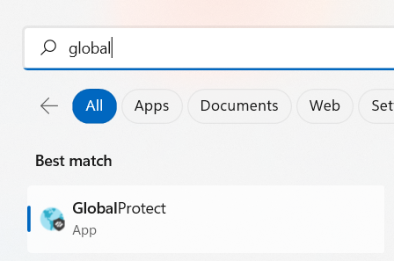

Step 39: connect with 192.168.100.240

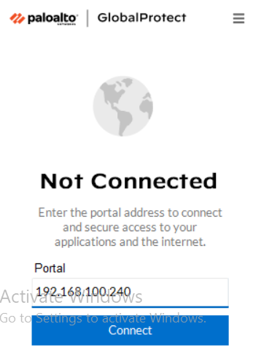

Step 40: Verify Connection

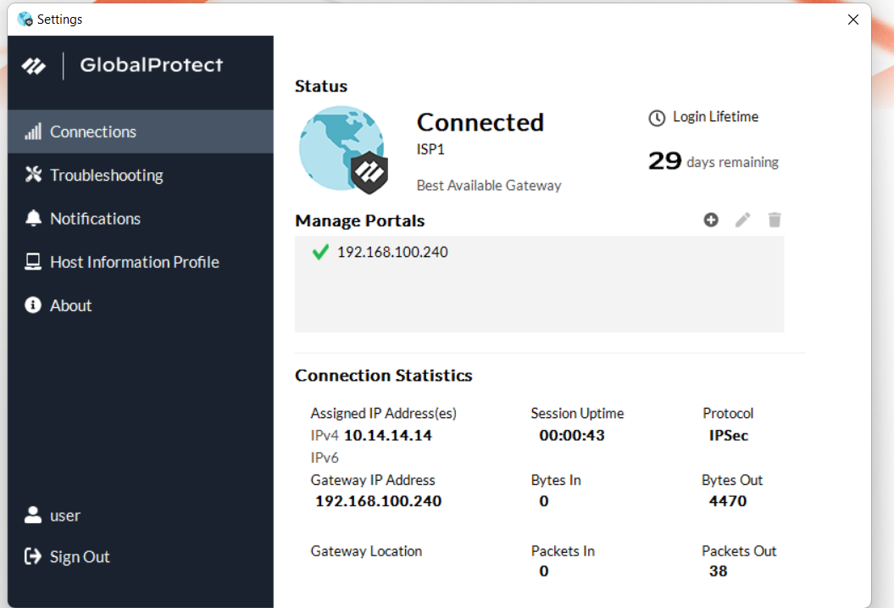

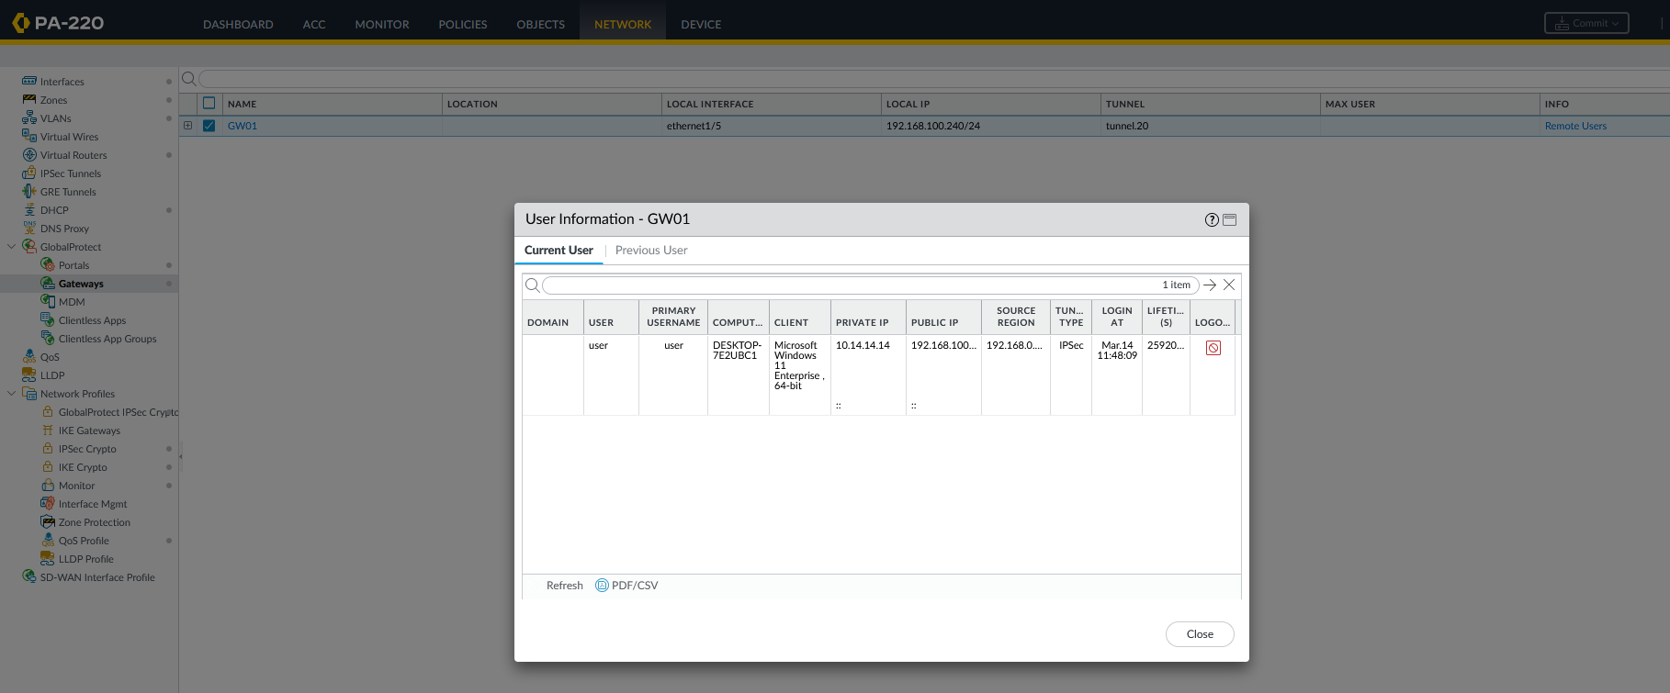

Problems

The main problem that we encountered was downloading Global Protect onto the device that was in the “remote site.” We couldn’t find a download file on the internet but were able to download it off the Microsoft store (device was configured with Windows OS). However, the Global Protect downloaded off the Microsoft store wouldn’t connect since it was a self-signed certificate and deemed the connection unsecure.

We solved this by configuring the firewall to connect to the internet to retrieve license keys and download Global Protect off Palo Alto servers. The software was then distributed from the firewall to the user devices.

Another problem we ran into was after connecting the firewall to the internet, we forgot to connect the management interface to the internet. This was quickly solved with a layer 1 link from the management interface to an ethernet port on the firewall.

Conclusion

The remote access VPN is widely used and has a very practical function especially with more people experimenting with working remotely. In this lab, we set up a remote access VPN on a private network with relatively few problems. In the future, we plan on continuing working with remote access VPNs but exploring the SSL and TLS protocols.

**Setting Up a Clientless VPN***Derek Liu*

Purpose

The purpose of this lab is to set up a clientless remote access VPN. With a clientless VPN, the remote should be able to set up a VPN tunnel to a network and access internal resources by typing an address into the search bar and entering credentials.

Background Information

A clientless VPN or browser-based VPN allows for users to access internal resources in a network through a web browser without the need to install software or client-based applications.

Clientless VPNs are useful when resources need to be accessed from a remote location easily and quickly and from any device. This can be helpful for those working on a public or shared computer that do not have administrative privileges to install software on their devices.

However, clientless VPNs are limited in terms of performance and functionality compared to VPN clients as they are only able to access web-based applications. They don’t offer advanced security protocols or features such as split tunneling.

Clientless VPNs also are not as secure compared to a traditional VPN since they do not offer advanced security features such as Open VPN, SSTP, or two factor authentication. Another shortcoming is its reliance on web browsers which have a lot of possible vulnerabilities due to their complexity.

Clientless VPNs are also not able to provide the same amount of control and visibility as a traditional VPN client which means that potential threats are harder to detect.

Lab Summary

In this lab, we set up a clientless remote access VPN with a Palo Alto 220. Functionality was tested by connecting to the VPN and accessing an internal web server that is not reachable from the internet.

Network Diagrams with IP

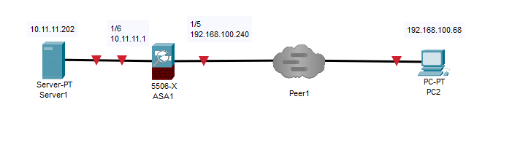

(note: The web server was set up with a windows computer running an Apache web server with XAMPP).

Configurations

Step 1: Create a SOHO and remote access configuration. Refer to labs Remote Access VPN and SOHO Setup if needed.

Step 2: go to dynamic updates. Download and install the GlobalProtect Clientless VPN

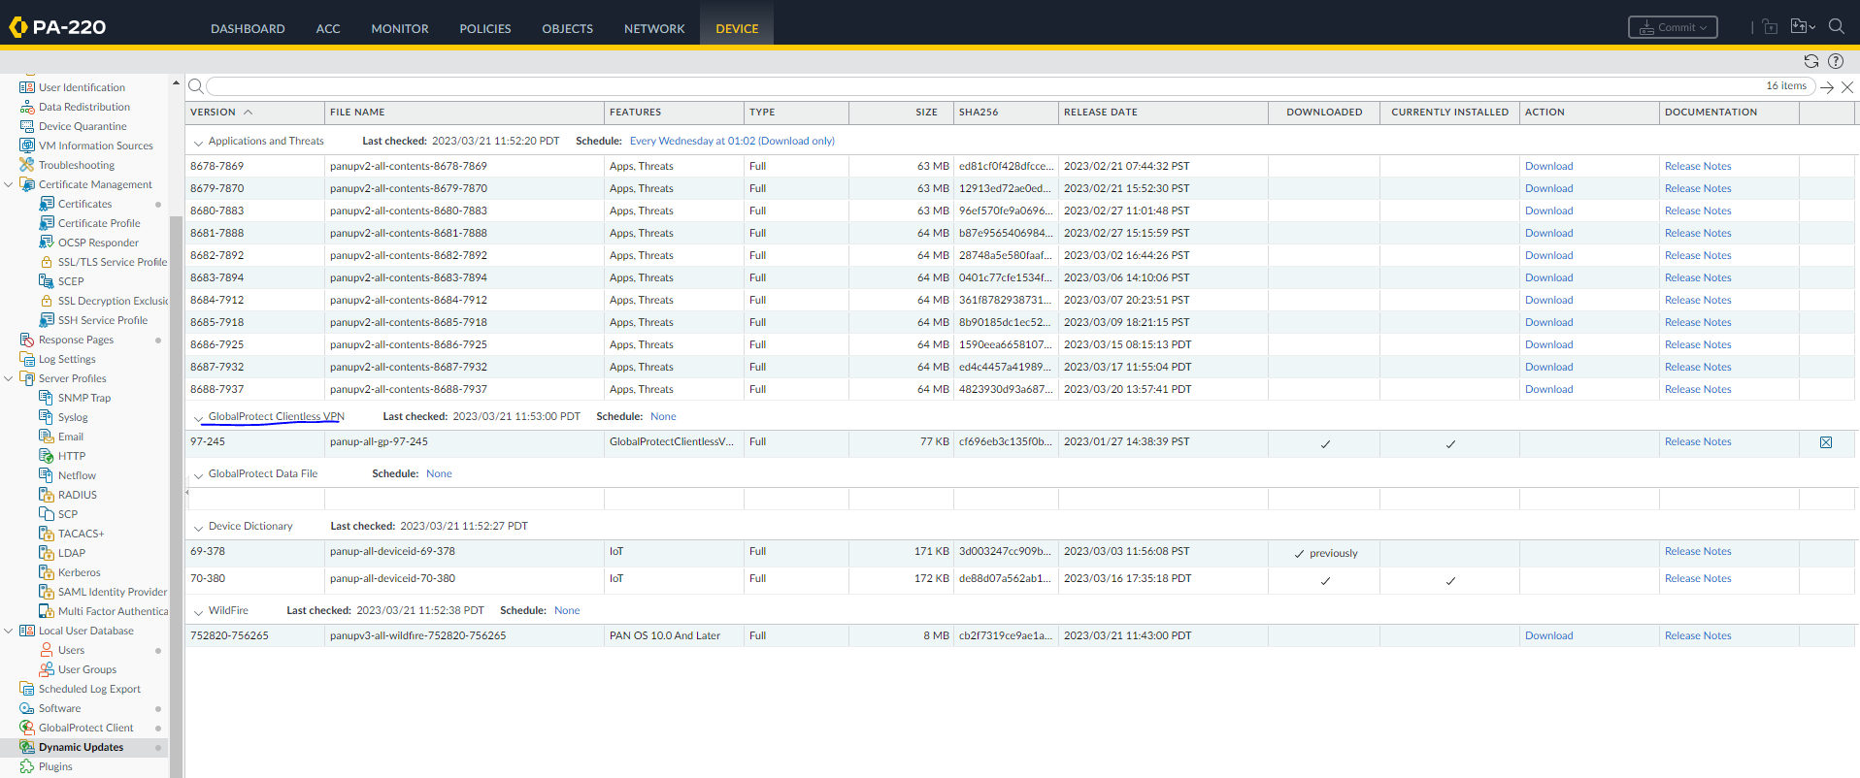

Step 3: go to Network, Clientless Apps, and configure the following

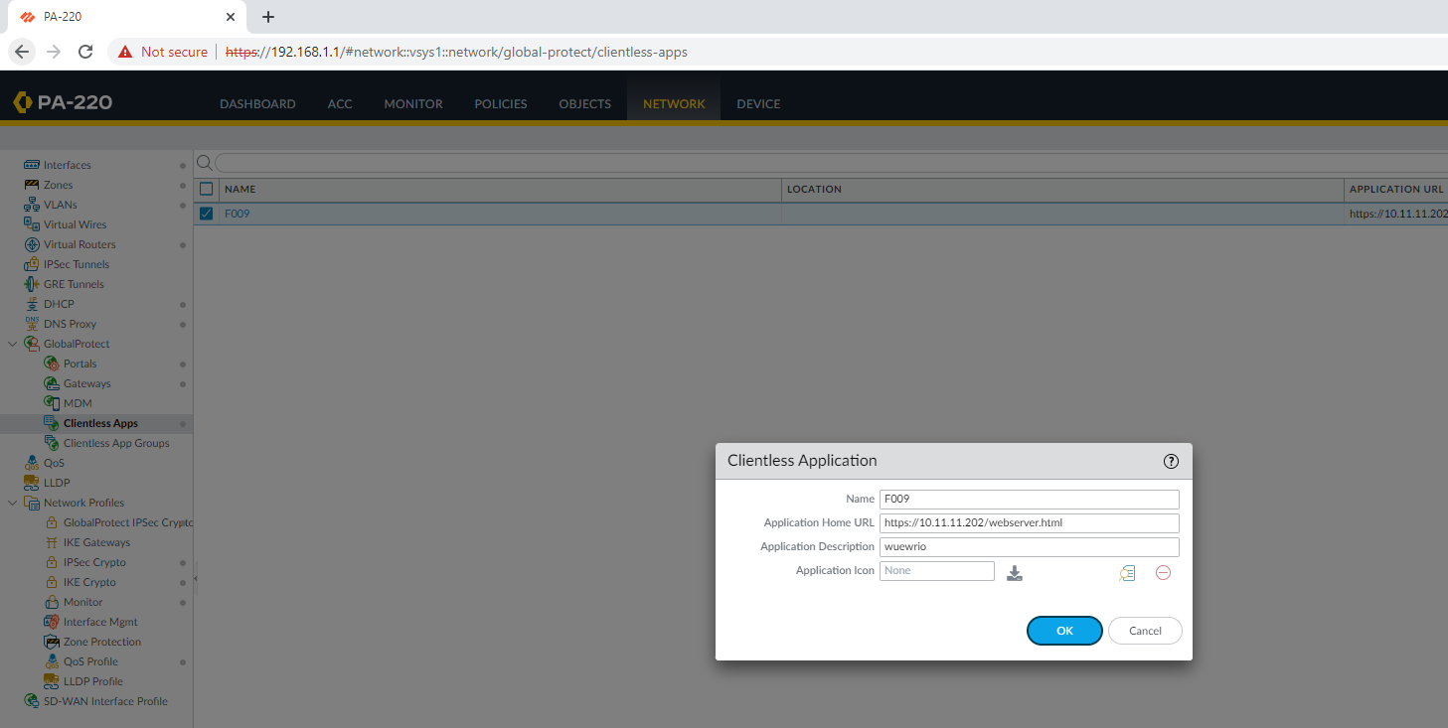

Step 4: go to DNS proxy and configure the following

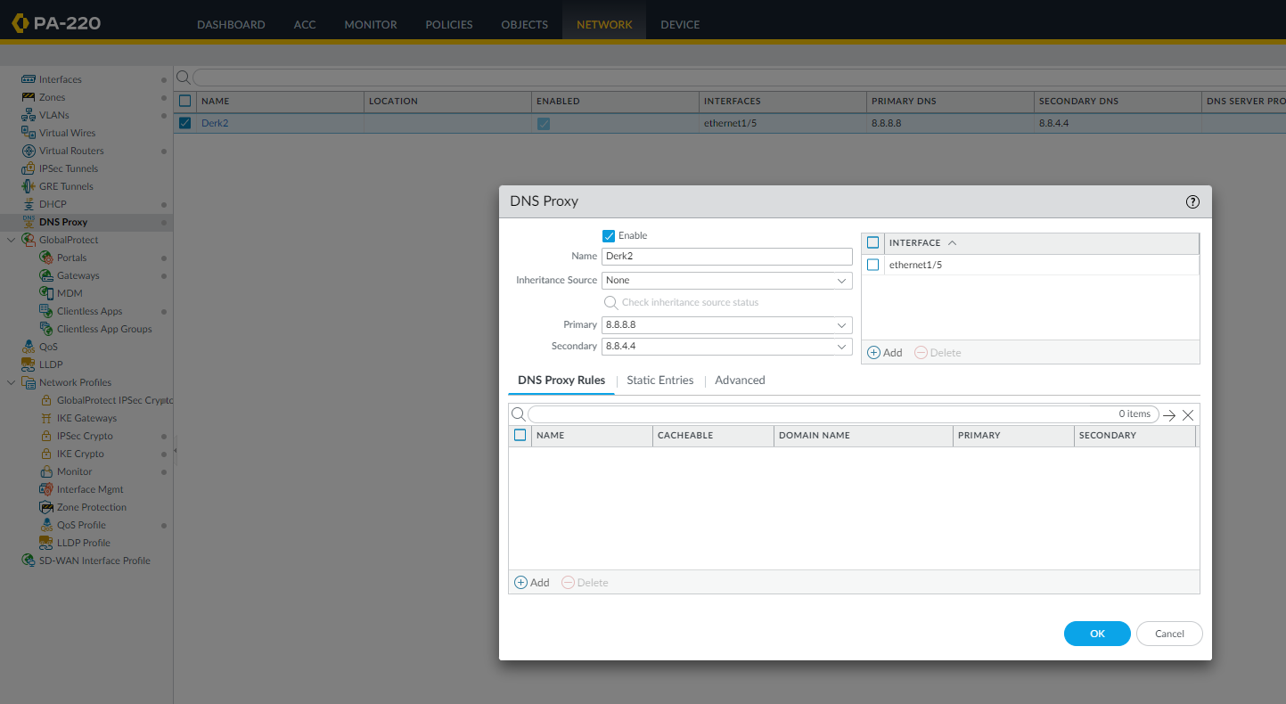

Step 5: Go to portals and configure the following (most of the tabs were configured in the previous lab)

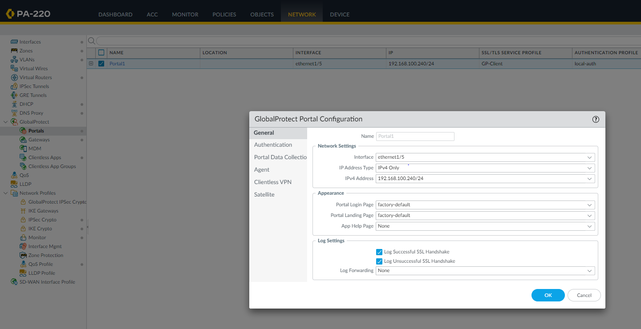

Step 6: Go to authentication and double check the configuration 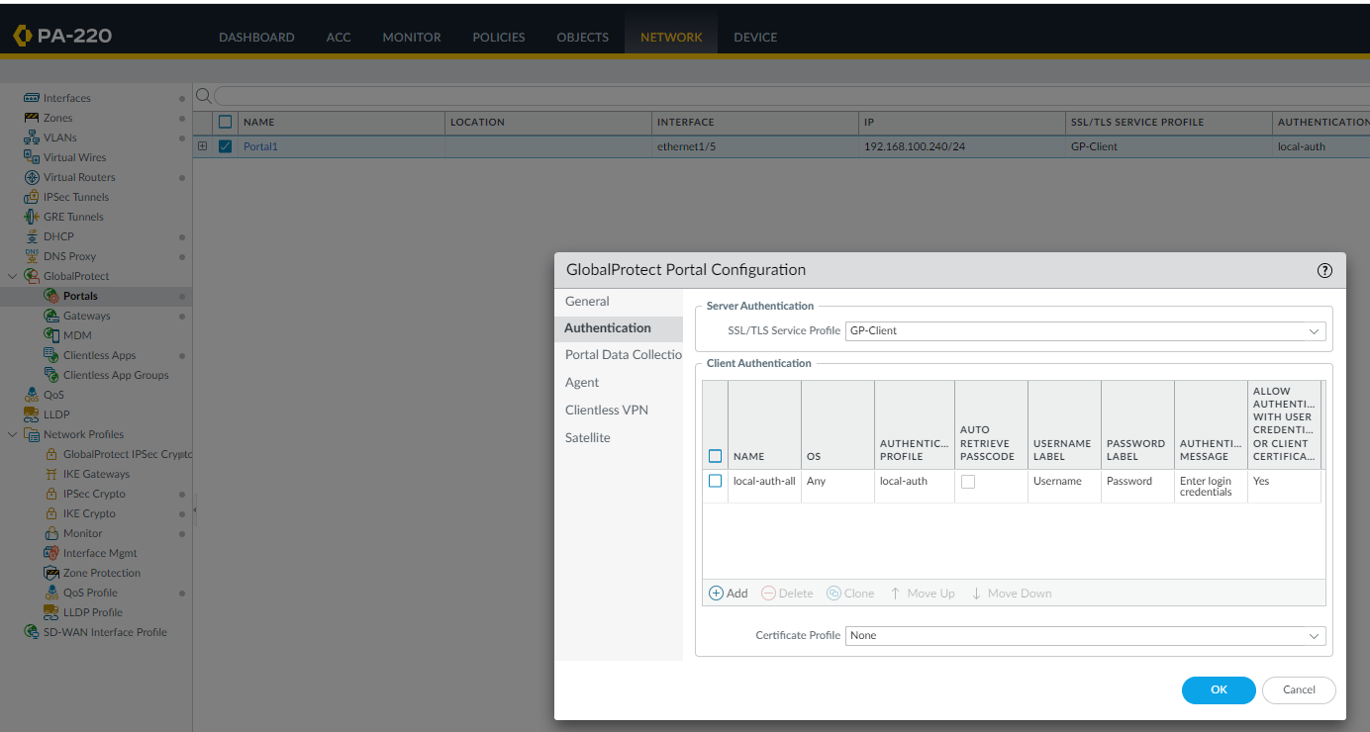

Step 7: go to Clientless VPN and configure the following

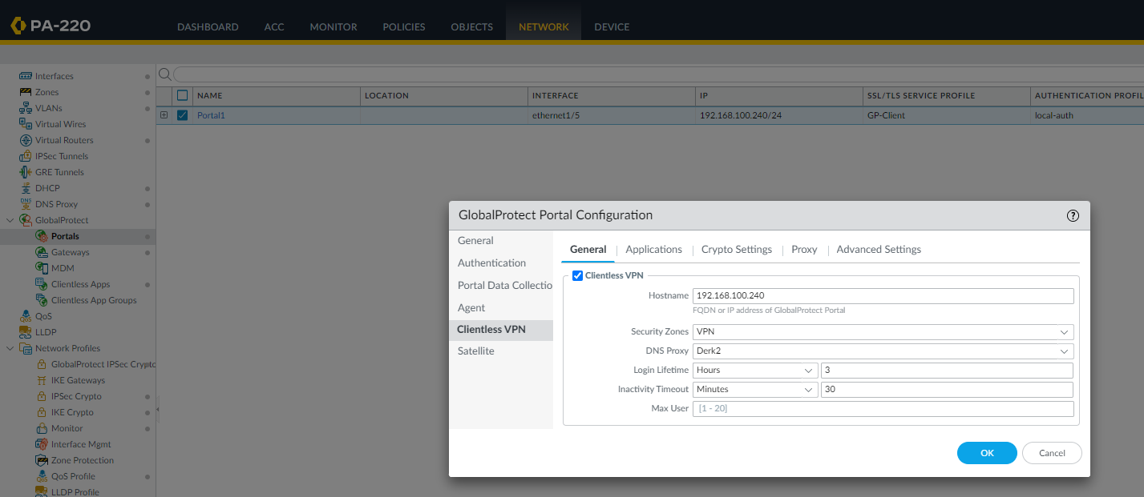

Step 8: go to applications and configure the following

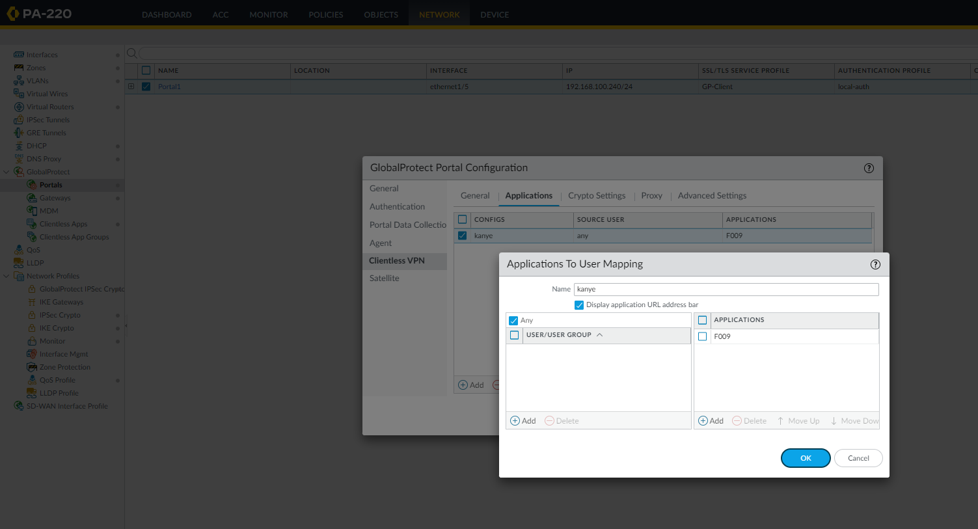

Step 9: go to Crypto Settings and configure the following

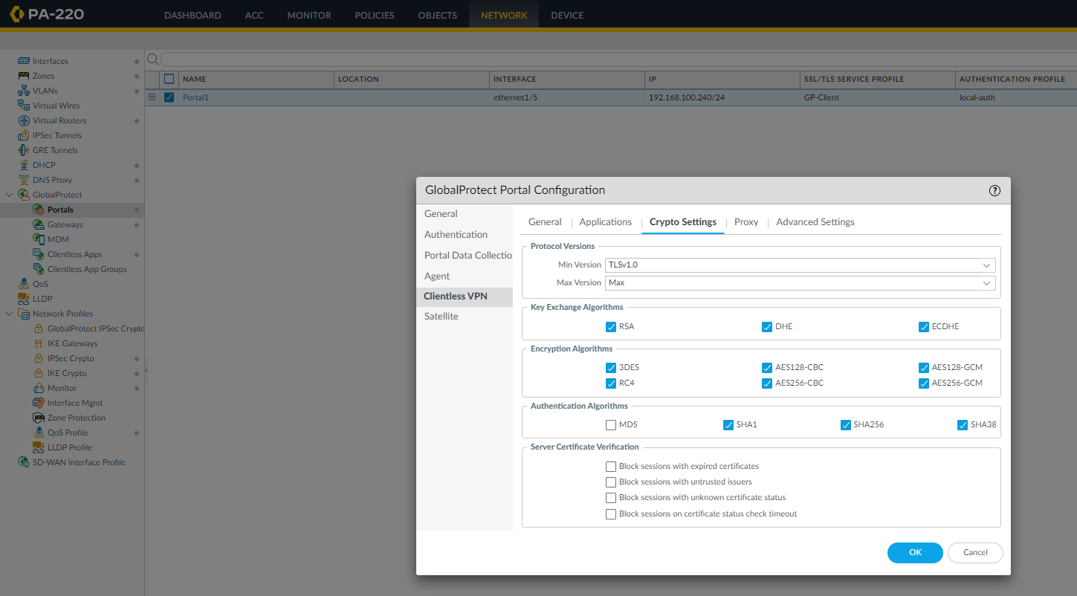

Step 10: go to Agent, Client Settings, and IP pools. We changed the IP pool so the devices will be on the same subnet.

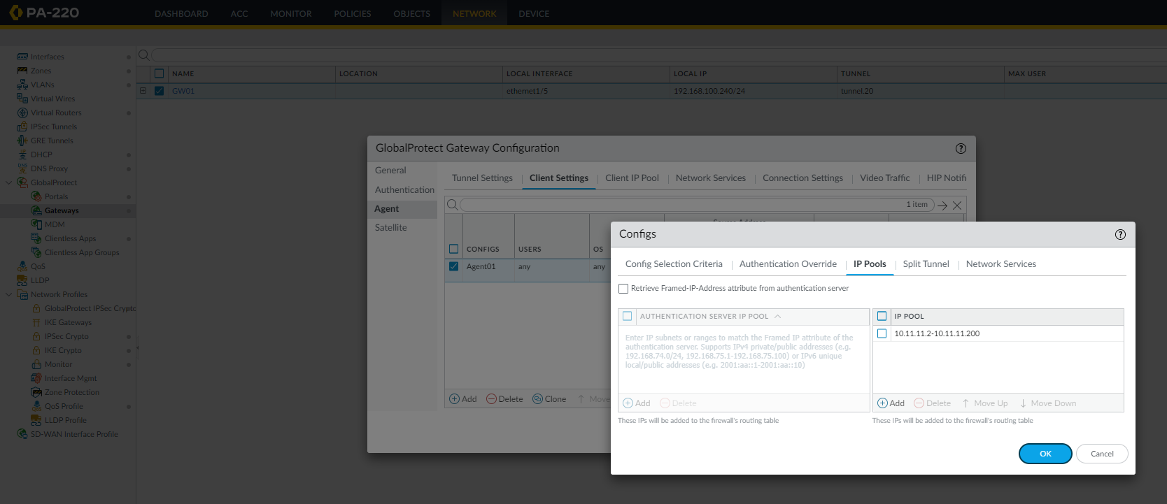

Step 11: access the remote user and go to the IP address of the WAN interface

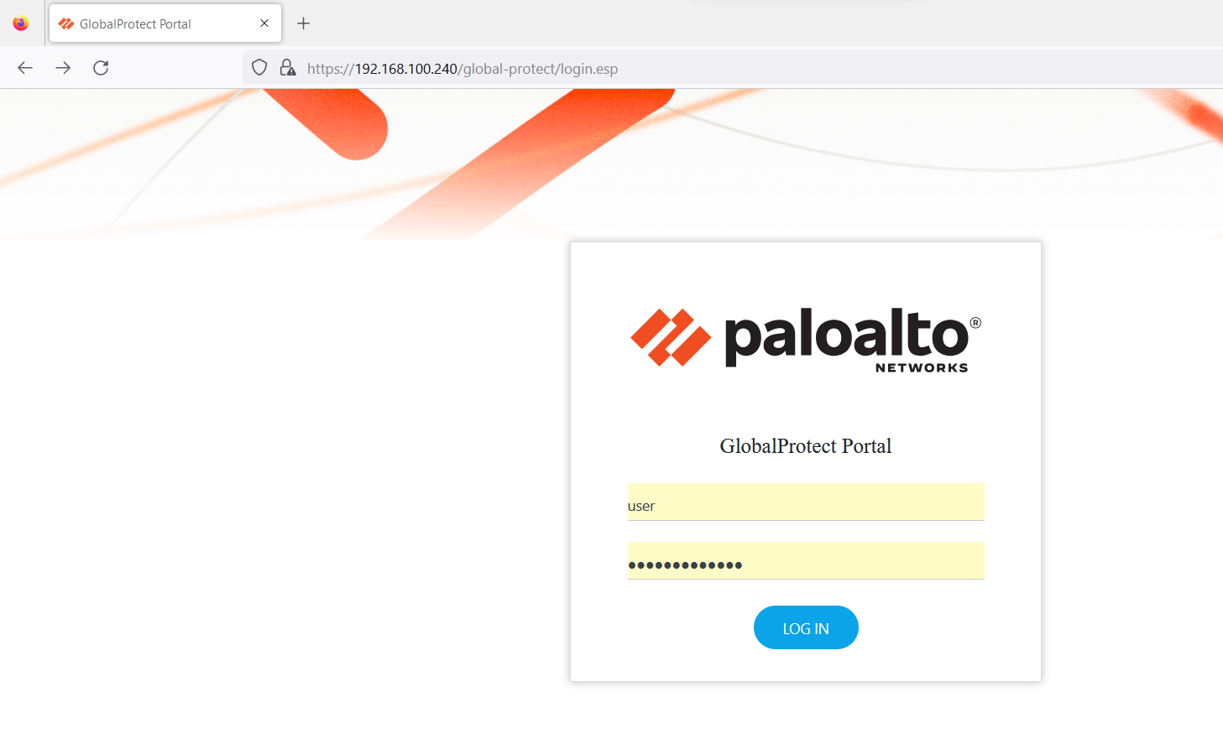

Step 12: Open the configured applicaiton

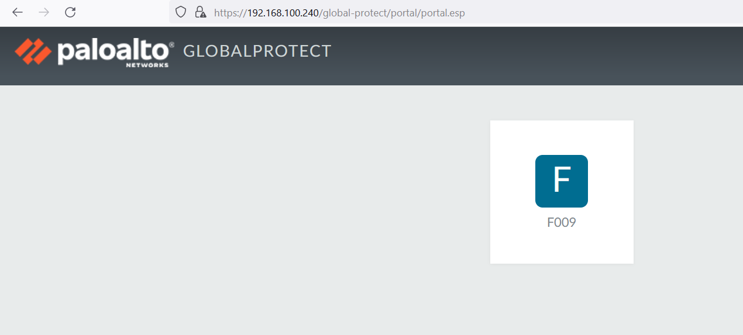

Step 13: our web server

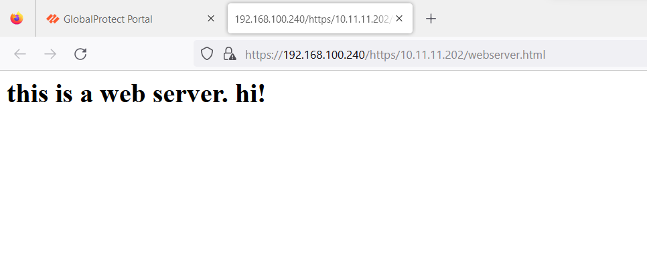

Problems

The original problem we ran into was we forgot to install the clientless VPN on the Palo Alto firewall, so the feature originally refused to activate. This was solved by going into dynamic updates and downloading and installing the clientless VPN feature.

Conclusion

In this lab, we configured a clientless VPN which is a VPN that establishes a connection with a web browser without the need to install any software or client. The process is very streamlined and simple on the Palo Alto and was completed with relatively few problems.

**PFSense SOHO Setup and Remote Desktop***Derek Liu*

Purpose

To setup and configure a pfSense firewall on a SOHO network and allow remote desktop access from the WAN side.

Background Information

The pfSense firewall is the free and open-source firewall and router. The software is distributed based on FreeBSD and is installed on a physical computer of a virtual machine to be used as a dedicated firewall/firewall. It can be easily configured through a web interface.

The management interface of the system is based in on the PHP language which means that the UNIX command line doesn’t need to be used. In terms of support, the developer and user community can provide support and assistance since it is open source.

Other than acting as a firewall by filtering data packets that pass through the network, a pfSense also supports NAT, load balancing, VPNs, DHCP, and others. In this lab we will mainly focus on configuring NAT and DHCP.

In this lab, the pfSense will be configured to receive an IP address from the WAN side as DHCP client and assign IP addresses on the LAN side as a DHCP server. After assigning addresses to the network card, the web interface can be accessed. In this lab, NAT will be configured to allow a remote desktop connection from the WAN side.

Remote desktop allows for a user to remotely control another computer’s desktop through a propriety protocol. In this case we will use Microsoft’s remote desktop software on a Windows device. A remote desktop by itself is not a secure setup and requires additional security measures in order to prevent it from being used maliciously. It can be useful in the case that an administrator needs to access a desktop but is unable to gain physical access to the device.

Configurations

1. Plug in a USB that will be used to contain the image of PFSense into a computer. Download RUFUS online

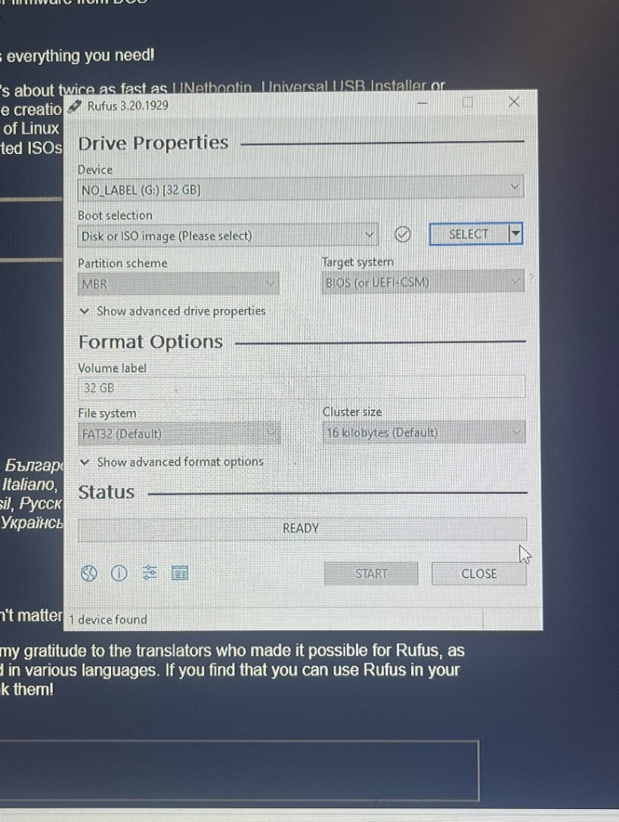

1. Download PFSense online

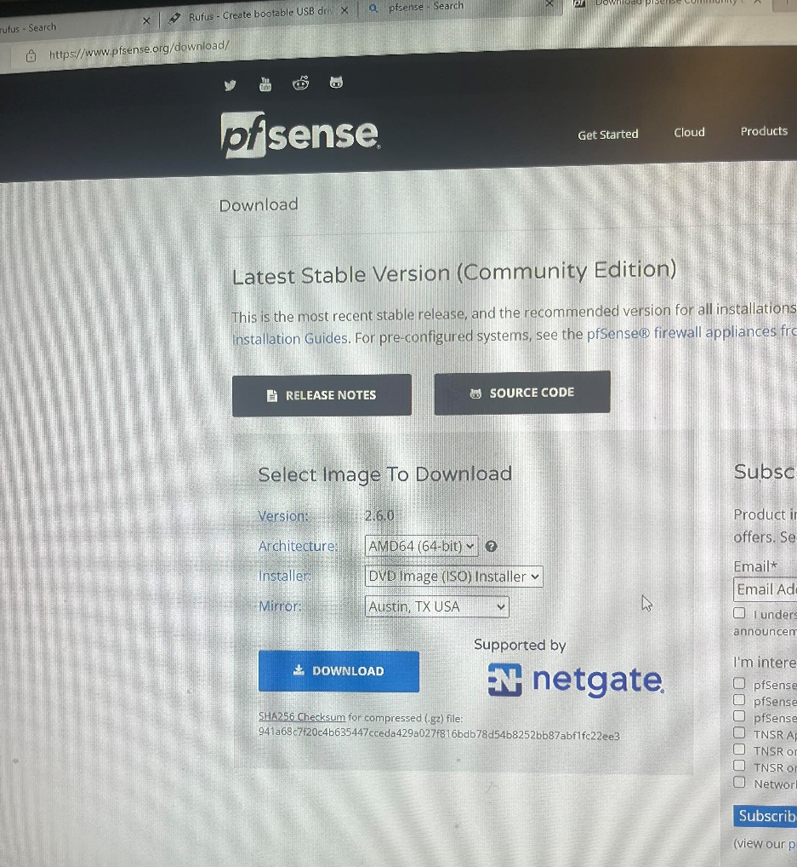

1. Unzip the PFSense ISO file that is downloaded

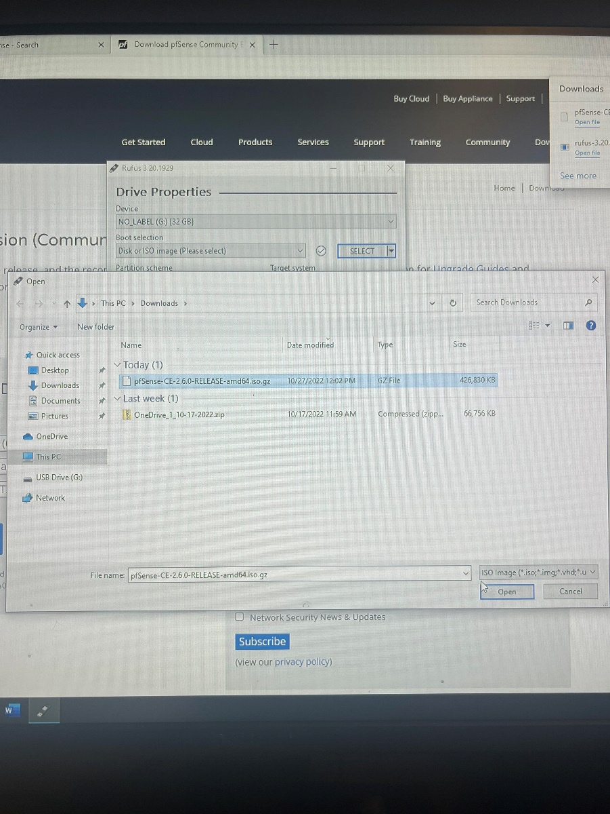

1. Select the ISO that was unzipped in RUFUS and reformat the USB. Plug in the USB into the device that will be used as the PFSense firewall (A laptop was used in this lab). Connect an ethernet cable from the PFSense to the WAN and another to the LAN.
2. Turn on the device and image it.
3. This should be the screen reached:

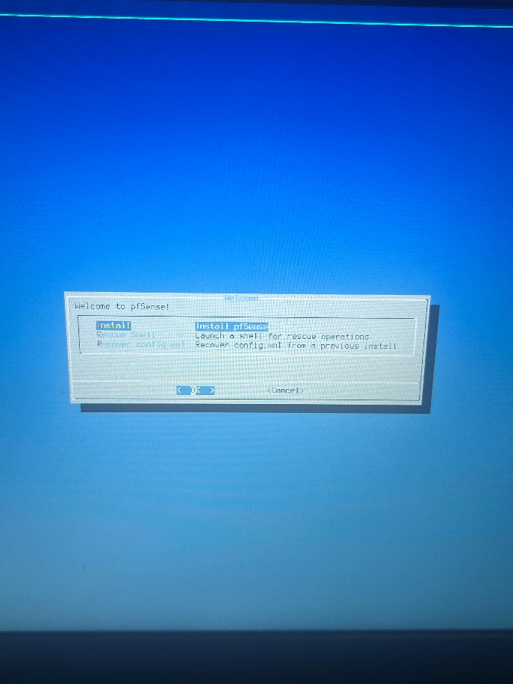

Select install.

1. Continue with a default keyboard, select Auto (UFS) UEFI, select no, select reboot.
2. This should be the result:

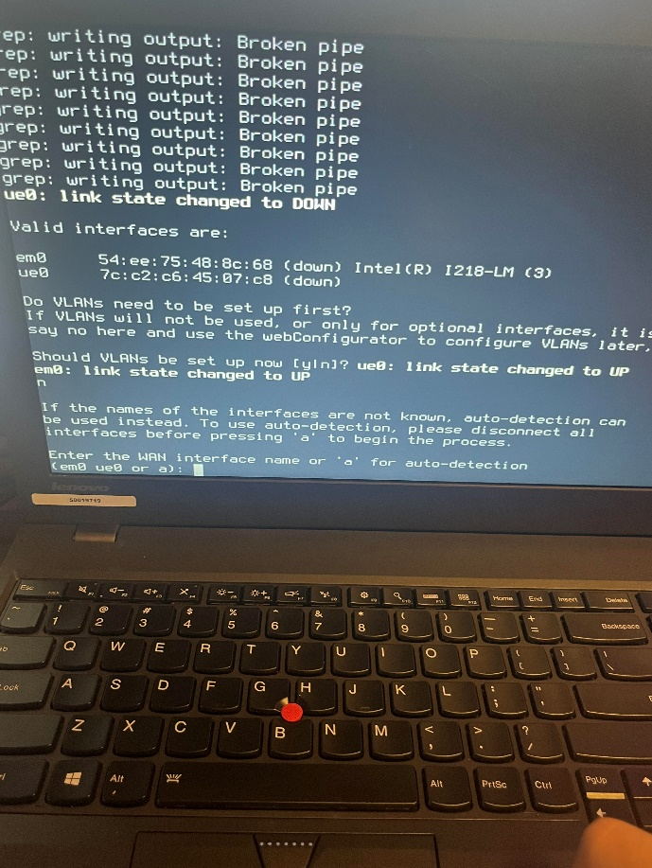

1. Select “no” for setting up VLANS
2. Assign the WAN and LAN interfaces accordingly.
3. Configure IP addresses for the WAN and LAN interfaces.
4. Got to <https://192.168.1.1>

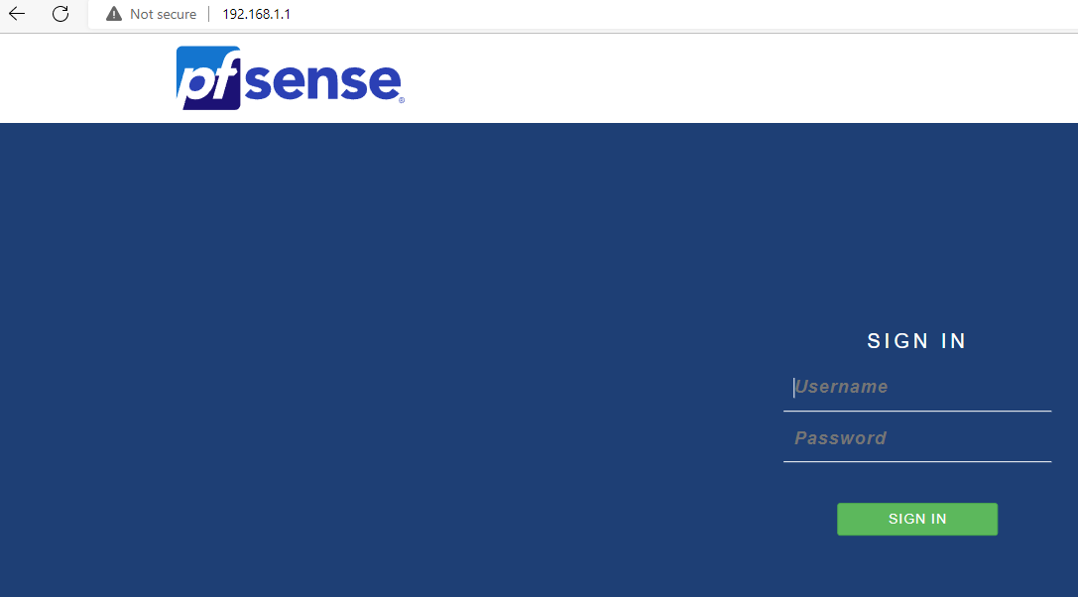

Default username: admin

Default password: pfsense

1. Go to firewall -> NAT

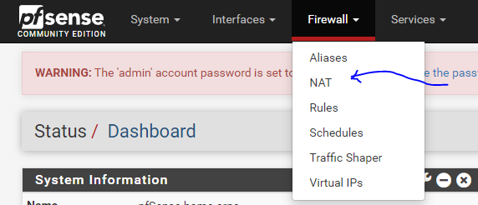

1. For interface port range use 3389. Target IP should be the ip address of PC. Target port: 3389. Save

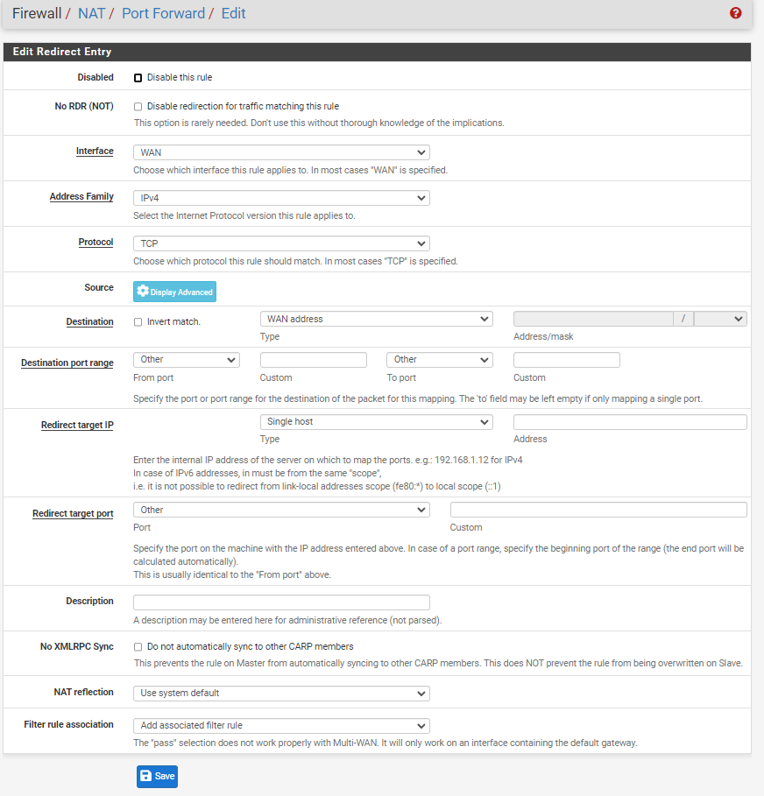

1. Enable remote desktop through settings and search for remote desktop.
2. Type in the address of the device you want to connect to

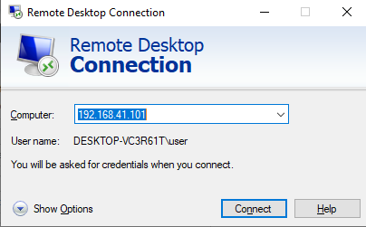

1. Click connect. Type in the username and password of the device you wish to connect to.

Problems

When setting up the pfSense, a problem came from experimenting with where it should be placed within a SOHO network and how to put the pfSense image into the device. Originally the device was booting into legacy so that was fixed by configuring the BIOs to boot into UEFI. Most problems arose from configuring pfSense. When assigning IP addresses to interfaces, the WAN side had trouble receiving an address through DHCP. This was fixed by detaching and reattaching the ethernet cable. Initially, when trying to access the web interface, it showed an error message of a bad gateway. This problem was solved by completely redesigning the lab with the exact same configurations since we were unsure of the root cause of this problem. It worked the second time through.

Conclusion

In this lab, we set up a pfSense in a SOHO environment. We configured interfaces using DHCP for both the WAN and LAN side in order to access the web interface. Through the web interface we set up remote access to allow a connection from the WAN side to the LAN side. The majority of the obstacles in the lab appeared during the initial set up of pfSense.

**Restoring Cisco ASA to Factory Default***Derek Liu*

Purpose

The purpose of this lab is to become familiar with the Cisco ASA and figure out how to factory reset the device and access the web interface.

Background Information

When accessing a Cisco ASA, it is unsure whether there were previous configurations on the device. If the intention is to use the ASA in a different network, it usually will be simpler to factory reset the ASA and configure it accordingly for the new network. In this lab, we connected a second-hand Cisco ASA to a network, factory reset it, and then accessed the Cisco Adaptive Security Device Manager (ASDM) launcher -- a web-based graphical user interface -- in order to proceed with configuration for our network.

The Cisco Adaptive Security Appliance (ASA) is a security device that provides firewall and network security for various network architectures. It can be deployed as a standalone device or integrated into a larger network. The Cisco ASA is designed to provide multiple security functions in a single device, including firewall, antivirus, intrusion prevention, virtual private network (VPN), and advanced threat protection. It also supports a variety of networking protocols and can be configured to meet the specific needs of an organization. One of the main features of the Cisco ASA is its firewall, which is designed to protect a network from external threats such as hackers and malware. It does this by inspecting incoming and outgoing traffic and allowing or blocking it based on predefined security rules.

This lab was considered completed when the firewall had been successfully integrated into the network. After successfully accessing the ASDM, we found it already was pre-configured for a SOHO environment.

Configurations

Step 1.

Connect ethernet cable from port 0 of the ASA to the WAN. Connect ethernet cable from any port other than 0 to workstation. Connect console cord into the console port of the ASA. Press the reset button the firewall. Open the terminal on the workstation and type “en”

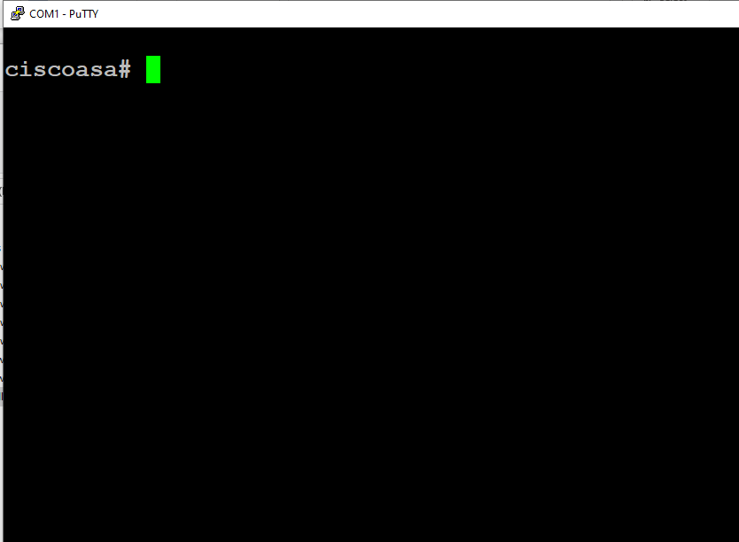

Step 2.

Type “config t” and then “config factory-default”.

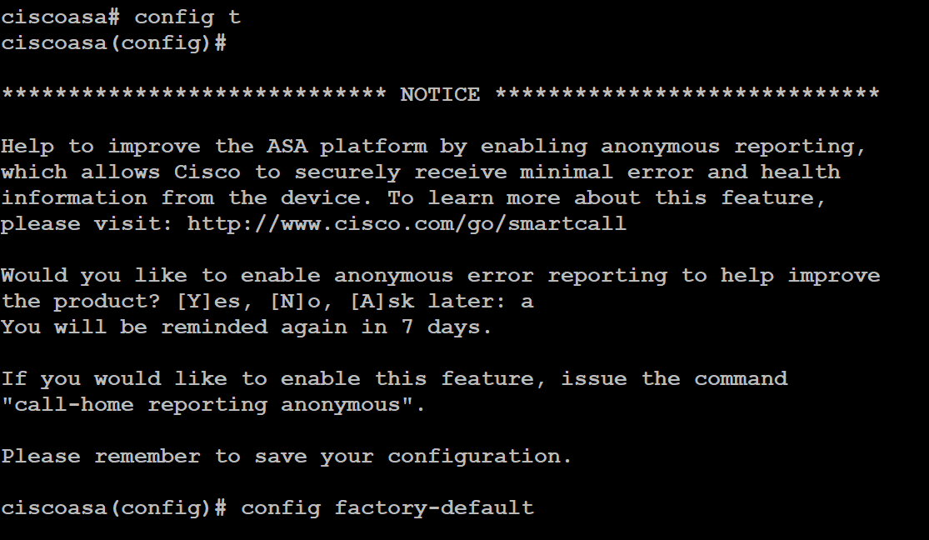

Step 3.

Set a password with “enable password [password]”



Step 4.

Save the configuration by typing “reload” and saving changes.



Step 5.

The default management address for the ASA should be <https://192.168.1.1/admin>

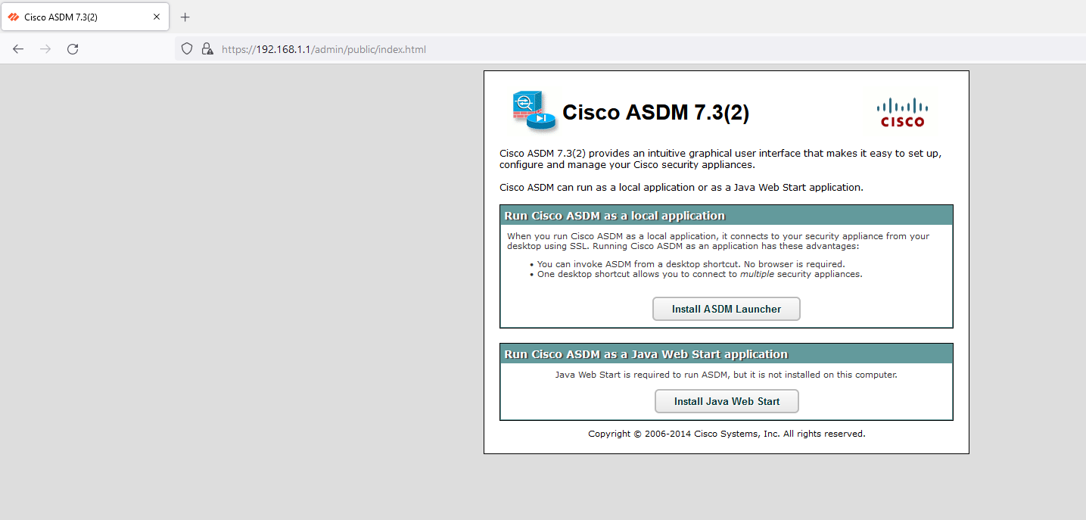

Step 6.

Install Java Web Start on the workstation by clicking “install Java Web start” and install the ASDM launcher by clicking “Install ASDM Launcher”.

Step 7.

Configure a username and password on the CiscoASA (these will be the credentials used to log into the ASDM launcher).

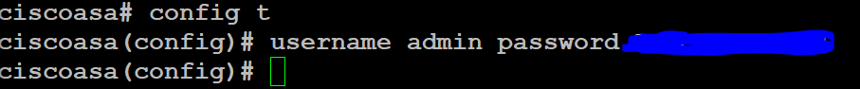

Step 8.

On the workstation’s desktop, there should be an installed desktop shortcut. Right click the icon and select “properties”

Paste the following into the target textbox:

C:\Windows\system32\wscript.exe invisible.vbs run.bat

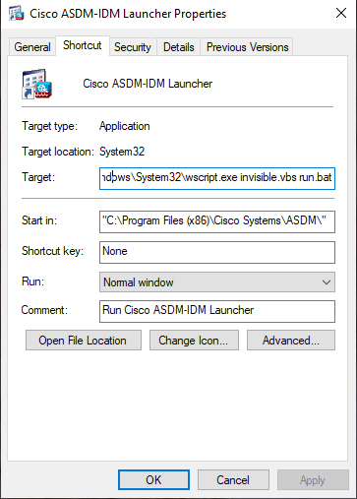

Step 9.

Open the workstation’s control panel (windows + r and search “control”).

Select “Programs” and then “Java.”

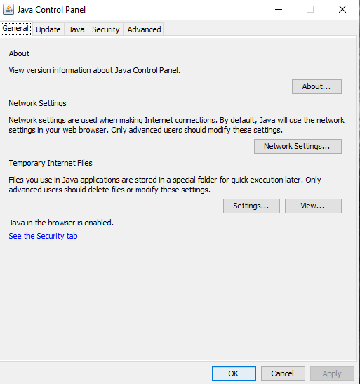

Step 10.

Go to “advanced” and scroll down. Enable only TLS 1 and TLS 1.1

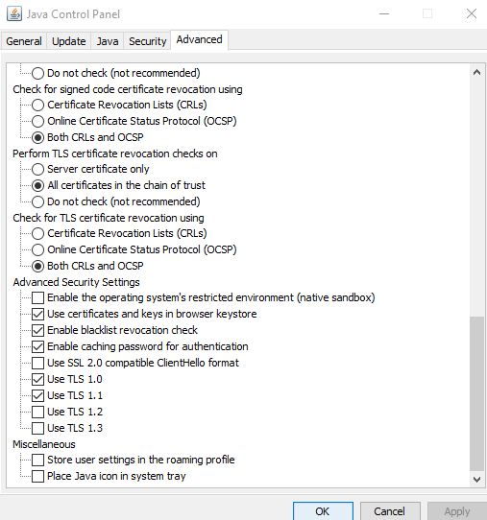

Step 11.

Open the file explorer on the workstation and go to C:\Program Files\Java\jre1.8.0_351\lib\security\java.security

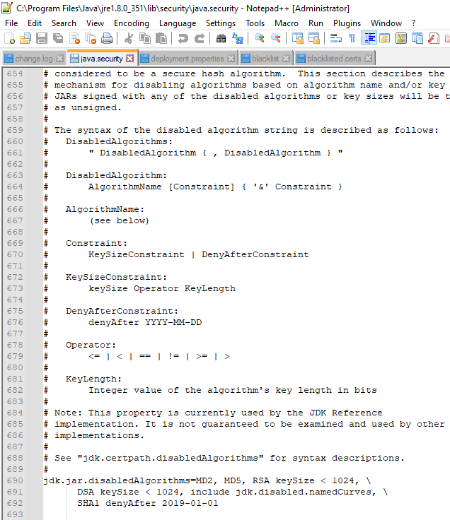

Step 12.

Under jdk.jar.disabledAlgorithms, remove TLSv1 and TLSv1.1 and under jdk.tls.legacyAlgorithms add TLSv1. Save the file.

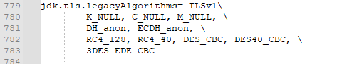

Step 13.

Open the ASDM launcher and type in the IP address of the ASA. Use the username and password configured in step 7.

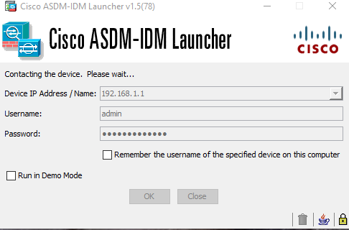

Problems

A problem that we ran into while setting up the ASA was the connection on the web interface failing initially but that started working after the ASA received an IP address from the WAN side and enabled TLS on the workstation. Most problems arose from trying to use the Cisco ASDM Launcher. Starting with trying to use the desktop shortcut, initially it wouldn’t open. This was fixed by editing the properties of the launcher and changing the target application shown in step 8 of the configuration. After trying to enter the device IP and credentials, an error message appeared on the Java console that said that the TLS version being used is not compatible with the system preferences of TLSv1.2. Our solution to this was to lower the preferred TLS version. This was done by removing TLSv1.1 and TLSv1 from disabled algorithms in the Java program files and changing the settings of settings of Java to use TLS 1.0 and TLS 1.1.

Conclusion

In this lab, we obtained a used a used Cisco ASA. We used a workstation with a console cord to console into the firewall to enter restore it to factory defaults. After factory resetting the ASA, we installed the required files to access the Cisco ASDM Launcher. After changing program preferences and program files due to an abundance of error messages that we had to work around while trying to access Launcher, we were ablet to access the configuration GUI. We can use this GUI to configure the ASA for our network in the future.

**Setting Up a Clientless VPN***Derek Liu*

Purpose

The purpose of this lab is to set up a clientless remote access VPN. With a clientless VPN, the remote should be able to set up a VPN tunnel to a network and access internal resources by typing an address into the search bar and entering credentials.

Background Information

A clientless VPN or browser-based VPN allows for users to access internal resources in a network through a web browser without the need to install software or client-based applications.

Clientless VPNs are useful when resources need to be accessed from a remote location easily and quickly and from any device. This can be helpful for those working on a public or shared computer that do not have administrative privileges to install software on their devices.

However, clientless VPNs are limited in terms of performance and functionality compared to VPN clients as they are only able to access web-based applications. They don’t offer advanced security protocols or features such as split tunneling.

Clientless VPNs also are not as secure compared to a traditional VPN since they do not offer advanced security features such as Open VPN, SSTP, or two factor authentication. Another shortcoming is its reliance on web browsers which have a lot of possible vulnerabilities due to their complexity.

Clientless VPNs are also not able to provide the same amount of control and visibility as a traditional VPN client which means that potential threats are harder to detect.

Lab Summary

In this lab, we set up a clientless remote access VPN with a Cisco ASA. It is a very straightforward and streamlined process with an SSL VPN Wizards that the Cisco ASA offers. Functionality was tested by connecting to the VPN and accessing an internal web server that is not reachable from the internet.

Network Diagrams with IP

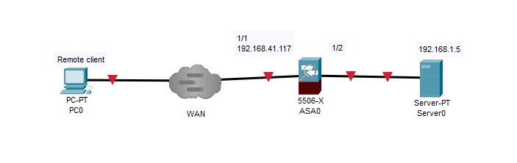

(note: in this lab, the 192.168.41.117 address was obtained with DHCP. The 192.168.1.5 address was obtained with the factory default DHCP configuration. The web server was set up with a windows computer running an Apache web server with XAMPP).

Configurations

Step 1: Set up the Cisco ASA with factory default configurations (refer to factory reset lab writeup if needed). Set up the topology as shown in the network diagram.

Step 2: In the Cisco ASDM, go to Wizards, VPN Wizards, Clientless VPN Wizard.

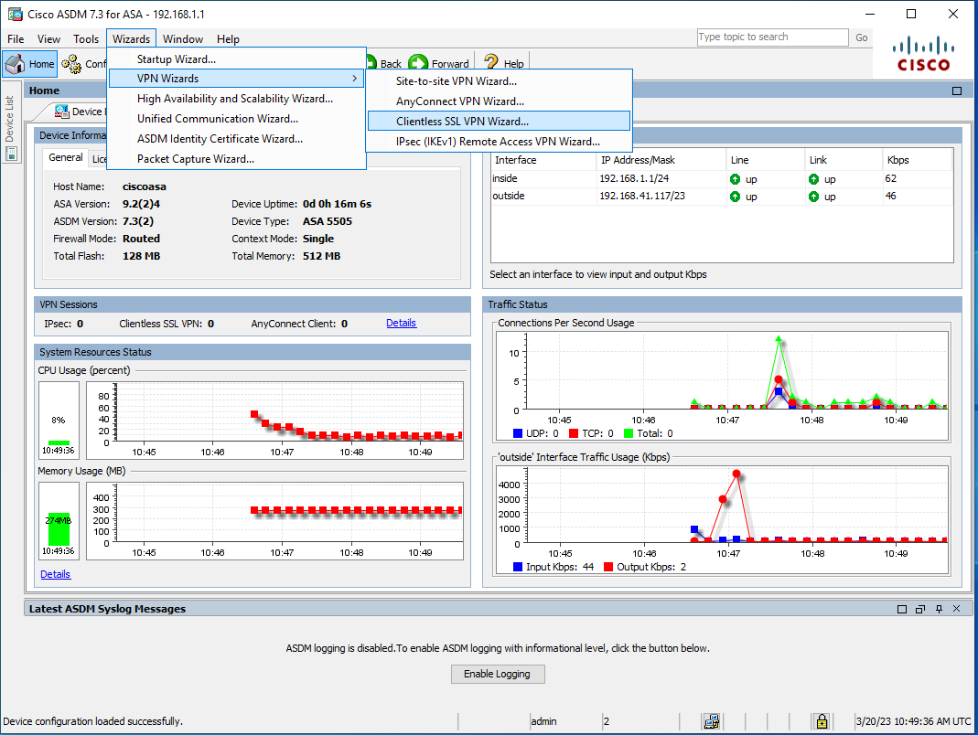

Step 3: click next

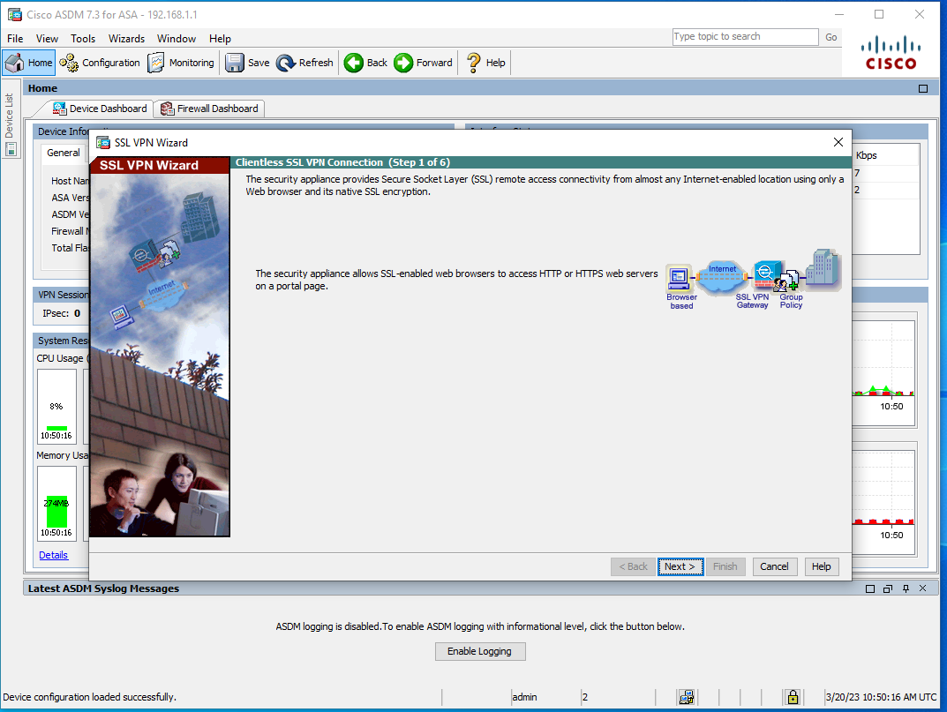

Step 4: type in the connection profile name as anyconnect_profile. Note the URL needed to access the VPN service.

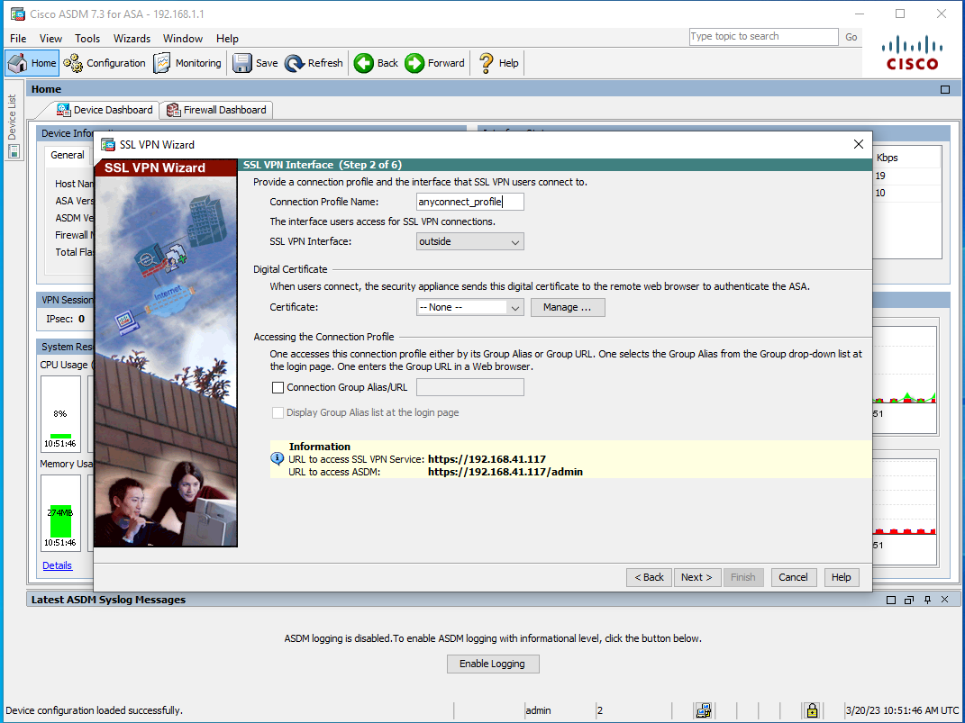

Step 5: choose Authenticate using local user database

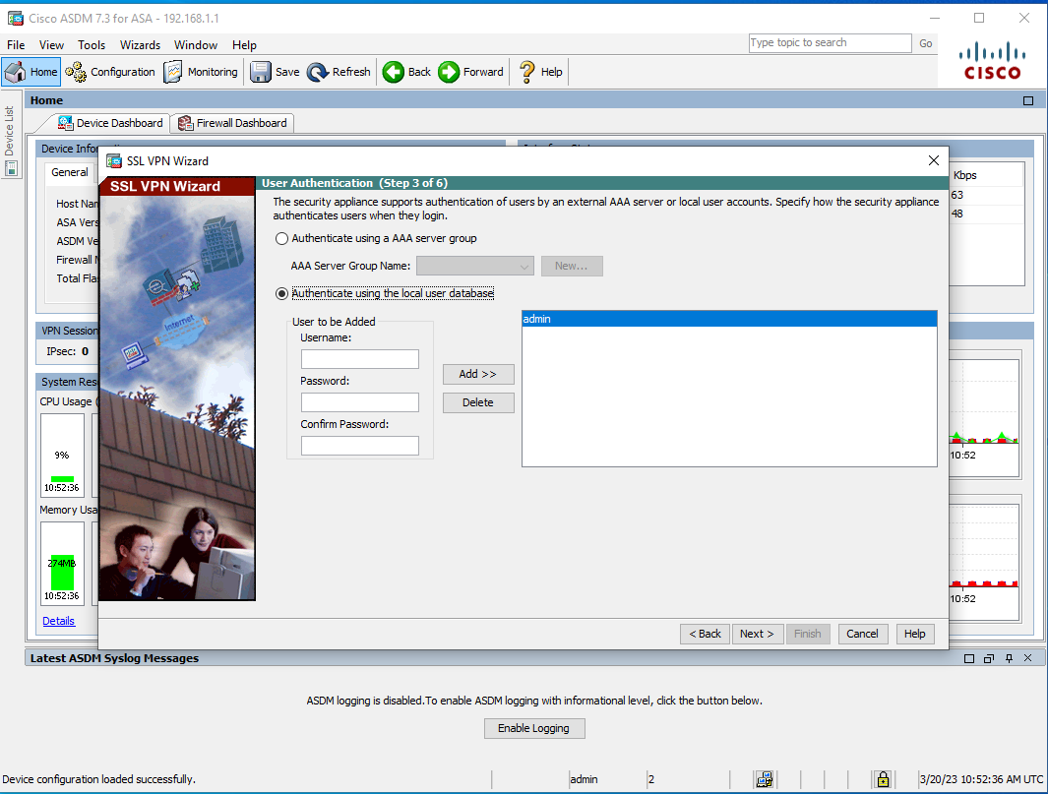

Step 6: Choose Create New Policy and name it test_anyconnect_policy

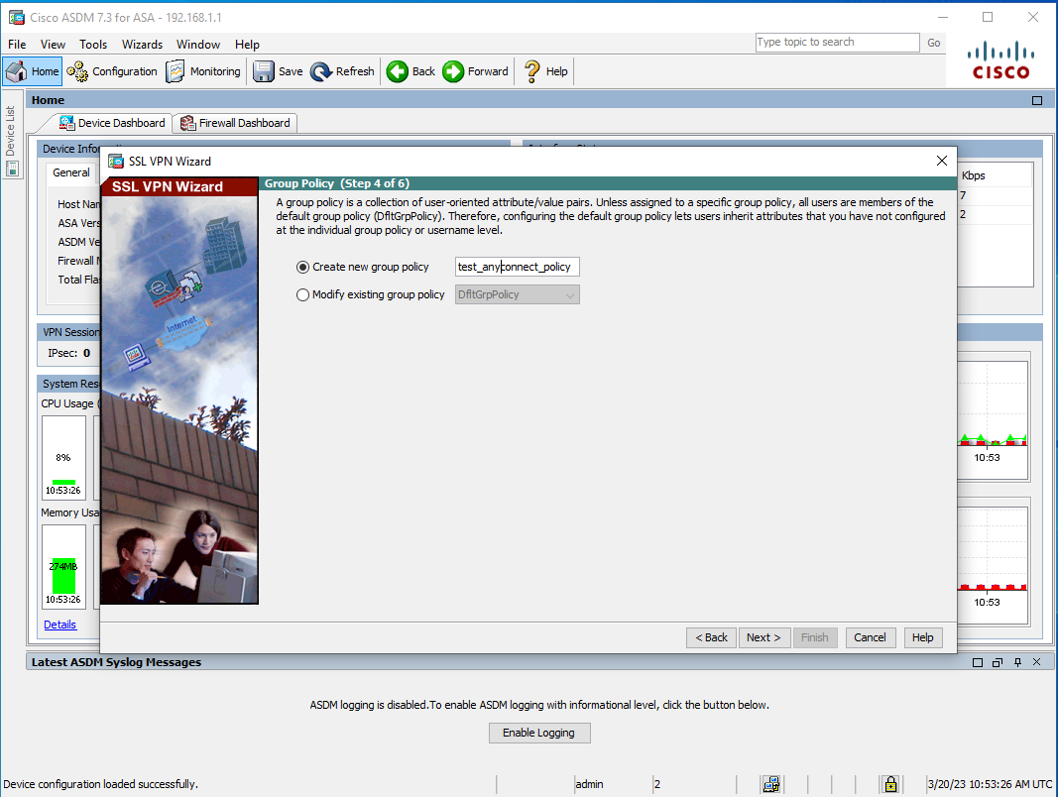

Step 7: click manage, add, and add.

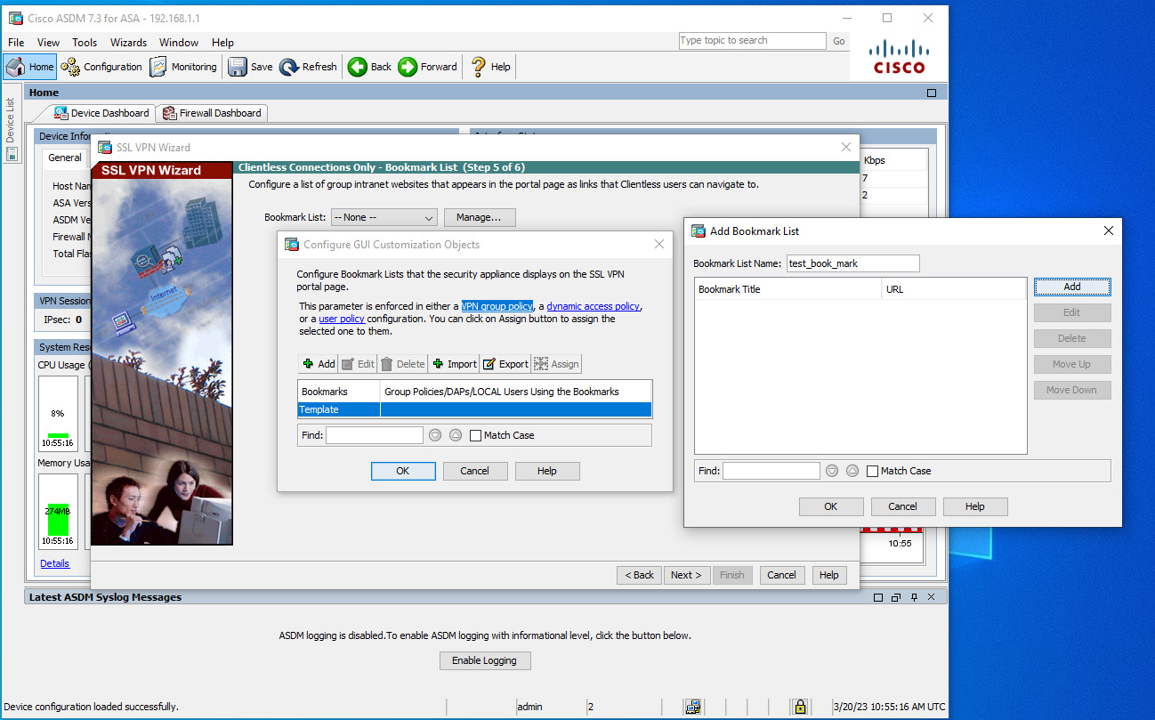

Step 8: select the following

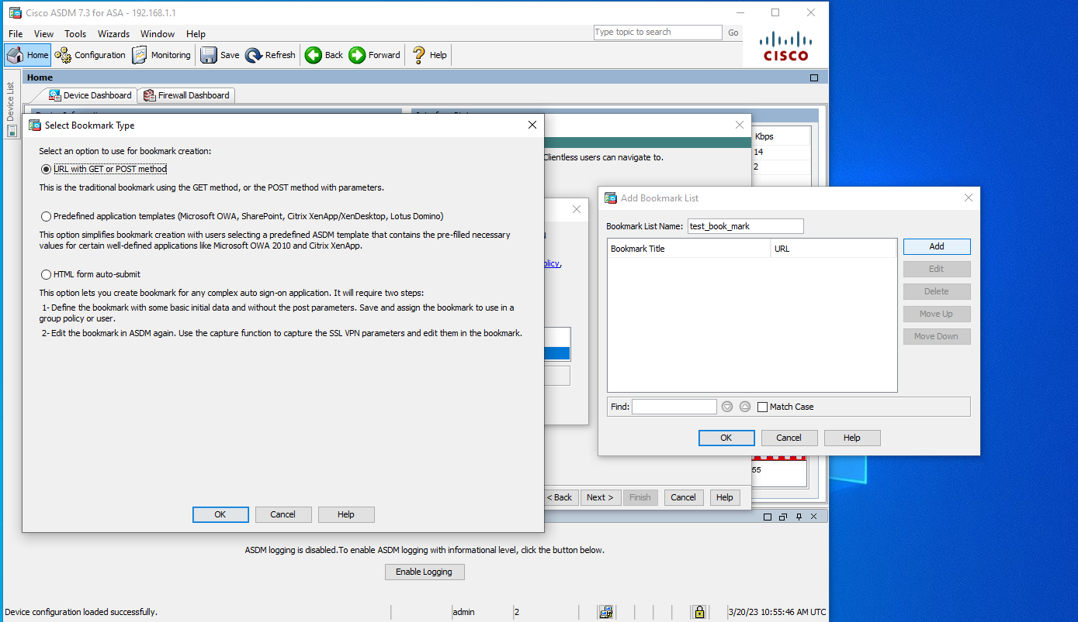

Step 9: configure the following.

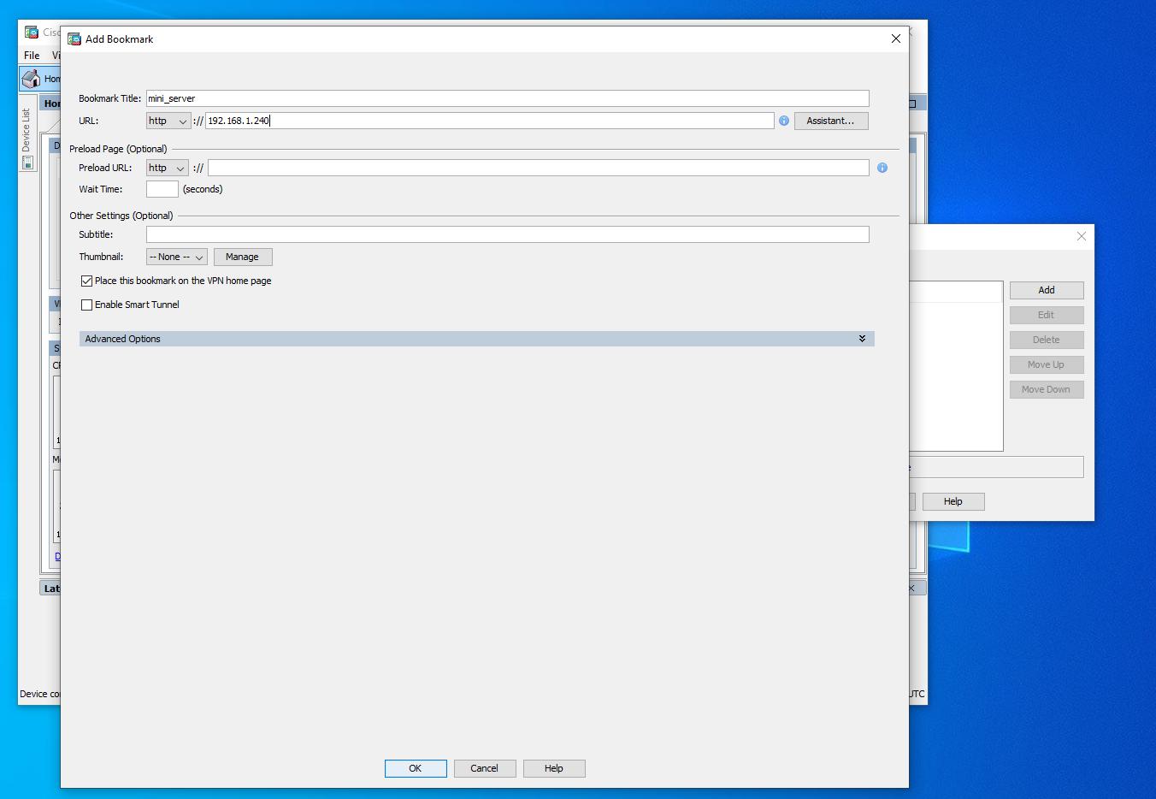

Step 10: click finish

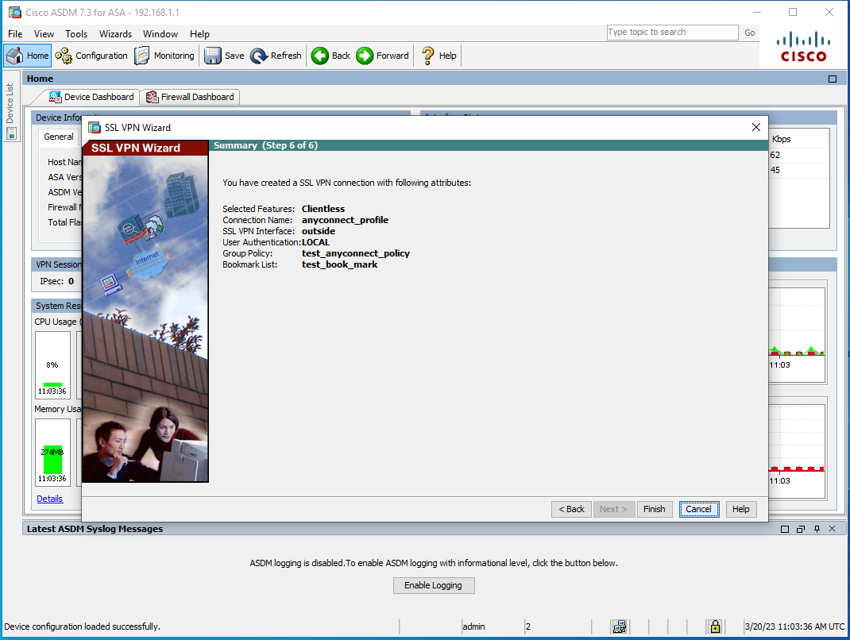

Step 11: go to configurations, remote access VPNs, connection profiles, anyconnect_profile

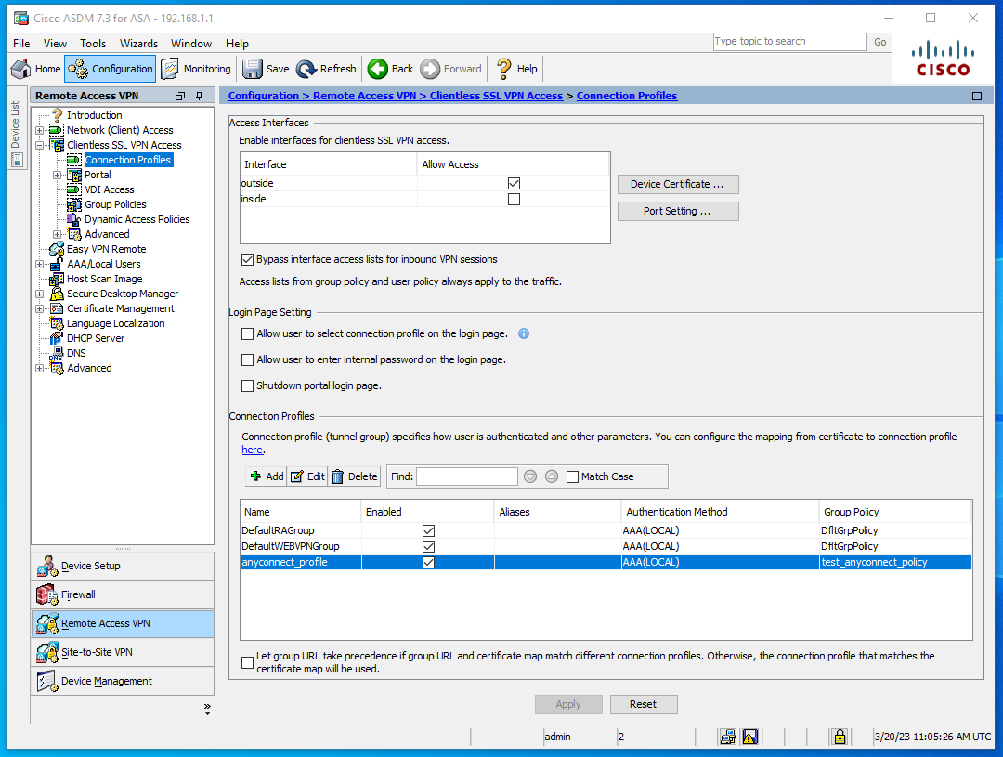

Step 12: click advanced, yes, and apply.

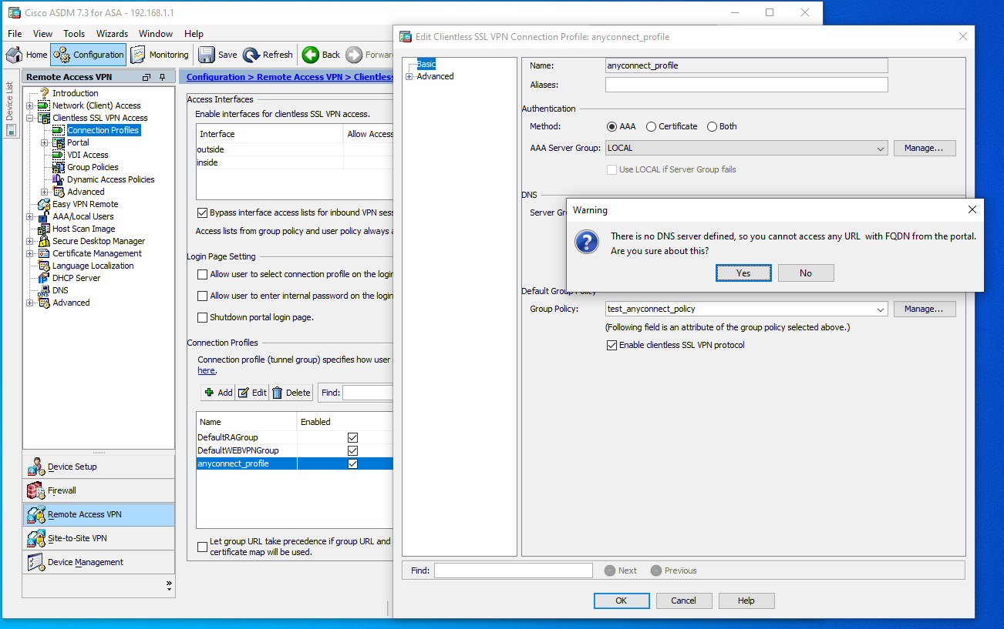

Step 13: access the remote user and type into a web browser (Firefox recommended) the URL noted in step 4

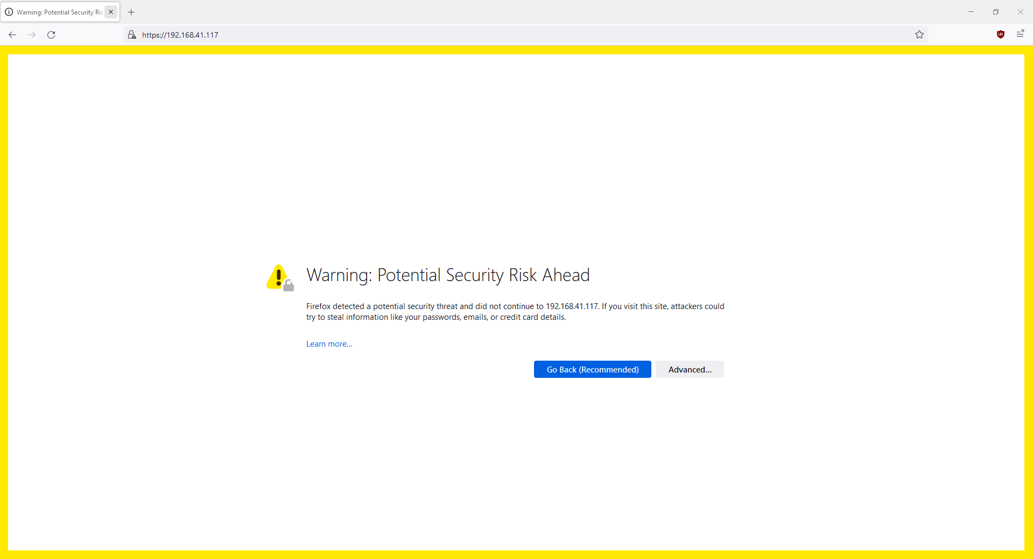

Step 14: enter credentials

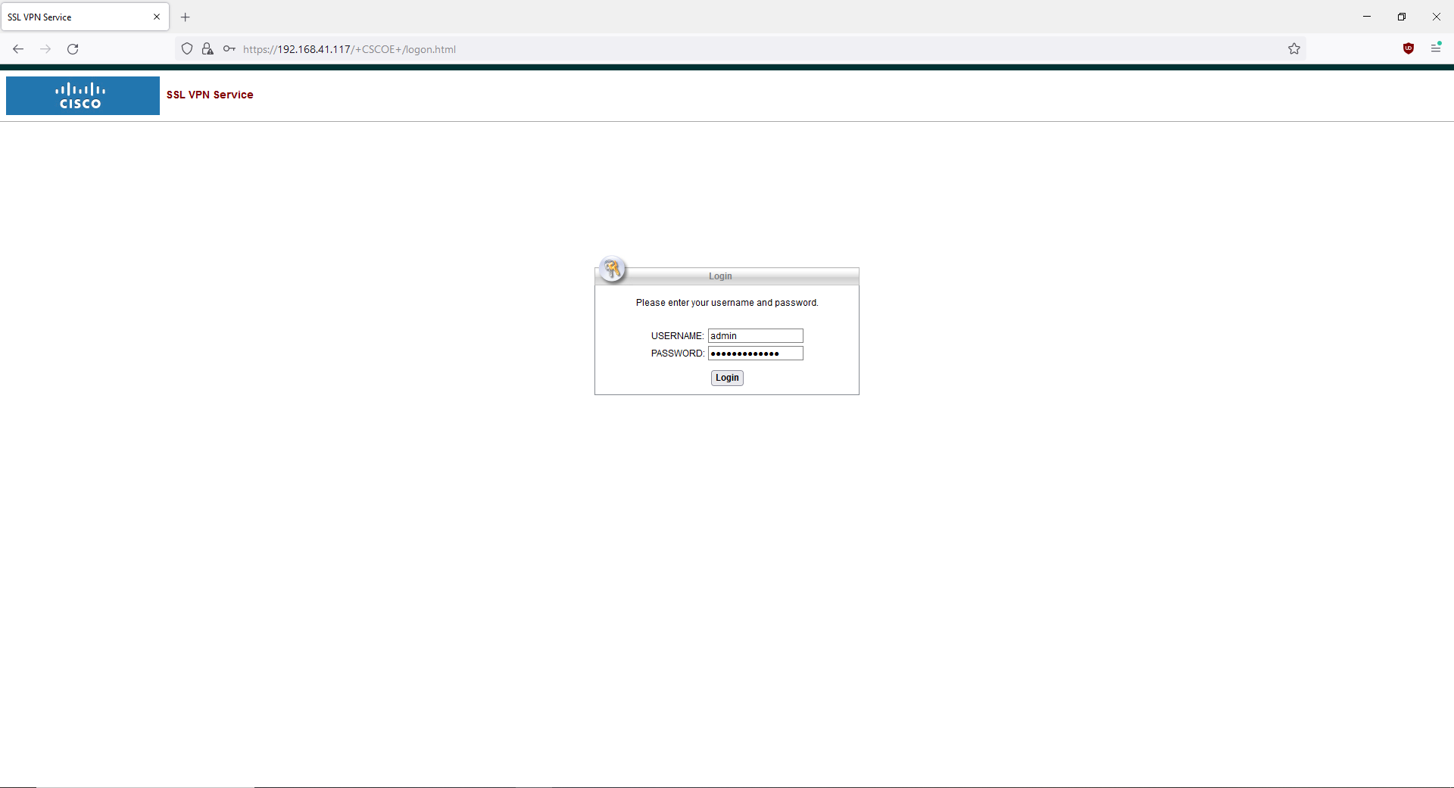

Step 15: from this screen, you can access internal resources. For example, we have an internal web server on <https://195.168.1.5/webserver.html> that can be accessed from here.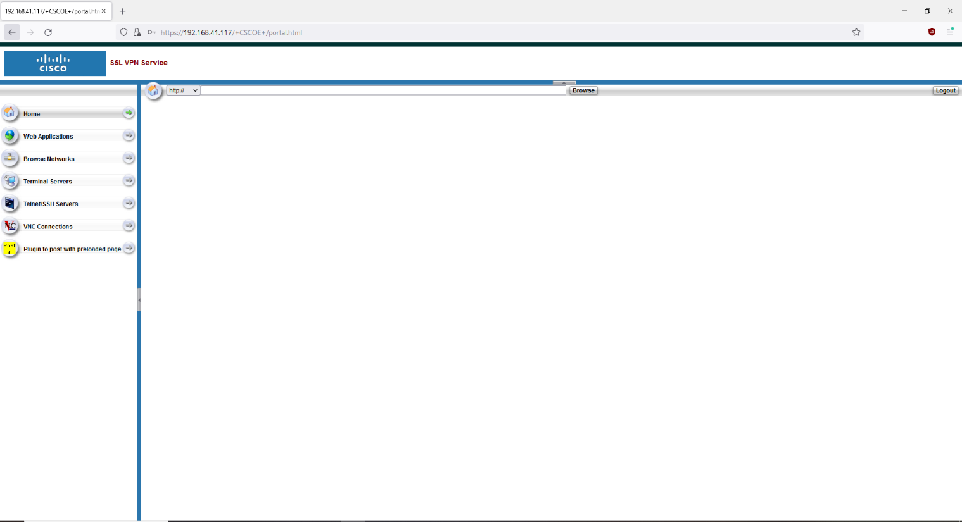

Problems

We were unsure of what IP address to put for the bookmark. Apparently, any IP address works. Someone unplugged our ASA while we were trying to get a sign off. Other than that, there were no problems.

Conclusion

In this lab, we configured a clientless VPN which is a VPN that establishes a connection with a web browser without the need to install any software or client. The process is very streamlined and simple on the Cisco ASA and was completed with relatively few problems.